:

**Treatments for Fractures:**

**1. 2.**

**3. 4.**

**5. 6.**

**7.**

**Joints are : __________________________________________**

**________________________________________________________**

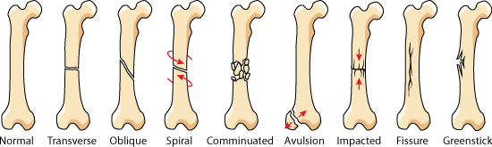

**Types of Joints:**

1) _______________________________ joints also called

_______________________________: have little or no movement

and made up of connective tissue

2) _______________________________ joints also known as

_______________________________: have limited movement &

made up of cartilaginous tissues

3) _______________________________ joints also known as

_______________________________: have lots of movement and

made up of synovial fluid

**Label the types**

**of fractures under**

**each image that**

**you see:**



**Types of Body Scans:**

**1.**

**2.**

**3.**

**4.**

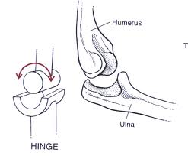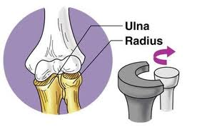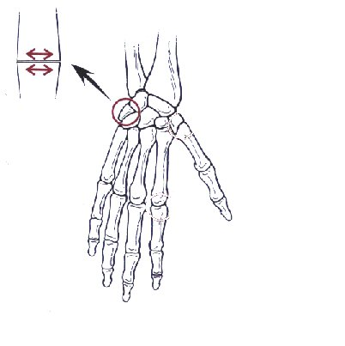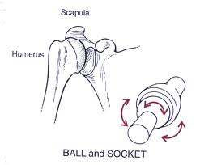

**Types of Synovial Joints**

**Example: Example: Example: Example:**

**Movement: Movement: Movement: Movement:**

Label which color is:

**Functions of Appendicular System**

**1.**

**2.**

**3.**

**4.**

**5.**

**Functions of Axial Skeleton**

**1.**

**2.**

**Functions of the Skeletal System**

**1.**

**2.**

**3.**

**4.**

**5.**

**Skeletal System Review**

**Name: ___________________________________________**

Axial skeleton: ______________________

Appendicular Skeleton: ____________

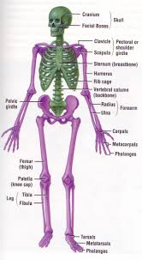

**Functions of Axial Skeleton**

**1.**

**2.**

**Parts of Axial Skeleton**

**1.**

**2.**

**3.**