WORD |  | PICTURE | YOUR DEFINITION
1. | Scientific Method | 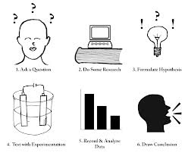
2. | Testable Question
3. | Variable | 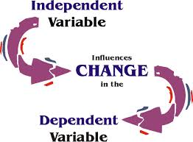

WORD |  | PICTURE | YOUR DEFINITION
4. | Independent Variable
5. | Dependent Variable
6. | Constant/Controlled Variable
WORD |  | PICTURE | YOUR DEFINITION
7. | Hypothesis | 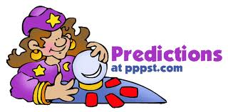
8. | Materials | 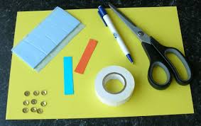
9. | Procedure

WORD |  | PICTURE | YOUR DEFINITION
10. | Observation
11. | Inference | 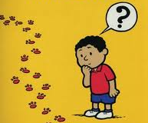
12. | Qualitative Observation | 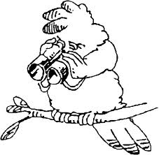

WORD |  | PICTURE | YOUR DEFINITION
13. | Quantitative Observation | 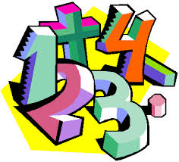
14. | X-axis | 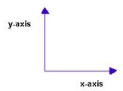
15. | Y-axis
16. | Number scale | 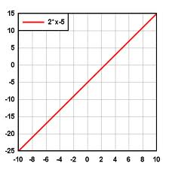
17. | Direct  relationship | 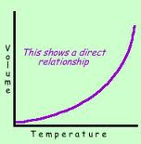
18. | Indirect relationship | 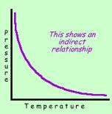
19. | Data | 