Skin Whitening—Stay Dark or Go Light?
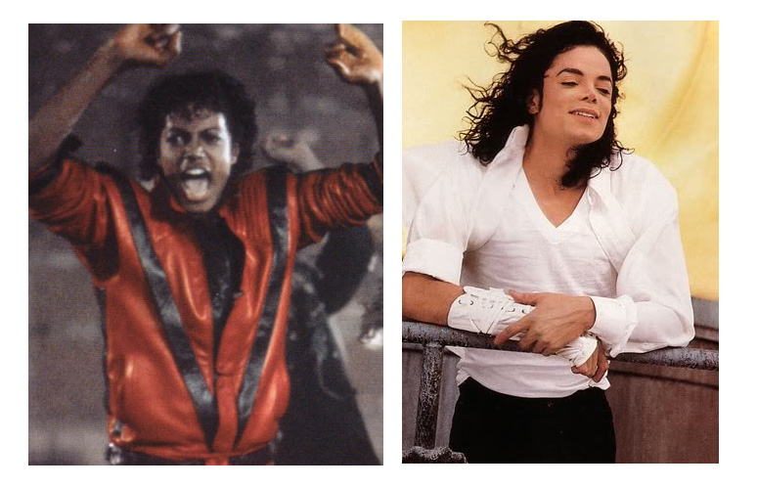

Notes: What do you think about this?

Stay Dark: Pros
Argument |  | Cite Evidence (Quote & Website)
Stay Dark: Cons
Argument |  | Cite Evidence (Quote & Website)
Go Light: Pros
Argument | Cite Evidence (Quote & Website)
Go Light: Cons
Argument | Cite Evidence (Quote & Website)

