Aim:
5.1

Objective:

Real world connection:

Vocabulary: kidneys, ureters, bladder, sphincter, urethra, renal artery, renal vein, pelvis, medulla, cortex, nephron, urea, dialysis

Urinary System aka Excretory System

For today’s lesson, to get an overview of the excretory system you are going to do a Webquest:

This means you will go online to the various websites provided on our class website and fill out the notes in your packet that correspond with those websites. We will go over some of this afterwards.

5.1 Class Notes

A. Go to the following website: http://www.ask.com/question/what-are-the-seven-functions-of-the-human-urinary-system

Answer the following:
What Are the Seven Functions of the Human Urinary System?

1.

2.

3.

4.

5.

6.

7.

B. Go to the following website: http://kidney.niddk.nih.gov/kudiseases/pubs/yoururinary/

Click on How does the urinary system work? Answer the following questions:

How are the lungs, skin, and intestines similar to the urinary system?

BONUS: What type of waste is excreted by the lungs, skin, and intestines?
1. Lungs: ______________________
2. Skin: ______________________
3. Intestines: ______________________

5.1 Class Notes

What factors affect the amount of fluid excreted by the urinary system?

What is urea and where does it come from?

How does it get to the kidneys?

Go to the following website: http://medicalcenter.osu.edu/patientcare/healthcare_services/urinary_bladder_kidney/anatomy_urinary_system/pages/index.aspx
Label the following diagram:
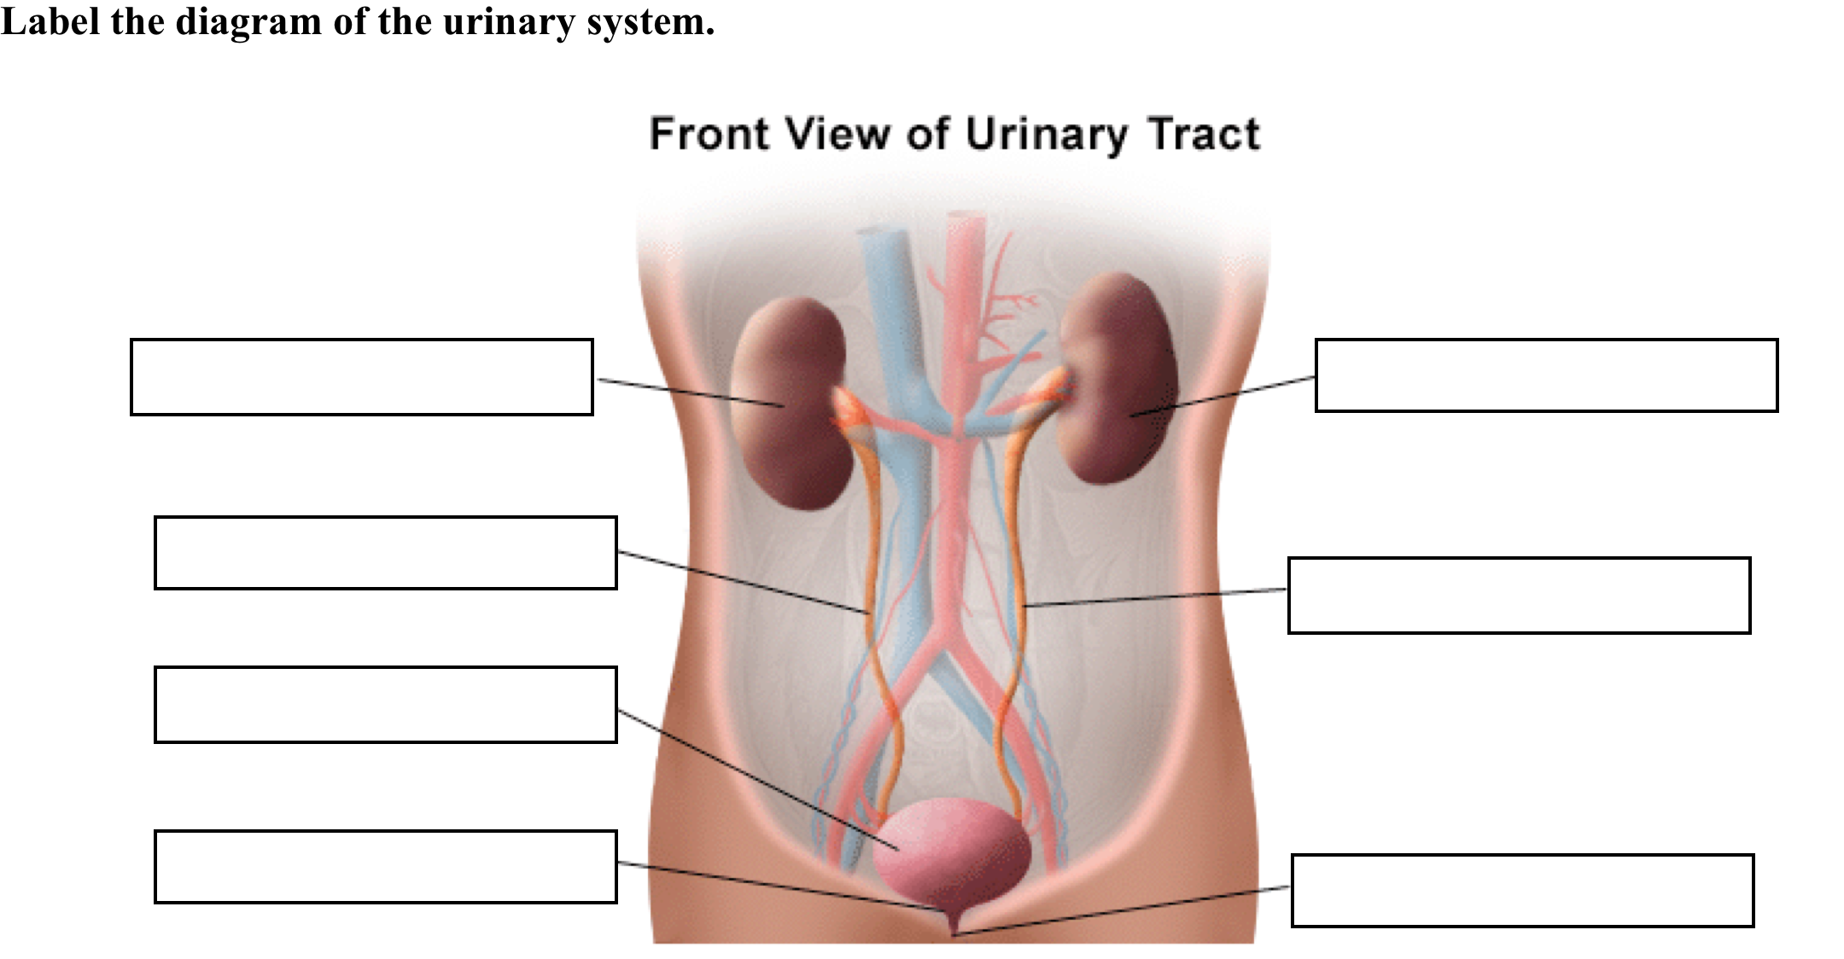
5.1 Class Notes

Continuing from this website: http://medicalcenter.osu.edu/patientcare/healthcare_services/urinary_bladder_kidney/anatomy_urinary_system/pages/index.aspx

Summarize the function of the following:
Kidneys - ____________________________________________________________________________________________________________________________________________________________________________________________________
Ureters - ____________________________________________________________________________________________________________________________________________________________________________________________________
Bladder - ____________________________________________________________________________________________________________________________________________________________________________________________________
Sphincters - ____________________________________________________________________________________________________________________________________________________________________________________________________
Nerves in bladder - ____________________________________________________________________________________________________________________________________________________________________________________________________
Urethra - ____________________________________________________________________________________________________________________________________________________________________________________________________

5.1 Class Notes

Go to the following website: http://www.biologymad.com/resources/kidney.swf

Use the mouse to scroll over and locate each part listed below and record its function

Summarize the function of the following:
Renal artery - ____________________________________________________________________________________________________________________________________________________________________________________________________
Renal vein - ____________________________________________________________________________________________________________________________________________________________________________________________________
Pelvis - ____________________________________________________________________________________________________________________________________________________________________________________________________
Medulla- ____________________________________________________________________________________________________________________________________________________________________________________________________
Cortex- ____________________________________________________________________________________________________________________________________________________________________________________________________

5.1 Class Notes
Go to the following website: http://www.medindia.net/animation/anatomy_urinary.asp
- Each kidney is about the size of a human ____________.
- Label the diagram.
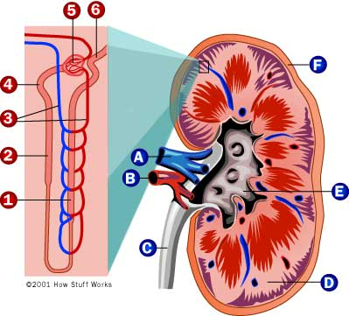

- The specialized unit of the kidney is called the nephron, and its function is to produce _________________________ by filtering waste and extra fluid from the blood.
- Blood enters the kidney through the renal ______________ and passes into the nephron.
- The bulk of the filtering takes place in the ____________________________.
- The filtered wastes then travel through the tubule where the excess fluid is converted to ____________________________.
- The urine reaches the renal pelvis and passes into the ________________________.
- Next, it enters the urinary __________________________ to be stored until it is released via the _____________________________.
- Finally, the filtered blood leaves the kidney through the renal _______________________.
5.1 Class Notes

Go to the following website: http://www.tutorvista.com/content/biology/biology-iv/excretion/nephron-structure.php
Label the 4 primary regions of the nephron:

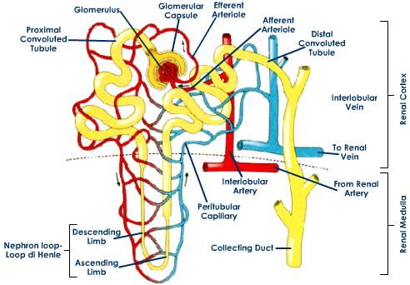

Go to the following website: http://www.biologymad.com/resources/kidney.swf

Now click on CONTINUE at the bottom of the page so you can see HOW THE NEPHRON WORKS. Click on each of the five substances, THEN click Start to find out what happens to each in the nephron. FILL IN THE TABLE BELOW
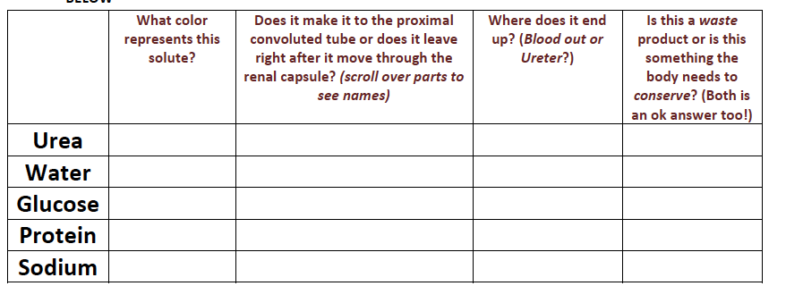

5.1 Class Notes

Continue on this website: http://www.biologymad.com/resources/kidney.swf

Bonus: How do all these substances get into and out of the blood stream?

Now click on Capsule, Proximal, Loop and Duct at the top of the page in the drop down menu. Watch each simulation and see if you can figure out what parts you are looking at. Then answer the questions below:

a. Which molecule is the largest urea, water, glucose, protein or sodium?

b. On the proximal simulation: What do the following represent?
i. Red circles at the bottom

ii. Yellow tic-tacs with lines inside them

iii. Small pink dots

Go to the following website: http://kidshealth.org/parent/general/body_basics/kidneys_urinary.html

Identify four different wastes produced by your body?

a.

b.

c.

d.

Out of these wastes produced by your body, which waste product is produced by the kidney?_________________________________

5.1 Class Notes

DIALYSIS

Go to this website: http://www.davita.com/articles/dialysis/
Click on Animated learning module about dialysis
1. What is dialysis?

2. What are some benefits of dialysis?

Go to this website: http://www.kidney.org/atoz/content/dialysisinfo.cfm
- When is dialysis needed?

- What does dialysis do?

5.1 Class Work

LABELING URINARY SYSTEM
Label using the following: bladder, ureter, kidney, and urethra
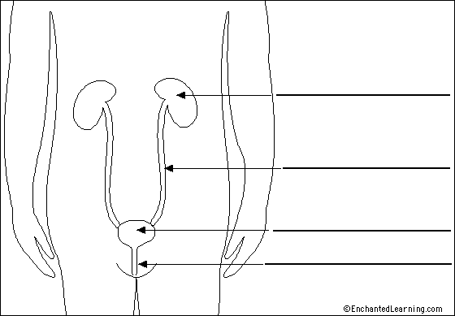

Label using the following:
Pyramids, ureter, renal pelvis, renal vein, renal artery, medulla, cortex, fibrous capsule

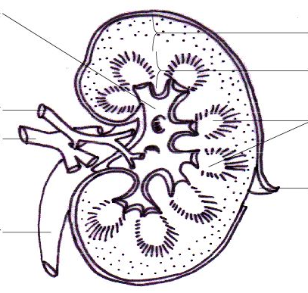
5.1 Class Work

Answer the following multiple-choice questions:

- What is the source of the waste products that are excreted by the urinary system?
- Pollutants in the water and food
- Undigested fiber
- Metabolic processes
- Excess food
2. What is the function of the urinary bladder?
- Store urine
- Filter the blood
- Aid defecation
- Contain bacteria to fight infection

- The ureter connects which part of the kidney to the bladder?
- renal cortex
- urethra
- renal medulla
- renal pelvis

- Which of the follow is not a function of the urinary system?
- removal of waste products from the bloodstream
- storage and excretion of urine
- regulation of leukocyte and platelet production
- regulation of blood volume and, indirectly, blood pressure

- All of the following structures are components of the urinary system except
- kidneys
- ureters
- urethra
- gallbladder
6. The outer layer of the kidney, just internal to the fibrous capsule, is the renal
a. medulla
b. column
c. pelvis
d. cortex

5.1 Class Work

LINES OF LEARNING (LOL): In a TIEDIEDC, explain how the structures of the urinary system helps carry out its function (Chose two structures to analyze a function). Be sure to cite two pieces of evidence.
T | Topic Sentence of Paragraph
I | Introduce how one part of bone helps with a function
E | Cite evidence from reading
D | Explain the example/evidence
I | Introduce how another part of bone helps with a different function
E | Cite evidence from reading
D | Explain the example/evidence
C | Conclusion

Aim:
5.2

Objective:

Real world connection:

Vocabulary: urea, Bladder, Collecting duct, Minor calyx, Major calyx, Pelvis, Ureters, Distal tube, Proximal tube, Loop of Henle, nephron, filtration, secretion, reabsorption, passive transport, active transport

All Things Urine
THINK INK: Why is releasing urine from the body important?

ACTUAL ANSWER:

WATCH VIDEO:
http://www.pennmedicine.org/encyclopedia/em_DisplayAnimation.aspx?gcid=000136&ptid=17
4.5 Class Notes

Components of Urine

Physical Characteristics of Normal Urine

Go the following website: http://www.ivy-rose.co.uk/HumanBody/Urinary/Urinary_System_Composition_Urine.php

Quantity/Normal Volume - ____________________________________________________________________________________________________________________________________________________________________________________________________
Color - ____________________________________________________________________________________________________________________________________________________________________________________________________
Specific Gravity/Density - ____________________________________________________________________________________________________________________________________________________________________________________________________
Odor- ____________________________________________________________________________________________________________________________________________________________________________________________________
Reaction/Acidity- ____________________________________________________________________________________________________________________________________________________________________________________________________

5.2 Class Notes

Chemical Composition of Normal Urine

Go the following website: http://www.ivy-rose.co.uk/HumanBody/Urinary/Urinary_System_Composition_Urine.php

- Urine is 95% _________________________
- The other 5% is made up of ___________________________
Organic Molecules:
a. Urea - __________________________________________________________________________________________________
b. Creatinine - __________________________________________________________________________________________________
c. Uric acid - __________________________________________________________________________________________________
d. Other substances- __________________________________________________________________________________________________
Ions:
Individual elements include (list them out)- ____________________________________________________________________________________________________________________________________________________________________________________________________
Small groups formed from a few different elements (list them out)-

____________________________________________________________________________________________________________________________________________________________________________________________________

5.2 Class Notes

Formation and Elimination of Urine

Go on this website: http://lyceum.algonquincollege.com/lts/aandpresources/interactive/14-6_UrineComposition/index.html

Use this website to go through step-by-step to answer questions. Make sure to complete the entire activity online.

Urine formation has three main stages:
NOTE: Click start, place arrow over the name of each stage to find out which structures are involved
Stage | Description | Structures Involved
Filtration
Reabsorption
Secretion

5.2 Class Notes
Step 1: Filtration
Filtrate = liquid passed through a filter
In filtrate | Not in filtrate

- Filtration is occurring in the _______________________________________.

5.2 Class Notes
Step 2: Reabsorption
Passive Transport | Active Transport

5.2 Class Notes
Step 3: Secretion
Active Transport

What distinguishes filtration, reabsorption, and secretion?

5.2 Class Notes

Pathway of Urinary Tract
Go to this website: http://kidshealth.org/kid/htbw/pee.html
1.
2.
3.
4.
Label the diagram below
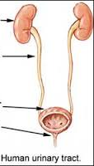
5.2 Class Notes
Pathway of Urine Formation in the Nephrons
Using the images above, list step-by-step the pathway of urine in the nephrons from the Bowman’s capsule to the collecting duct
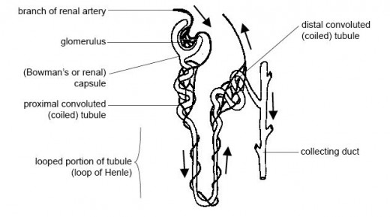
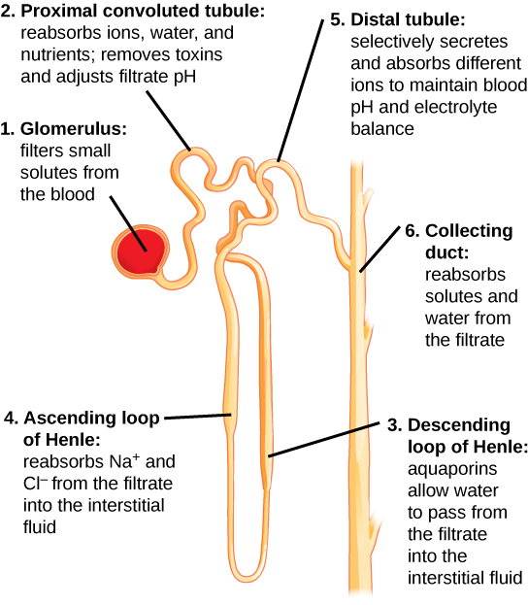
List Steps of Urine Formation
1.
2.
3.
4.
5.
6.
5.2 Class Notes

How urination is controlled?

Go to this website: http://www.aviva.co.uk/health-insurance/home-of-health/medical-centre/medical-encyclopedia/entry/function-urine-formation-and-excretion/
What happens when the bladder is full?

What causes urine to be released?

What does it mean to expel?

How is urine timing controlled in older children and adults?

What happens in young children?

How is the bladder emptied out?

5.2 Class Work

LABELING URINARY SYSTEM

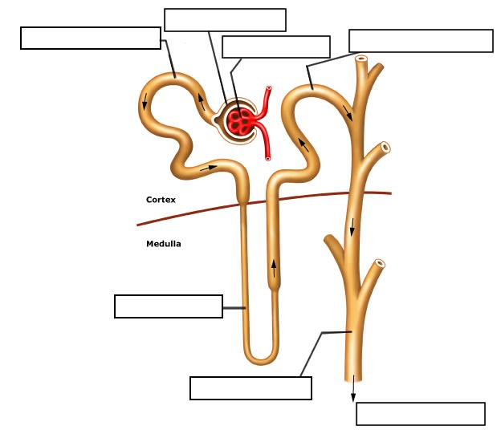
Summarize the pathway of urine in a nephron starting with the Bowman’s capsule.

5.2 Class Work

Answer the following questions:

- The three interrelated processes of urine formation are
- filtration, secretion, and excretion
- secretion, reabsorption, and micturition
- excretion, storage, and micturition
- filtration, reabsorption, and secretion

- Arrange the following to trace the path of filtration through a renal tubule (1) proximal convoluted tubule, (2) distal convoluted tubule, (3) ascending limb of nephron loop, (4) descending limb of nephron loop
- 1, 2, 3, 4
- 2, 3, 4, 1
- 1, 4, 3, 2
- 3, 2, 1, 4

- Urination is controlled by _____________
- hormones
- both voluntary and involuntary actions
- the internal urethral sphincter
- impulses from the prostate gland

- Which of the following is the largest component of urine?
- glucose
- sodium
- urea
- water

- Which of the following is not a characteristic of normal urine?
- pH is very basic
- specific gravity is above 1.00
- it is yellow in color
- it is slightly aromatic

- Which of the following terms includes all of the others?
- proximal tubule
- Bowman’s capsule
- Loop of Henle
- nephron

Aim:
5.3

Objective:

Real world connection:

Vocabulary: dilute, concentrated, ADH, pituitary gland

Water and Electrolyte Balance
THINK INK: What happens when you eat too many salty potato chips?
How does your body try to maintain homeostasis?

PAIR SHARE:

5.3 Class Notes

Water balance webquest continued…
Use this website to fill in the following notes: http://www.bbc.co.uk/schools/gcsebitesize/science/add_ocr_pre_2011/homeostasis/waterbalrev1.shtml

Page 1:
The kidneys maintain our body's water balance by:
- controlling ___________________________________________________ of blood plasma.
- control __________________ levels and the excretion of _________________________

How do we take in water?

How do we lose water?

What does it mean when our body has water balance?

What organ of our body helps with water balance? How does it do that?

5.3 Class Notes

Water balance webquest continued…
Use this website to fill in the following notes: http://www.bbc.co.uk/schools/gcsebitesize/science/add_ocr_pre_2011/homeostasis/waterbalrev1.shtml
Page 2:
How is the water balance maintained?
- The kidneys maintain our water balance by producing ____________ of different _____________________.
Example:
- When the water level is low, ________________ water is reabsorbed back into the blood and the urine becomes ______________________ concentrated.
- When the water level is high, _______________ water is reabsorbed back into the blood and our urine is _________________ concentrated (also known as dilute)

Level of water depends on

- External temperature - ______________________________________________________________________________________________________________________________________________________________________________________
- Amount of exercise - ______________________________________________________________________________________________________________________________________________________________________________________
- Fluid intake - ______________________________________________________________________________________________________________________________________________________________________________________
- Salt intake- ______________________________________________________________________________________________________________________________________________________________________________________
5.3 Class Work

Water balance webquest continued….
Use this website to fill in the following notes (Page 2): http://www.bbc.co.uk/schools/gcsebitesize/science/add_ocr_pre_2011/homeostasis/waterbalrev1.shtml

Drugs that affect water balance

- Alcohol - ______________________________________________________________________________________________________________________________________________________________________________________
- Ecstasy - ______________________________________________________________________________________________________________________________________________________________________________________
Page 3:

How the kidneys are controlled?
Which hormone controls the concentration of urine?

Which gland produces the hormone? Explain the role of the gland in controlling the levels of this hormone.

ADH Is short for _________________________________________
(Google it)
5.3 Class Notes

Examples of Negative Feedback Mechanisms

Use this website to fill in the following notes (Page 3): http://www.bbc.co.uk/schools/gcsebitesize/science/add_ocr_pre_2011/homeostasis/waterbalrev1.shtml
TOO LITTLE WATER:

5.3 Class Notes

Examples of Negative Feedback Mechanisms

Use this website to fill in the following notes (Page 3): http://www.bbc.co.uk/schools/gcsebitesize/science/add_ocr_pre_2011/homeostasis/waterbalrev1.shtml
TOO MUCH WATER:

5.3 Class Notes

Effect of Alcohol & Ecstasy

Use this website to fill in the following notes (Page 3): http://www.bbc.co.uk/schools/gcsebitesize/science/add_ocr_pre_2011/homeostasis/waterbalrev1.shtml
Effect of alcohol & ecstasy on ADH:

- Alcohol - ______________________________________________________________________________________________________________________________________________________________________________________

- Ecstasy - ____________________________________________________________________________________________________________________________________________________________________________________

THINK ABOUT IT:
Alcohol and ecstasy both affect water balance. Which substance do you think poses a worst effect on the body, especially to water balance? Explain your answer in a TIEDC paragraph.

5.3 Class Notes

Effect of Sodium on Water Balance

Use this website to fill in the following notes:
http://www.modernmedicine.com/modern-medicine/news/restoring-electrolyte-balance

- Water follows ___________________ in the body, so a gain or loss in sodium results in a gain or loss in water.

What happens when you eat too much salt? Does that cause you to lose water or gain water?

What happens when you eat too little salt? Does that cause you to lose water or gain water?

HOMEOSTATIC IMBALANCES

Hypernatremia

Definition:

Symptoms:

Treatment:

Prognosis:

Hyponatremia

Definition:

Symptoms:

Treatment:

Prognosis:
5.3 Class Work

Answer the following questions:

1. ADH is secreted from the _____.
a. hypothalamus
b. pituitary gland
c. kidneys
d. stomach

2. Which of the following would have a diuretic effect?
a. eating salty pretzels
b. drinking alcohol
c. sleeping
d. most drugs

3. ADH has a direct effect on _______________
a. blood pressure
b. water reabsorption
c. blood concentration
d. all of these

4. The hormones aldosterone and ADH both have an important function in:
A) fluid balance in the body
B) the regulation of acid concentration in the body
C) stimulation of a conscious desire for water
D) the activity of buffer systems

5. Hyposecretion (very low secretion) of ADH has this effect on urine volume and concentration.
 |  | A) | increased volume and decreased concentration
 |  | B) | increased volume and increased concentration
 |  | C) | decreased volume and increased concentration
 |  | D) | decreased volume and decreased concentration

6. When the body has to get rid of excess water, the mechanism that is used is
 |  | A) | sweating
 |  | B) | diarrhea
 |  | C) | increased respiratory rate and depth
 |  | D) | increased urine production

