Aim:
4.4

Objective:

Real world connection:

Vocabulary: Joints, -arthro, Synarthroses, Amphiarthroses, Diarthroses, Fibrous joints, Cartilaginous joints, Synovial joints, Ball-and-socket joint, Gliding joint, Hinge Joint, Pivot Joint, Dislocation, Reduction

Joints
Joints
Prefix: “arthro”
Facts:
- Joints are also known as ___________________________________________

- Every bone except bone of the __________________ forms a joint with at least one other bone of the body

Functions of Joints
1.

2.

4.4 Class Notes

Joints Classified by Movement/Function & Structure
Synarthroses  (Fibrous Joints)  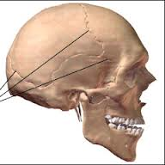  _________________________________ | Prefix/Meaning:
 | Definition: Joints where little or no movement normally happens
 | Composition: held together by connective/ fibrous tissue
 | Movement:
 | Example:
Amphiarthroses  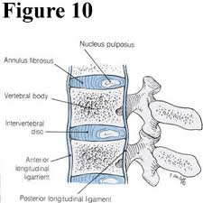  (Cartilaginous Joints)  ________________________________  _______________ | Prefix/Meaning:
 | Definition: Joints where limited/slight movement
 | Composition: held together by cartilage
Movement: Bending, twisting, and
slight compression

 | Example:
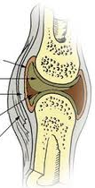  Diarthroses  (Synovial Joints)  _____________________ | Prefix/Meaning:
 | Definition: Joints where full movement occur
 | Composition: joint surrounded by synovial fluid
 | Movement: range of movement (rotation, flexion, extension, etc.)
 | Example:

4.4 Class Notes

Types of Synovial Joints Based on Shape/Movement
Type of Joint | Movement |  | Example
- Ball-and-socket joint
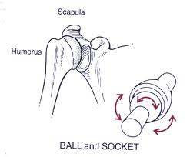
- Gliding (Plane) joint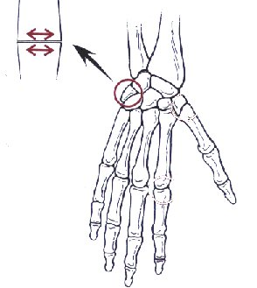
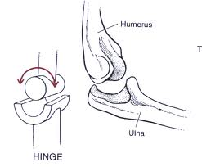
- Hinge Joint

4. Pivot (Rotary) Joint
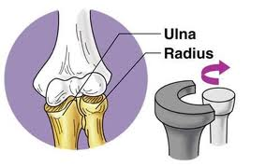

 |  | 4.4 Class Reading

Use the article to then fill out the chart about different types of joints:
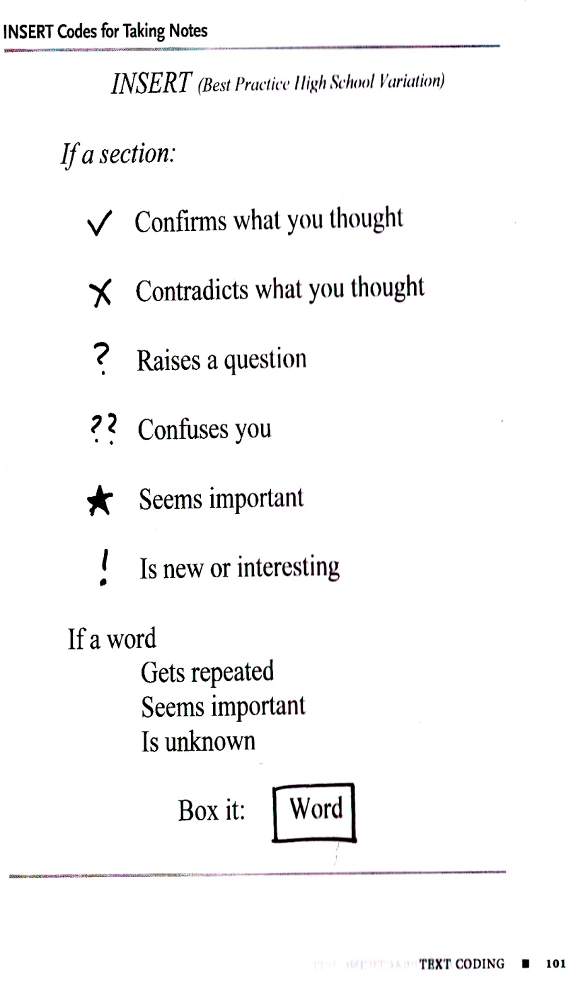
“What Kind of Joint is This”
Peppi and Bollo renter Joanne’s body (this time they slip through a pore in her skin) and head for the shoulder. The spies are ready to take an inside look at the musculoskeletal system.
“This is a joint—a place where bones meet,” says Peppi. “The joints are held together by those thick, elastic bands, called ligaments. Joints make it possible for the human body to bend, twist, and reach—to be flexible. Some people have even greater flexibility at their joints, because their ligaments stretch more than normal. These people are sometimes said to be ‘double jointed.’
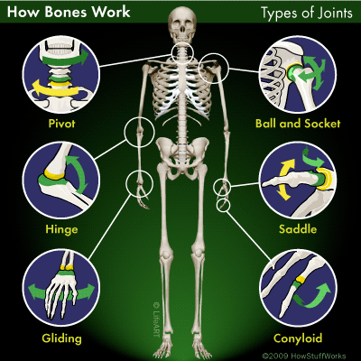
“There are several kinds of joints, and each permits a human to move an arm, leg, finger, or whatever—in a different way. But since we’re at the shoulder, let’s stop and take a look. This is a ball-and-socket joint. Its design allows humans to move their arms in just about any direction.”
“Kind of slippery in here,” says Bollo as he touches the shiny white end of a bone. “Many joints need to be ‘oiled’ in order to work well, just like the moving parts of a machine. The joints are oiled by the body’s homemade lubricant, which is called synovial fluid. Humans also have a special substance called cartilage at the ends of bones. The cartilage is softer and smoother than bone tissue. The cartilage, along with the synovial fluid, helps reduce the friction between bones.”
Bollo sneaks down into the space where the shoulder bone and the upper arm bone meet. “Do you know what this joint reminds me of? A computer joystick! “Great comparison. Now let’s move on down the arm,” says Peppi. “Watch how this joint works. What could you compare it with?” Bollo watches. “It works like a door that can swing open and shut.” “Good comparison. This is the elbow. It is a hinge joint.”
We don’t have time to visit all the types of joints. If we could, you’d see many varieties. For example, the head swivels on a pivot joint. The feet have gliding joints that help the body keep its balance. Wrists have special joints that let them move back and forth and side to side.”
Comprehension Questions:
- What does it mean to be double jointed?

- How are joints like the moving parts of a machine?

- What two things help bones move more easily?

4.4 Class Notes

Relationship between movement and strength of joints

THINK INK: As joints are able to move more, do you think that increases or decreases
the strength of joints? Explain your reasoning.

ACTUAL ANSWER:

When Joints Go Wrong
Dislocation (luxation)
Reduction

4.4 Class Work

Movable Joints Charades

Activity #1: ______________________________________________________________________________________

Bones used: _____________________________________________________________________________________

Synovial joints used: ______________________________________________________________________________

Type of movement: ______________________________________________________________________________

Activity #2: ______________________________________________________________________________________

Bones used: _____________________________________________________________________________________

Synovial joints used: ______________________________________________________________________________

Type of movement: ______________________________________________________________________________

Activity #3: ______________________________________________________________________________________

Bones used: _____________________________________________________________________________________

Synovial joints used: ______________________________________________________________________________

Type of movement: ______________________________________________________________________________

Activity #4: ______________________________________________________________________________________

Bones used: _____________________________________________________________________________________

Synovial joints used: ______________________________________________________________________________

Type of movement: ______________________________________________________________________________

Which type of synovial joint permits the greatest movement?

4.4 Class Work

LINES OF LEARNING (LOL): In a TIEDC, explain how joints with the greatest movement make the weakest joints.

T | Topic Sentence of Paragraph
I | Introduce answer
E | Cite evidence from reading
D | Explain the example/evidence
C | Conclusion

Aim:
4.5

Objective:

Real world connection:

Vocabulary: Fracture, Closed (simple) fracture vs. open (compound) fracture, Complete fracture vs. Incomplete fracture, Stressed (fatigue) vs. traumatic fracture, Transverse, Oblique, Spiral, Comminuated, Avulsion, Impacted, Fissure, Greenstick, Open Reduction Internal Fixation, External Fixation

Fractures
THINK INK: Did I Break the Bone or Just Fracture It? What does this mean?

ACTUAL ANSWER:

4.5 Class Notes
FRACTURE = BROKEN BONE
BROKEN BONE = FRACTURE

Types of Fractures
PAIRS OF FRACTURES: Closed vs. Open Fractures
Type of Fracture | Definition
1. Closed (Simple) fracture
2. Open (compound) fracture

4.5 Class Notes

PAIRS OF FRACTURES: Complete vs. Incomplete Fractures
Type of Fracture | Definition
1. Complete
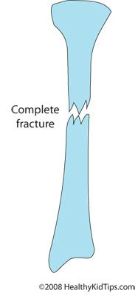
2. Incomplete

PAIRS OF FRACTURES: Stress vs. Traumatic Fractures
Type of Fracture | Definition
1. Stressed (Fatigued) Fracture

2. Traumatic Fracture

4.5 Class Notes
Types of Fractures

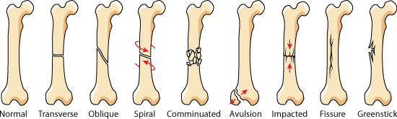
Type of Fracture | Definition
1. Transverse
2. Oblique
3. Spiral
4. Comminuated
5. Avulsion
6. Impacted
7. Fissure
8. Greenstick

4.5 Class Notes
Children vs. Adult Fractures
Child Fracture | Adult Fracture

Treatments for Fractures
Treatment | Description
1. Casting Immobilization
2. Functional Cast/Brace
3. Physical Therapy
4. Refracturing
5. Amputation

4.5 Class Notes
Treatments for Fractures Continued…
Treatment | Description
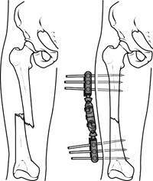
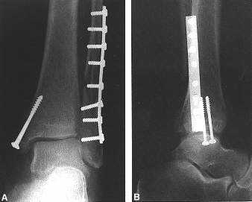
6. Open Reduction Internal Fixation (ORIF)
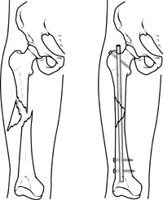
7. External Fixation

4.5 Class Work

Answer the following questions:
- What causes most broken bones?  - too little blood flow to a bone  - too much stress placed on a bone  - a muscle or tendon detaching from a bone  - a lack of marrow inside a bone | - What can you infer about X-rays from the information presented in the movie?  - They help doctors identify the location and severity of fractures  - They help bones heal  - They are useful in healing simple fractures, but not compound fractures  - They are rarely used when patients have broken bones
- What is the major difference between a closed fracture and an open fracture?  - In a closed fracture, the bone doesn’t break the skin; in an open fracture, it does  - In a closed fracture, the bone breaks all the way through; in an open fracture, it doesn’t  - In a closed fracture, the bone breaks the skin; in an open fracture, it doesn’t  - In a closed fracture, the bone doesn’t break all the way through; in an open fracture, it does | - Why do doctors use casts to repair broken bones?  - Medicine inside the cast helps the bones heal  - The cast immobilizes the bones so they mend properly  - The cast gives patients a greater range of mobility  - The cast prevents other bones from breaking
- Which of the following images depict an incomplete fracture?  B  D  A  C | - In the movie, Tim says that kids’ bones are more pliable than adults’. What is the best synonym for “pliable”?  - Hard  - Small  - Brittle  - Flexible
- What might cause a stress fracture?  - A sudden fall from a tree  - A heavy object landing on your foot  - Too much physical activity over a long period of time  - Being involved in a car accident | - How can older adults avoid osteoporosis  - By making sure they don’t put too much stress on their bones  - By consuming plenty of calcium and vitamin D  - By avoiding all physical activity  - By consuming plenty of red meat
- What happens immediately after a bone breaks?  - The end of each piece of bone becomes brittle and dies  - The bone begins producing new tissue to bind the break  - Marrow from inside the bone begins leaking into the break  - Nothing happens, so the bone has to be glued together by the doctor | - Which of the following types of fractures has the greatest chance of not healing properly?  - A greenstick fracture  - A stress fracture  - A compound fracture with an infection at the site of the break  - A closed fracture

Aim:
4.6

Objective:

Real world connection:

Vocabulary: Body Scan, CT Scan (Computed Tomography), MRI (Magnetic Resonance Imaging), PET Scan (Positron Emission Tomography), X-Ray

Body Scans
THINK INK: How do we know there is a fracture?

TERM:
Body Scan

4.6 Class Notes

Types of Body Scans
Machine | Description
1. CT Scan (Computed Tomography)
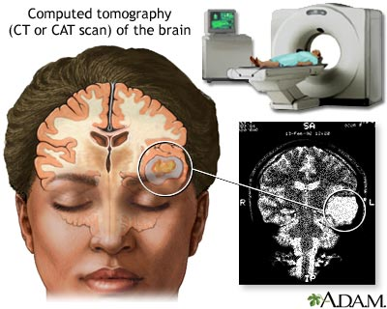
2. MRI (Magnetic Resonance Imaging)
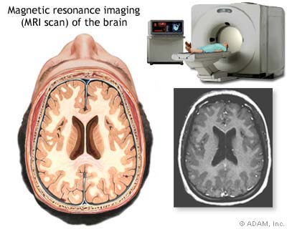

4.6 Class Notes

Types of Body Scans
Machine | Description
3. PET Scan
(Positron Emission Tomography)
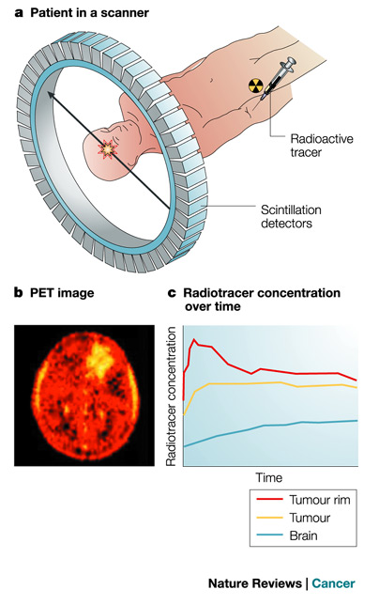
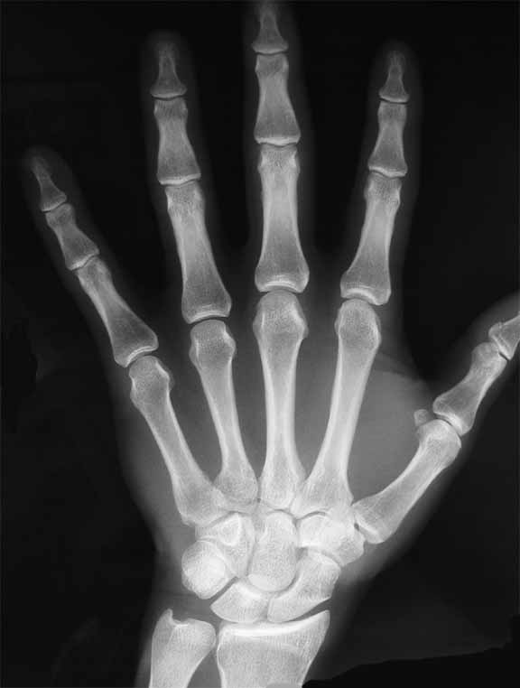
4. X-Ray
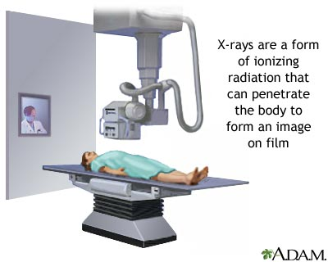

4.6 Class Work

Categorize It
For each statement, write an X below the type of body scan it describes. Statements may describe more than one type of body scan.
 | CT Scan | MRI | PET Scan | X-Ray
Machine is shaped like a long tube
Creates images with the help of computers
Uses radioactive chemicals
Makes excellent images of soft tissues
Shoots x-rays
Can detect cancer
Makes excellent images of bones
Shoots radio eaves
Can be used on both humans and animals

THINK ABOUT IT:
Body scans are known to be safe, but which of the four types described probably poses the least risk to your health? Explain your answer in a TIEDC paragraph.

4.6 Class Work

Answer the following questions:

- What does an MRI machine have in common with a cell phone?  - They are both very small devices  - They both emit radio waves  - They both depend on satellite networks to operate  - They are both inexpensive pieces of technology. | - When might a doctor order a CT scan instead of an MRI?  - When she wants to examine bones as well as soft tissue  - When she wants to examine different types of soft tissue  - When she wants an image taken from a side angle  - When she wants to examine a two-dimensional image
- Which type of body scan is shown in this image?  - A PET scan  - An MRI  - A CRT scan  - A CT scan | - How do your body’s cells “resonate” during an MRI scan?  - They vibrate  - They emit electromagnetic radiation  - They bounce around in your tissues  - They emit sound waves
- What advantage does a CT scanner have over a conventional x-ray machine?  - It allows doctors to look at a patient’s bones  - It provides the highest-quality images of soft tissue available  - It provides images from many different angles  - It uses radio waves instead of x-rays | - In the sentence, “One deficiency of MRI technology is its ability to capture images of bone,” what does “deficiency” mean?  - Strength  - Attribute  - Shortcoming  - Lack of nutrients
- What is the main advantage of an MRI scan over a CT scan?  - MRI scans can provide higher-quality images of bone  - MRI scans produce higher-quality images of soft tissue  - MRI scans are less expensive than CT scans  - MRI scans are much faster than CT scans | - Why might a doctor order a PET scan?  - To determine where a cyst or tumor is location in your body  - To remove a cyst or tumor in your abdomen  - To find out whether your dog or cat has a broken bone  - To shrink a cyst or tumor with radiation
- Which of the following conclusions can you draw from the information presented in the movie?  - PET scan technology is extremely risky  - Body scan technology was perfected in 1972  - CT scans are the most important type of body scans  - Different types of scans are useful for different purposes | - Which of the following images represents a cross-section of a human brain?

Aim:
4.7

Objective:

Real world connection:

Vocabulary: Osteoporosis, Arthritis (Rheumatoid, Osteoarthritis, Gout), Scoliosis, Rickets, Blount’s Disease, Sprain, Achondroplasia (Dwarfism), Marfan Syndrome

The diseases being covered in this lesson are:
- Osteoporosis
- Arthritis (Rheumatoid, Osteoarthritis, Gout)
- Scoliosis
- Rickets
- Blount’s Disease
- Sprain
- Achondroplasia (Dwarfism)
- Marfan Syndrome

Unit 4 REFERENCE SHEET:
Skeletal System Pathology (Study of Diagnosis & Treatment)

Disease | What is It? | Symptoms | Causes | Treatment
Osteoporosis  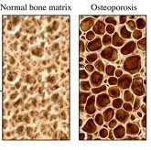 | Osteo =  Porosis = |  | breaking down the bone for replacement outpaces the process of the bone being built back up leading to a thinning of the bone..
Arthritis (Osteoarthritis, rheumatoid, gout)  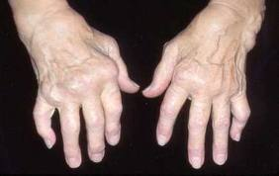 |  |  | Depends on type  Osteoarthritis: by the wear and tear on the cartilage due to age, injury, frequent use, or infection. - Rheumatoid: antibodies attack the cartilage leading to the inflammation.  Gout: uric acid builds up in blood and causes joint inflammation | Depends on cause
ACL injuries  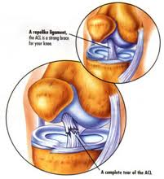 |  |  | The knee can become swollen and painful.
Disease | What is It? | Symptoms | Causes | Treatment
Scoliosis  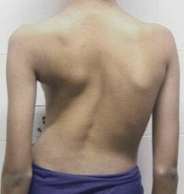 | Osis = |  | Most cases its unknown.(1) Can develop from problems in other parts of the body such as nervous & muscular system (2) bones in the spine developing abnormally when the fetus is developing (rare) (3) Leg length - if one leg is longer than the other (4) bad posture (5) using heavy backpacks
Rickets
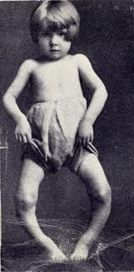
Blount’s Disease
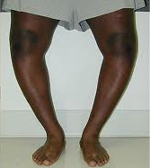
Disease | What is It? | Symptoms | Causes | Treatment
Sprain

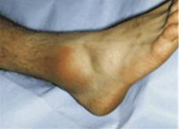
Achondroplasia (Dwarfism)
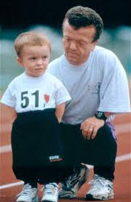
Marfan Syndrome  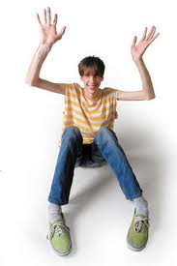 |  |  |  | Marfan syndrome can affect many parts of your body, including your heart, bones and joints, eyes, nervous system, and lungs. The type of treatment you receive will depend on your signs and symptoms.

4.7 Class Work

Skin Diagnosing
Patient Scenarios
Directions: For each scenario, in a paragraph (at least 5 sentences) please provide the following information:
- Patient diagnosis (what disease does he/she have)
- Symptoms that indicate that diagnosis
- What parts are affected
- Why did it happen? (Causes)
- Suggested treatment

Example: This patient is diagnosed with squamous cell carcinoma. This is because the patient showed symptoms such as dry, scaly skin. This disease had an impact on the epidermis layer of the skin. The patient has this cancer as a result of being out in the sun too much without wearing protection. To treat this cancer, I suggest performing an excision to remove it and apply a cream to keep the spot smooth.

Patient#1
A seventy-year old man comes in for an annual check-up. When you get the X-rays back, you notice that the bones look thinner than normal.

4.7 Class Work

Patient #2
A fifty-year old man comes in complaining that his knees are starting to bother him after going for walks. You take an X-ray and notice that the cartilage in his knee seems to have worn down and is much thinner than normal.

Patient #3
A football player comes in complaining about his ankle. He mentions he rolled it during his last game and it has swollen and been bruised since then.

4.7 Class Work

Patient #4
An over-weight teenager comes in worried about becoming bow-legged. Looking at a body scan, you see. Make sure in your diagnosis, you state which type of body scan was used to produce this image:
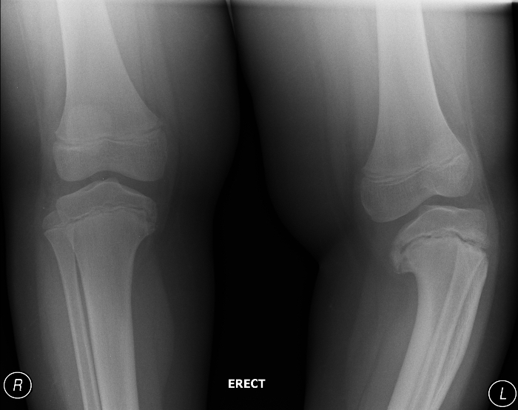

Patient #5
A mother brings in her six-year-old child, concerned that her child is not growing properly. The child seems abnormally short for his age. He is currently a foot shorter than the height projected for his age.

