Aim:
4.1

Objective:

Real world connection:

Vocabulary: Skeleton, Periosteum, Bone Marrow, Compact bone, Spongy bone, Metaphysis, Epiphysis, Diaphysis, Articular cartilage

Activity: THINK INK…PAIR SHARE
THINK INK: How do bones serve as the “frame of the house” of our bodies?

PAIR SHARE:
4.1 Class Notes

Introduction to the Skeletal System
Skeleton

The skeletal system includes:
- _________________________________________________________
- _________________________________________________________
- _________________________________________________________
- _________________________________________________________
Functions of the Skeletal System
1. | 3. |  | 4.
2. |  |  | 5.
 |  | 4.1 Class Notes

Anatomy Fact of the Day
- The body has __________________ bones.
- Another name for bone is ______________________.
- The prefix for bone = ______________________.

Structure of Bone
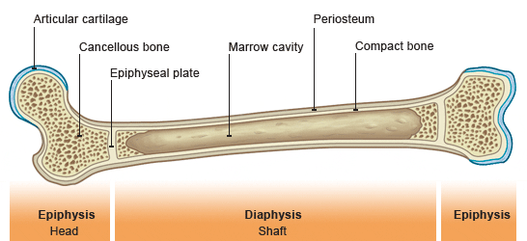
Using the following words and reading the article on
the next page, label the diagram:

Periosteum Bone Marrow Metaphysis
Compact bone Epiphysis Articular cartilage
Spongy bone Diaphysis
4.1 Class Reading
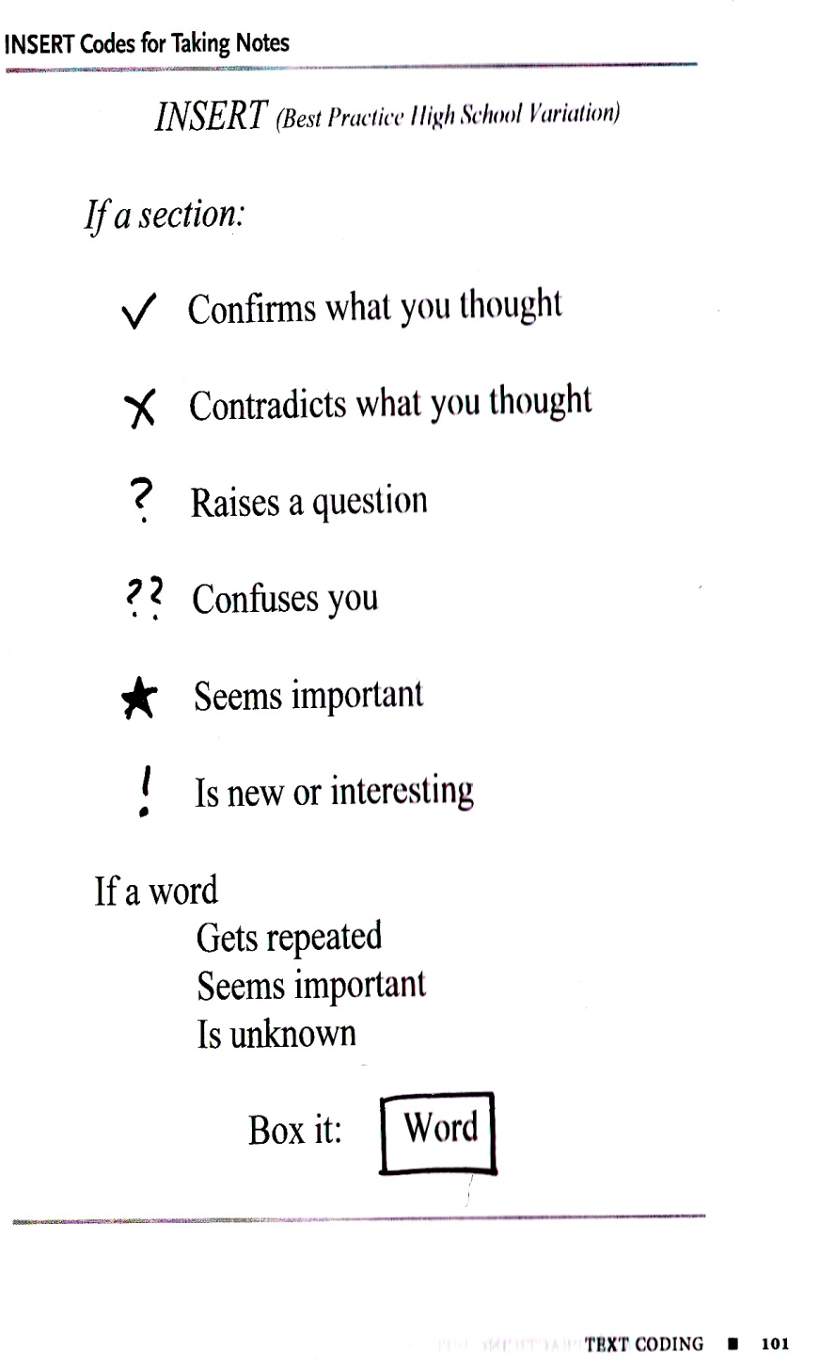
“Skeletal System Anatomy”
Prepared by Tim Taylor, Anatomy and Physiology Instructor
The long bones of the body contain many distinct regions due to the way in which they develop. At birth, each long bone is made of three individual bones separated by hyaline cartilage. Each end bone is called an epiphysis (epi = on; physis = to grow) while the middle bone is called a diaphysis (dia = passing through). The epiphyses and diaphysis grow towards one another and eventually fuse into one bone. The region of growth and eventual fusion in between the epiphysis and diaphysis is called the metaphysis (meta = after). Once the long bone parts have fused together, the only hyaline cartilage left in the bone is found as articular cartilage on the ends of the bone that form joints with other bones. The articular cartilage acts as a shock absorber and gliding surface between the bones to facilitate movement at the joint.
Looking at a bone in cross section, there are several distinct layered regions that make up a bone. The outside of a bone is covered in a thin layer of dense irregular connective tissue called the periosteum. The periosteum contains many strong collagen fibers that are used to firmly anchor tendons and muscles to the bone for movement. Stem cells and osteoblast cells in the periosteum are involved in the growth and repair of the outside of the bone due to stress and injury. Blood vessels present in the periosteum provide energy to the cells on the surface of the bone and penetrate into the bone itself to nourish the cells inside of the bone. The periosteum also contains nervous tissue and many nerve endings to give bone its sensitivity to pain when injured.
Deep to the periosteum is the compact bone that makes up the hard, mineralized portion of the bone. Compact bone is made of a matrix of hard mineral salts reinforced with tough collagen fibers. Many tiny cells called osteocytes live in small spaces in the matrix and help to maintain the strength and integrity of the compact bone.
Deep to the compact bone layer is a region of spongy bone where the bone tissue grows in thin columns called trabeculae with spaces for red bone marrow in between. The trabeculae grow in a specific pattern to resist outside stresses with the least amount of mass possible, keeping bones light but strong. Long bones have a spongy bone on their ends but have a hollow medullary cavity in the middle of the diaphysis. The medullary cavity contains red bone marrow during childhood, eventually turning into yellow bone marrow after puberty.
4.1 Class Notes

Based on the article, write down the function for each part.
Structure | Function |  | Prefix/Suffix
Epiphysis |  |  | Epi =  Physis =
Diaphysis |  |  | Dia =  Physis =
Metaphysis |  |  | Meta =  Physis =
Periosteum
Compact bone (cortical bone)
Spongy bone (cancellous bone)
Articular cartilage

 |  | 4.1 Class Work

LINES OF LEARNING (LOL): In a TIEDIEDC. explain how the structure of the bone helps carry out the functions of the skeletal system. Be sure to cite two pieces of evidence.
T | Topic Sentence of Paragraph
I | Introduce how one part of bone helps with a function
E | Cite evidence from reading
D | Explain the example/evidence
I | Introduce how another part of bone helps with a different function
E | Cite evidence from reading
D | Explain the example/evidence
C | Conclusion
 |  | 4.1 Class Work

Answer the following multiple-choice questions:
1. Which of the following is NOT a function of the skeletal system?
- protection
- support
- manufacture of red blood cells
- synthesis of growth hormones

2. The bone marrow that produces blood cells is found in ____________.
- developing bone
- spongy bone
- compact bone
- strong bone

3. The periosteum _________________.
- is found woven within spongy bone
- lines the inner cavity of the long bone and contains blood vessels
- covers the ends of a long bone to cushion it
- covers the outer surface of the bone and contains fibroblasts, osteoblasts, and nerve endings

4. The name spongy bone refers to the _______________.
- latticework of air spaces
- ability to absorb nutrients
- wet outer surface of the bone
- soft touch

5. Which of the following statement is INCORRECT?
- Bone is where most blood cells are made.
- Bone serves as a storehouse for various minerals.
- Bone is a dry and non-living supporting structure.
- Bone protects and supports the body and its organs.

6. The part of the bone that the articular cartilage covers directly is the _____.
- Diaphysis
- Endosteum
- Epiphysis
- periosteum

Aim:
4.2

Objective:

Real world connection:

Vocabulary: Appendicular Skeleton, Axial Skeleton, Mandible, Maxilla, Orbit, Nasal Bone, Parietal bone, Occipital Bone, Frontal bone, Temporal bone, Zygomatic bone, Sternum, Costal Cartilage, True Ribs, False Ribs, Floating Ribs, Thoracic, Lumbar, Cervical Coccyx, Sacrum

The Skeleton is divided into:
Appendicular | Axial
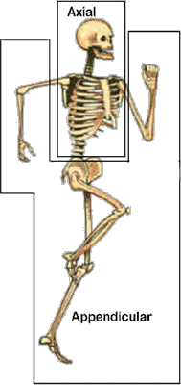

4.2 Class Notes
Axial Skeleton
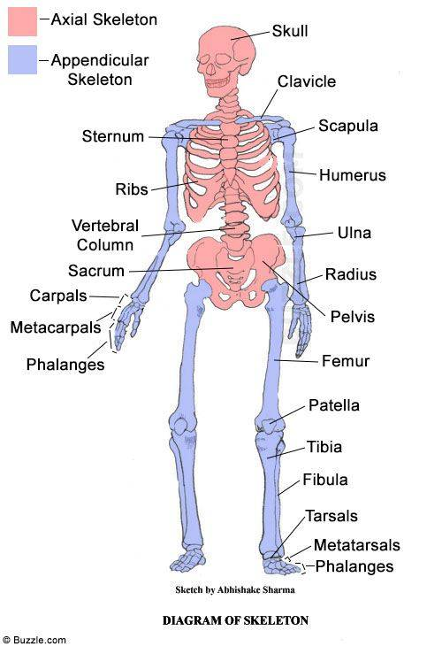
Functions of Axial Skeleton
1.

2.

Parts of Axial Skeleton
1.

2.

3.

4.2 Class Notes
Axial Skeleton—Skull
Skull = ___________________________
Based on the diagram, fill in the missing part:
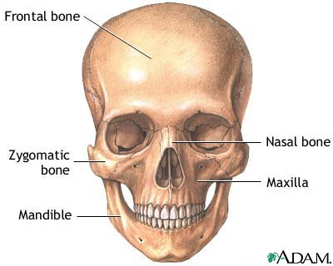
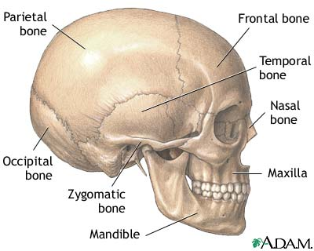
orbit

Anatomical term | Location | Anatomical term | Location
Parietal bone |  | Nasal bone
Occipital bone |  |  | Eye Socket
Frontal bone |  |  | Lower Jaw
Temporal bone |  |  | Upper Jaw
Zygomatic bone |  |  | Skull
4.2 Class Notes
Axial Skeleton—Thoracic Cage = Rib Cage
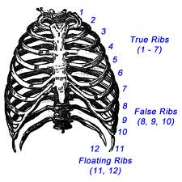
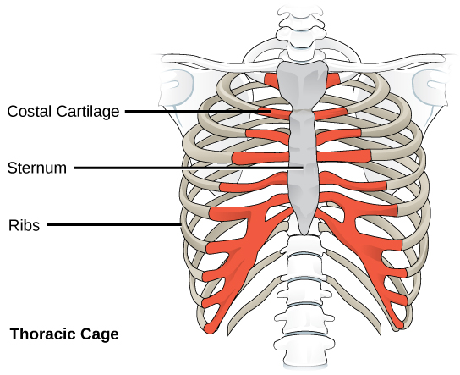

Anatomical term | Location
 | Rib Cage
 | cartilages that connect the sternum and the ends of the ribs
 | Breastbone
joined directly to the sternum
Ribs1-7
joined to the sternum ("breast-bone") by cartilage
Ribs 8-10
not connected to the sternum at all,
connected to the diaphragm
Ribs 11-12
4.2 Class Notes
Axial Skeleton—Vertebral Column = Spine
The spine protects the spinal cord, holds the head and torso upright, and allows for twisting and bending of the torso. It is composed of an S-shaped stack of irregularly shaped bones called vertebrae.
The spine is divided into 5 regions; each region is designed for a specific purpose. The vertebrae in each region are shaped differently according to their purpose.
Between the vertebrae are springy disks of tough cartilage. Disks are designed to absorb forces of up to several hundred pounds during exercise.
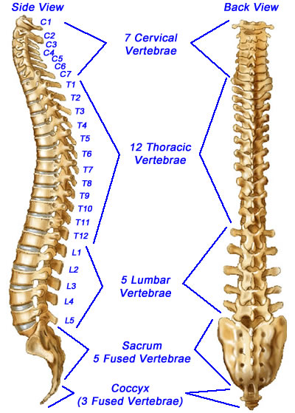
With the exception of the singular sacrum and coccyx, each vertebra is named for the first letter of its region and its position along the superior-inferior axis. For example, the most superior thoracic vertebra is called T1 and the most inferior is called T12.
Anatomical term | Location | Way to Remember
 | Neck
 | Chest
 | Lower back
Triangular Bone
“Holy Bone”

 | Tailbone

4.2 Class Work

1. Which bone or bones does not/do not belong to the axial skeleton?
 |  | A) | skulls
 |  | B) | ribs
 |  | C) | Hip bone
 |  | D) | Spinal column

2. Which skull bone is not part of the cranium?
 |  | A) | frontal
 |  | B) | temporal
 |  | C) | sphenoid
 |  | D) | maxilla

3. Which of the following relationships is NOT correct for the regions of the vertebral column?
 |  | A) | sacral—3 vertebrae fused into single bone
 |  | B) | lumbar—5 vertebrae
 |  | C) | cervical—7 vertebrae
 |  | D) | thoracic—12 vertebrae

4. The axial skeleton consists of:
- the vertebral column and skull
- upper limbs, lower limbs, and pelvic girdle
- the skull, vertebral column, and bony thorax (ribs and sternum)
- the bony thorax, upper limbs, and pelvic girdle

Label the following parts of the CRANIUM using the words below:
Mandible Maxilla Orbit Nasal Bone Parietal bone
Occipital Bone Frontal bone Temporal bone Zygomatic bone
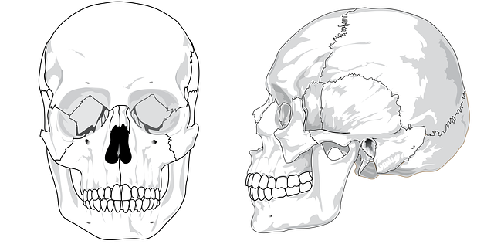

4.2 Class Work
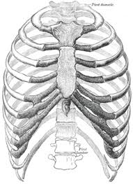
Label the following parts of the THORACIC CAGE using the words below
(Make sure to # all 12 ribs)

Sternum Costal Cartilage
True Ribs False Ribs Floating Ribs

Label the following parts of the VERTEBRAE using the words below:
*Make sure to label & number each vertebrae bone (i.e. L1, T1)
Thoracic Lumbar Cervical Coccyx Sacrum
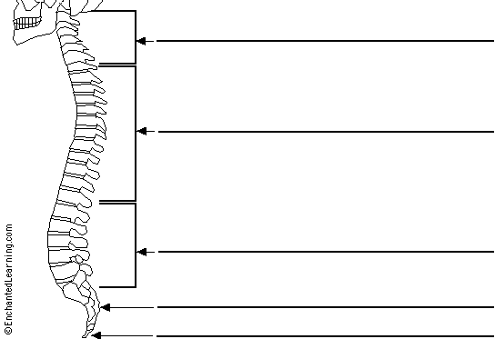

Aim:
4.3

Objective:

Real world connection:

Vocabulary: Appendicular skeleton, Pelvic girdle, Pectoral girdle, Clavicle, Scapula, Humerus, Ulna, Radius, Metacarpals, Carpals, Phalanges, Proximal Phalanges, Intermediate Phalanges, Distal Phalanges, Talus, Tarsal, Metatarsal, Tibia, Fibia, Femur, Patella, Sacrum, Coccyx, Ilium, Pubis, Ischium
Appendicular Skeleton
Function of the Appendicular Skeleton
1. | 3 | 4.
2. |  | 5.

Parts of Appendicular Skeleton
1. | 3.
2. | 4.

4.3 Class Notes
Appendicular Skeleton
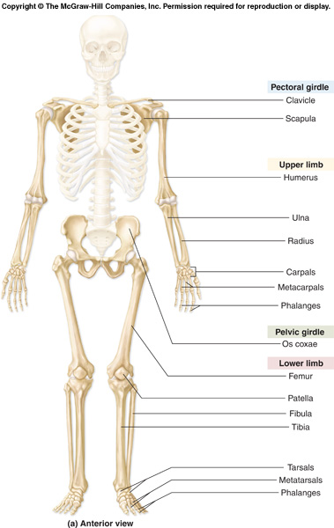

4.3 Class Notes

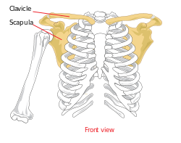
Appendicular Skeleton—Pectoral (Shoulder) Girdle
Anatomical term | Location
Pectoral
Clavicle
Scapula

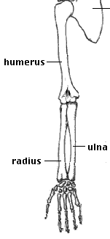
Appendicular Skeleton—Upper Limb
Anatomical term | Location
Humerus
Radius
Ulna

4.3 Class Notes
Appendicular Skeleton—Upper Limb continued
Hand Bones:
The bones of the hand consist of 8 carpal bones in the wrist, 5 metacarpals, and 14 phalanges. The carpals of the hand are arranged in two rows of four, and provide great flexibility. Each finger has three phalanges, except the thumb, which has two.
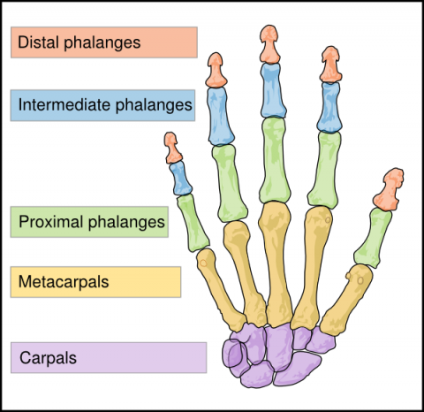
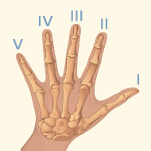

Anatomical term | Location | Anatomical term | Location
 | Wrist | Proximal phalanges
 | Knuckles | Intermediate phalanges
 | Fingers (digits) | Distal phalanges

4.3 Class Notes

Appendicular Skeleton—Pelvic Girdle
Hip Bone = Os Coxae
The hipbone is made up of three separate bones –the illium, the ischium, and the pubis—that fuse together at the end of the teenage years. The two hipbones, along with the sacrum and coccyx, form the pelvis, which connects the trunk of the body to the lower limbs.

Anatomical term | Location
Ilium
Pubic
Ischium

Os Coxae

4.3 Class Notes

Appendicular Skeleton—Lower Limbs
Anatomical term | 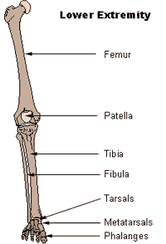  Location
Femur
Patella
Tibia

Fibula

4.3 Class Notes
Appendicular Skeleton—Lower Limb continued
Foot Bones:
The bones of the foot consist of 7 tarsal bones in the wrist, 5 metatarsals, and
[
14 phalanges. Each toe has three phalanges, except the big toe, which has two.
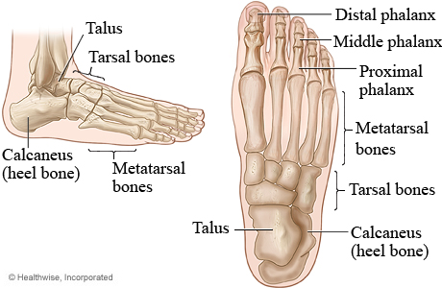
phalanges

3
1
2
4
5

Anatomical term | Location | Anatomical term | Location
 | Heel bone | Proximal phalanges
 | Ankle bone | Intermediate phalanges
 | Short, lower foot bones
 | Midfoot bones | Distal phalanges

4.3 Class Work

The bones of the pectoral girdle include the:
- ilium and ischium
- ulna and radius
- clavicle and scapula
- humerus and scapula

The bones that form the palm of the hand are the:
- phalanges
- metacarpals
- metatarsals
- carpals

The technical name for the kneecap is ____________.
- patella
- tibia
- fibia
- cuboid

Which bone or bones does not/do not belong to the appendicular skeleton?
 |  | a) | ulna
 |  | b) | radius
 |  | c) | tarsal
 |  | d) | sacrum

Label the following parts of the PELVIC GIRDLE using the words below:
Pelvic Girdle is also known as the ___________________ Girdle
Clavicle Scapula Humerus (not part of it but still label)
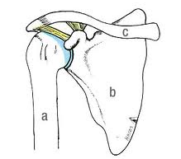

4.3 Class Work
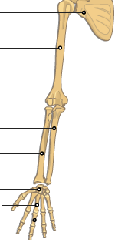
Label the following parts of the UPPER LIMBS using the words below:
Carpals
Humerus
Ulna
Metacarpals
Phalanges
Radius
Scapula (not part of it)

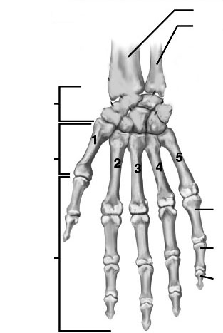

Label the following parts of the HAND using the words below:
(Make sure to # all fingers)
Carpals
Metacarpals
Ulna
Radius
Proximal Phalanges
Intermediate Phalanges
Distal Phalanges

4.3 Class Work

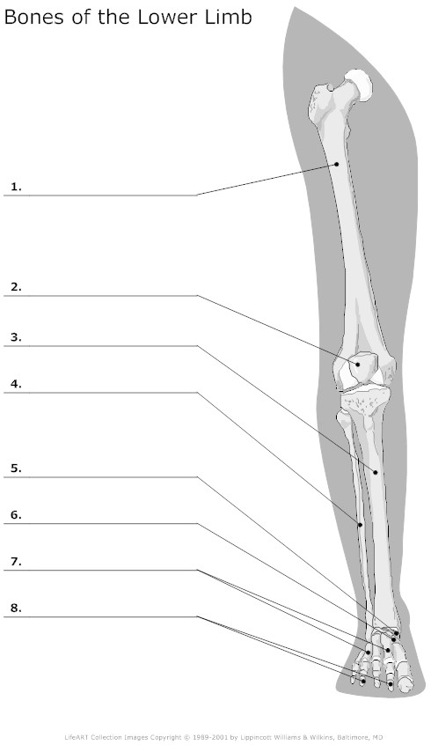
Label the following parts of the LOWER LIMBS using the words below:
Talus
Tarsal
Metatarsal
Tibia
Fibia
Femur
Phalanges
Patella

4.3 Class Work
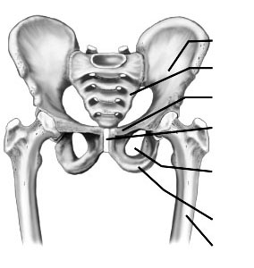
Label the following parts of the PELVIC GIRDLE using the words below:
Sacrum
Coccyx
Femur
Ilium
Pubis
Ischium

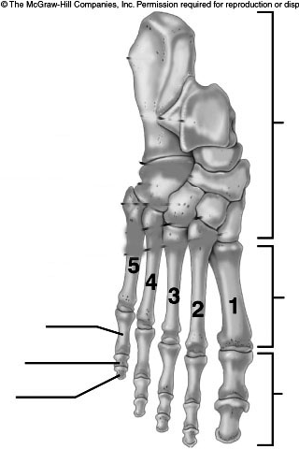

Label the following parts of the HAND using the words below:
(Make sure to # all fingers)
Tarsals
Metatarsals
Talus
Calcaneus
Proximal Phalanges
Intermediate Phalanges
Distal Phalanges

