Aim:
3.5

How can we distinguish among various degrees of burns?

Objective:

I will distinguish among various degrees of burns.

Real world connection:

Burns ranging from accidentally touching a hot surface to catching on fire

Vocabulary:

First degree burn, second degree burn, third degree burn, fourth degree burn, rules of nine

Guest speakers from Columbia’s Physical Therapy Program will conduct this lesson. Please save those notes, as you would be tested on that.

Aim:
3.6

Objective:

Real world connection:

Vocabulary:

Vellus hair, terminal hair, cuticle, cortex, medulla, hair shaft, anagen, catagen, telogen

Facts about Hair
- Another name for hair is _______________________________
- Made of ____________________________________________ cells
- Human body has _________________________________ hairs
- 75% of hair is all over the body, NOT on the head
- Humans are born with the amount of hair follicles as they will have
- Hair grows everywhere EXCEPT:
Why do you think that is the case?
- ____________________________________
- ____________________________________
- ____________________________________
- ____________________________________
- ____________________________________

Functions of Hair
- ____________________________________________________________________
- ____________________________________________________________________
- ____________________________________________________________________
- ____________________________________________________________________
- ____________________________________________________________________
3.6 Class Notes
Types of Hair
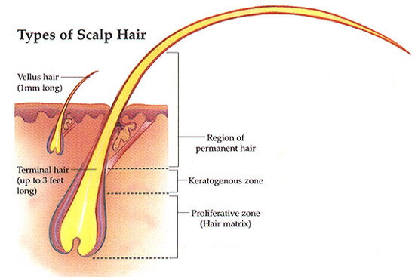
- ________________________________
- large, coarse, colored hair
- found in scalp, eyebrows, eyelashes, and armpits

- ________________________________
- smaller, shorter, more delicate hair
- found throughout most of body

Structure of a Hair Strand
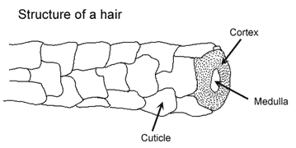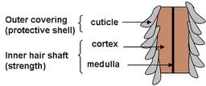

Structure |  | Function
Outer Covering | Cuticle

3.6 Class Notes

Structure |  | Function
Inner Hair Shaft | Cortex
 | Medulla

Hair Growth Cycle Phases
- _____________________________ (ana = __________________________)
- also called the active phase or stage of growth
- What occurs: Hair grows at the rate of 0.33mm/day (6 inches a year)

- _____________________________ (cata = __________________________)
- also called the transitional phase
- What occurs: Hair follicle gets smaller because it falls apart & detaches from blood supply

- _____________________________ (telo = __________________________)
- also called the resting phase.
- What occurs: Hair detaches from the follicle and is pushed out by new hair, becomes club hair (process called shedding)
- Pulling out hair in this phase will show a solid, white material at root
3.6 Class Notes

Why do we get split ends?

Why do people have different hair colors?

- Hair pigment is made by __________________________ (cells that produce melanin) in _______________________

- Varying amounts of different types of _______________________ combines to produce different hair colors

Why do we get gray hair?

- As you get older, the amount of melanin produced ______________________ causing hair to get lighter

- White hair results from:

- _______________________________________________________

- _______________________________________________________

3.6 Class Notes

Why do people have different hair textures?

- Texture of hair depends on the __________________________________ which depends on ________________________________

Hair Shaft Shape | Hair Texture | Hair Type
Oval
Flat and Ribbonlike
Round

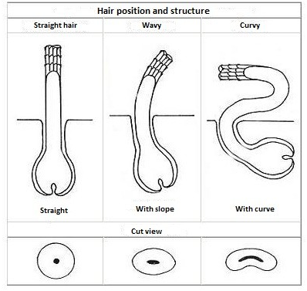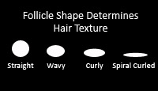

3.6 Class Work

Answer the following questions:

All of the following are important functions of human hair except:
A) | protecting the scalp from sunburn and injury
B) | preventing entry of foreign particles into the eyes, ears, and nose
C) | To make a person look beautiful
D) | assisting in the dispersal of pheromones (scent)

The relatively coarse, pigmented hair of the scalp, eyebrows, and eyelashes is
A) | terminal hair
B) | vellus hair
C) | Club hair
D) | none of the above

The hair strand contains all of the following except
A) | cuticle
B) | medula
C) | cortex
D) | matrix

Read the article about hair straightening. Then answer the following questions:

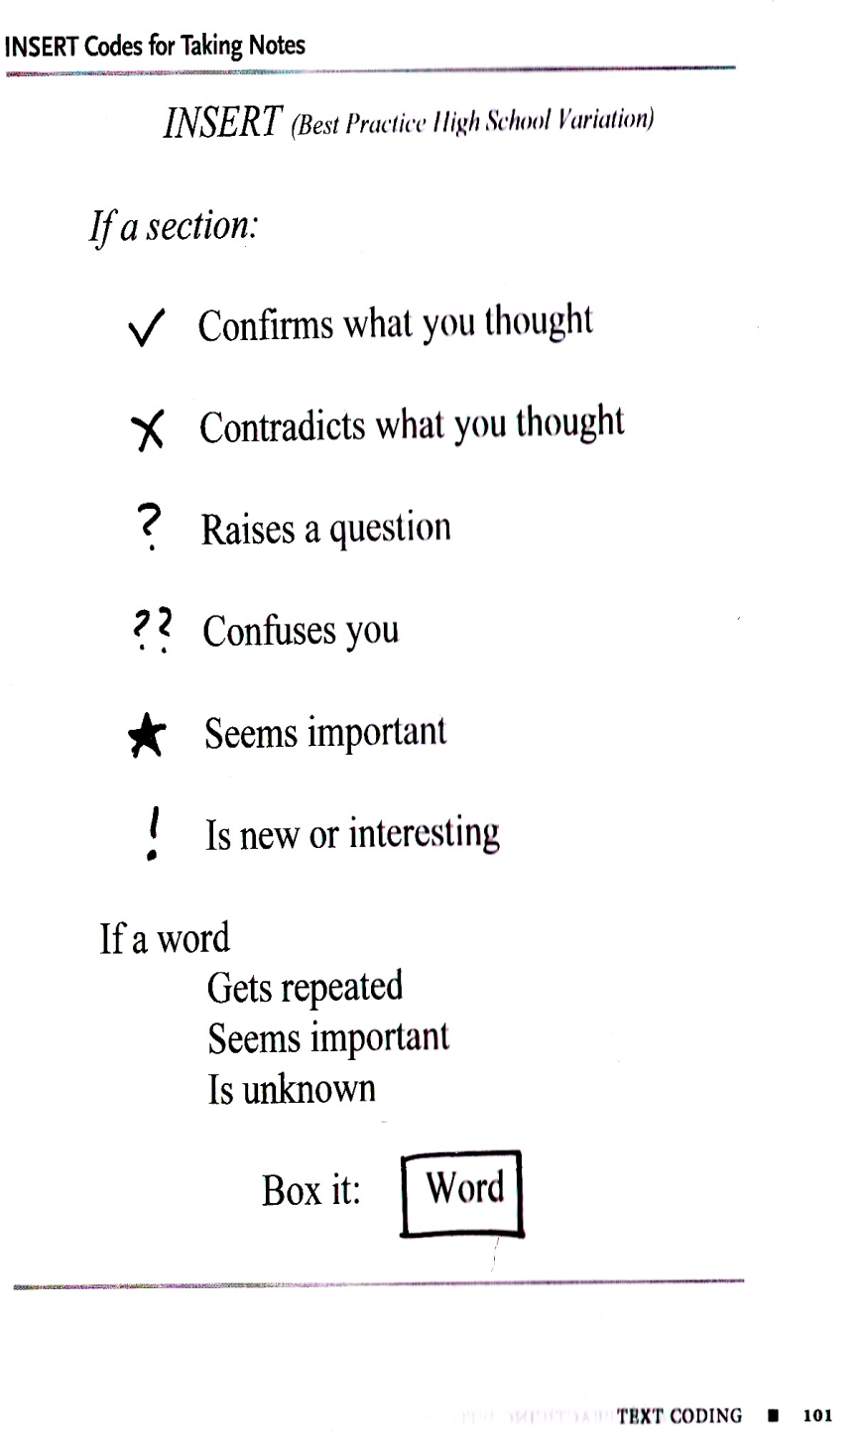
Real World Application: Hair Straightening
As surprising as it may sound, cosmetics and styling often involve a large amount of science. Whether it be producing safe makeup or coming up with effective shampoos and moisturizers, science is everywhere. Hair straightening is one such technique that relies heavily on the basic scientific properties of hair.
Hair is made up of a protein known as keratin. Keratin is composed of long chains of amino acids. Along with hair, nails and teeth enamel are also made up of keratin. Hair, nails, and teeth have one important factor in common — they are all strong. It is extremely difficult to break a strand of hair apart without a pair of scissors. No amount of twisting, pulling, rubbing, or even hammering can do anything to hair.
3.6 Class Work

(Continued) Real World Application: Hair Straightening
The strength of hair can be attributed to a special property unique to proteins like keratin, which are made up of a large number of sulfur-containing amino acids. Sulfur atoms, from adjacent chains of keratin, bond together to form disulphide bonds. These extra bonds make the fibers that have keratin very strong. In addition, they ensure that the position of the keratin molecules remains fixed, such that the shape of the hair fiber stays the same.
Naturally, this is a good property since hair — especially long hair — is normally subjected to a large amount of stress, and one would not want hair breaking or changing its shape because of this everyday wear and tear. However, when people do want to change the shape of their hair — get rid of curls, add curls, make it wavy, make it straight — these disulphide bonds pose a great problem. Most hair-straightening techniques, therefore, target these bonds. An easy method of breaking these bonds is using heat. This brings us to what is probably the most common technique for straightening hair — the flat iron.
The plates of the iron are usually heated to high temperatures, generally between 300 and 500 degrees Fahrenheit. When hair is passed through the iron quickly, while being held tight and straight, the extreme heat causes the disulphide bonds to break. This breakage allows the keratin chains to move around slightly and assume a position that results in straightened hair. When the hair cools down, the disulphide bonds between the keratin are reformed. Because the keratin molecules are in different positions when the bonds are reformed, the hair stays in the straightened shape for a long period of time. As most people who use flat irons know, this method of straightening hair is not permanent.
Exposure to moisture causes the hair to revert back to its original shape.

3.6 Class Work
Follow-Up Questions:
NOTE: To cite evidence, provide a quote! According to this article, “…..”

- What protein makes up hair?

- Why is hair such a strong protein? What bonds strengthen the hair? Cite evidence.

- Explain what hair straightening does to these bonds. How does it do this? Cite evidence.

- Explain what happens to the keratin as hair is being straightened. Cite evidence.

- What does moisture do to straightened hair? Why is that the case?

3.6 Class Work

Things to think about:
- If someone has blonde or red hair, what does that indicate about the amount of melanin the person has in his/her hair follicle.

- Why do you think a person with blonde hair or red hair tends to have light, fair skin? Relate this to the amount of melanin the person has in his/her hair follicle and skin.

- Which pigment does a person with blonde hair or red hair has more of?

Aim:
3.7

Objective:

Real world connection:

Vocabulary:
Acne, baldness, vtiligo, psoriasis, eczema, athlete’s foot, albinism, basal cell carcinoma, squamous cell carcinoma, melanoma

The diseases being covered in this lesson are:
- acne
- baldness
- vtiligo
- psoriasis
- eczema
- athlete’s foot
- albinism
- skin cancer—basal cell carcinoma
- skin cancer—squamous cell carcinoma
- skin cancer—melanoma

Unit 3 REFERENCE SHEET:
Integumentary Pathology (Study of Diagnosis & Treatment)

Disease | What is It? | Symptoms | Causes | Treatment
Acne

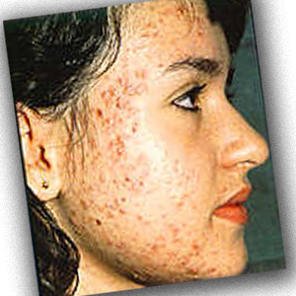
Baldness

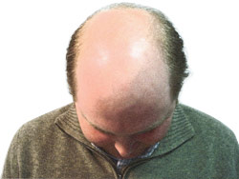

Disease | What is It? | Symptoms | Causes | Treatment
Vitiligo
Psoriasis

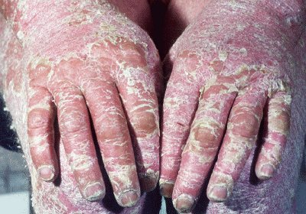
Eczema
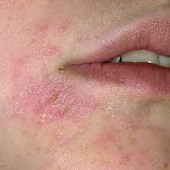

Disease | What is It? | Symptoms | Causes | Treatment
Athlete’s
Foot
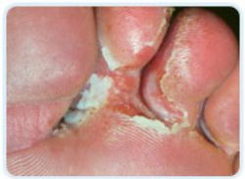
Albinism
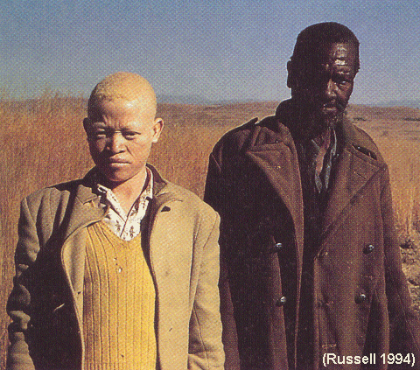
Shingles

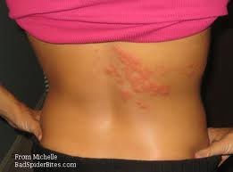

Disease | What is It? | Symptoms | Causes | Treatment
Skin Cancer (Basal Cell Carcinoma)
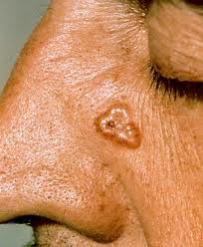
Skin Cancer (Squamous Cell Carcinoma)
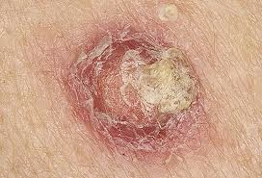
Skin Cancer (Melanoma)
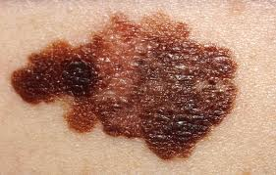

Aim:
3.8

Objective:

Real world connection:

Vocabulary:
Acne, baldness, vtiligo, psoriasis, eczema, athlete’s foot, albinism, basal cell carcinoma, squamous cell carcinoma, melanoma

Skin Diagnosing
Patient Scenarios
Directions: For each scenario, in a paragraph (at least 5 sentences) please provide the following information:
- Patient diagnosis (what disease does he/she have)
- Symptoms that indicate that diagnosis
- What parts are affected
- Why did it happen? (Causes)
- Suggested treatment

Example: This patient is diagnosed with squamous cell carcinoma. This is because the patient showed symptoms such as dry, scaly skin. This disease had an impact on the epidermis layer of the skin. The patient has this cancer as a result of being out in the sun too much without wearing protection. To treat this cancer, I suggest performing an excision to remove it and apply a cream to keep the spot smooth.

3.8 Class Work

Patient#1
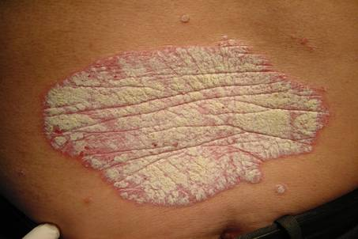
A middle-aged woman comes in complaining about a large patch of inflamed skin that had developed a scaly, silvery covering. She mentions that his condition has happen many times in the past and that her mother has the same issues.

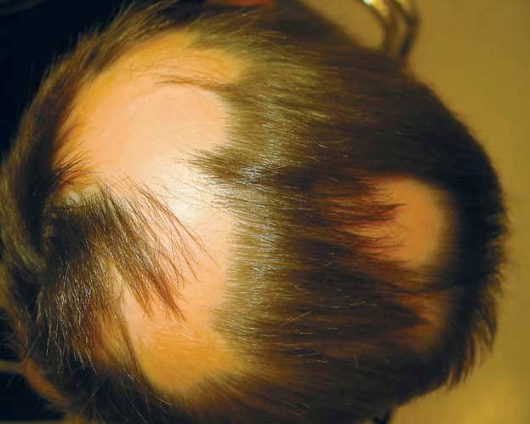
Patient #2
A middle-aged man comes in complaining that large sections of his head are losing hair. He says they seem to come off when he is showering or brushing his hair and he has not started using any new shampoos or hair treatments. He says that both his grandfathers lost all the hair on their heads.

3.8 Class Work

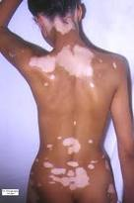
Patient #3
A twenty-five year old black female comes in complaining that a few small white patches of skin on her back are now rapidly expanding and leaving large white blotches on her skin. She cannot think of anything that she might have touched to change her skins color and has not changed her routine recently.

Patient #4
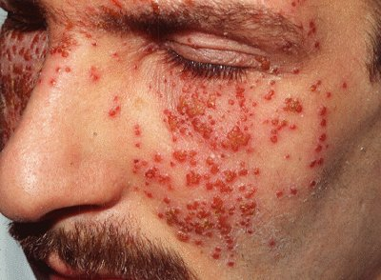
A thirty-year old man comes in complaining about little red bumps that have been appearing on his skin and blistering causing him a lot of pain. He says he has had reactions like this to certain things in the past and mentions that he recently started to re-finish his basement and has been doing all of the insulate on work the past few days.

3.8 Class Work

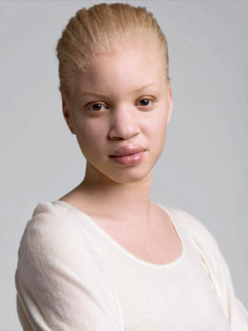
Patient #5
A twenty-year old woman comes in complaining about large skin-burns all over her body. Her skin is all white as is her hair and she mentions she has always been this way. She wants to know what she can do to prevent these painful skin burns in the future.

Patient #6
A forty-year old man comes in complaining about a white, dry and itchy area between his toes that recently appeared. He does not recall exposing his feet to anything new, and the only routine change he can think of is he started to shower at the gym after working out instead of waiting until he got home.

3.8 Class Work
Patient #7
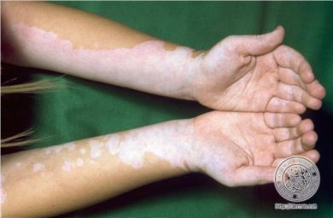
A thirty-five year old white male comes in complaining about how his skin tanned when he was at the beach this weekend. When he checked out his tan, he noticed that large regions on his hands and arms were not tanning and still looked white. He went to tan the next day to make sure those areas got sun and they did not tan again. He has never had this problem before and didn’t notice these white areas until he went tanning.

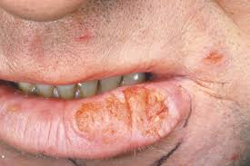
Patient #8
A 65-year-old woman comes in complaining that she has a flat sore that has been peeling over the past weeks in her mouth. It has been getting red and dry. She thinks it is an ulcer. It has begun when she started using a tanning bed during the winter because she thought she was too pale.

