Aim:
3.1

Objective:

Real world connection:

Vocabulary:

Activity: THINK INK…PAIR SHARE
THINK INK: How can you compare skin to plastic wrap that covers food that we place in the freezer?

PAIR SHARE:
3.1 Class Notes

Your Skin!
The skin is an organ system called _____________________________________________
Facts:
- Makes up 16% of total body weight
- Largest organ system of body

Parts of Integumentary System:
- _______________________________________________
- _______________________________________________
- _______________________________________________
- _______________________________________________
- _______________________________________________

Functions of Integumentary System
Function of the Skin
1. Temperature Maintenance | 2. Protection
3. Vitamin D Production | 4. Sensory Reception
3.1 LAB ACTIVITY
- Have the students put on one glove and stick their fingers into the water with pepper. Have the students pretend the glove is representing their skin. Now have the students take their fingers out of the water after a few seconds.

What happened? Have the students leave on their glove while you discuss what happened.

What function of the skin do you think this activity relate to?

- By the time you finish discussing function one, the student’s hand with the glove should be warm and somewhat sweaty. Have the students take off the glove and wave that
hand in the air.

What do you feel?

What function of the skin do you think this activity relate to?

What is the pepper symbolizing?

- Have the students take the toothpick and gently rub it on their arm.

What do you feel?

What function of the skin do you think this activity relate to?

Have the students pinch themselves (gently) and turn to the person next to them and touch them.

What do you feel? What function of the skin do you think this activity relate to?

Aim:
3.2

Objective:

Real world connection:

Vocabulary:

Activity: THINK INK…PAIR SHARE
THINK INK: Why is it that when you get a small scratch, you do not bleed, but when you get a deep scratch, you bleed?

PAIR SHARE:

3.2 Class Notes

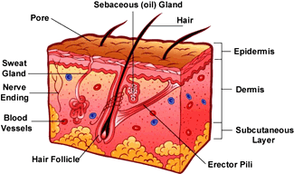
Parts of the Skin
The skin is made of three layers:

- _____________________________________
- ________________________________
- ________________________________
- _____________________________________
- _____________________________________

Each group will focus on a part of the reading and make a chart to present to the rest of the class.

Structure | Made up of | Function | Prefix/Suffix
1. Epidermis
a. Upper epidermis
b. Lower epidermis
2. Dermis
3. Hypodermis (Subcutaneous layer)
3.2 Class Work

The functions of the skin include all of these except __________________.
 |  | A) | taking in nutrients
 |  | B) | preventing the entry of microorganisms
 |  | C) | Slowing down water loss
 |  | D) | regulating body temperature

Adipose tissue is most abundant in the ________________ layer under the skin.
 |  | A) | epidermal
 |  | B) | dermal
 |  | C) | subcutaneous
 |  | D) | transdermal

Which term does not belong with the others?
 |  | A) | epidermis
 |  | B) | dermis
 |  | C) | cutaneous membrane
 |  | D) | subcutaneous region

What would happen if our body did not have a hypodermis layer? Explain your reasoning.

LINES OF LEARNING (LOL): In a well-written paragraph compare and contrast the three major layers of the skin, noting at least two similarities and two differences.

3.2 Class Work
Read the article about how do tattoos work. Then answer the following questions:
TeensHealth.org A safe, private place to get doctor-approved information on health, emotions, and life.

Tattoos
It seems like everyone has a tattoo these days. Once sported only by sailors, outlaws, and biker gangs, tattoos are now popular body decorations for many people. And it's not just anchors, skulls, and battleships anymore — from school emblems to Celtic designs to personalized symbols, people have found many ways to express themselves with their tattoos.
Maybe you've thought about getting one. But before you head to the nearest tattoo shop and roll up your sleeve, there are a few things you need to know.

So What Exactly Is a Tattoo?
A tattoo is a puncture wound, made deep in your skin, that's filled with ink. It's made by penetrating your skin with a needle and injecting ink into the area, usually creating some sort of design. What makes tattoos so long-lasting is they're so deep — the ink isn't injected into the epidermis (the top layer of skin that you continue to produce and shed throughout your lifetime). Instead, the ink is injected into the dermis, which is the second, deeper layer of skin. Dermis cells are very stable, so the tattoo is practically permanent.
Tattoos used to be done manually — that is, the tattoo artist would puncture the skin with a needle and inject the ink by hand. Though this process is still used in some parts of the world, most tattoo shops use a tattoo machine these days. A tattoo machine is a handheld electric instrument that uses a tube and needle system. On one end is a sterilized needle, which is attached to tubes that contain ink. A foot switch is used to turn on the machine, which moves the needle in and out while driving the ink about 1/16 inch or less (about 1 millimeter) into your skin.
Most tattoo artists know how deep to drive the needle into your skin, but not going deep enough will produce a ragged tattoo, and going too deep can cause bleeding and intense pain. Getting a tattoo can take about 15 minutes to several hours, depending on the size and design chosen.

Tattoo Ink Placement
The tattooing process causes damage to the epidermis, epidermal-dermal junction, and the papillary layer (topmost layer) of the dermis. These layers appear homogenized (or in other words, like mush) right after the tattooing process. The ink itself is initially dispersed as fine granules in the upper dermis, but aggregate into more concentrated areas at 7-13 days.
Like any injury, the initial response is to stop bleeding, followed by tissue swelling, and the migration of non-resident immune cells into the area. The "automatic response" immune cells are mostly neutrophils, and macrophages later on. They are phagocytic cells that "swallow" debris to clean up the area and then leave via the lymphatics. This is the extent of an immune response unless an allergic reaction occurs or an infection sets in. The tissue is then repaired and/or regenerated by fibroblasts. Initially the tissue formed is known as granulation tissue (think fresh scar, pinkish and soft), which later matures into fibrous tissue (think old scar).
Stages of Ink Dispersal
Initially ink is taken up by keratinocytes, and phagocytic cells (including fibroblasts, macrophages and mast cells).
At one month the basement membrane of the epidermis (epidermal-dermal junction) is reforming and the basal cells contain ink. In the dermis, ink containing phagocytic cells are concentrated along the epidermal-dermal junction below a layer of granulation tissue that is surrounded by collagen. Ink is still being eliminated through the epidermis with ink present in keratinocytes, macrophages and fibroblasts.
At two to three months the basement membrane of the epidermis is fully reformed, preventing any further loss of ink through the epidermis. Ink is now present in dermal fibroblasts. Most of these ink-containing fibroblasts are located beneath a layer of fibrous tissue, which has replaced the granulation tissue. A network of connective tissue surrounds and effectively traps these fibroblasts. It is assumed that these fibroblasts are the cells that give tattoos their lifespan.
Then why does the tattoo fade over time?
It is debated whether all the ink particles are in fibroblasts, or if some remain as extracellular aggregations of ink. Also, the lifespan of the ink containing fibroblasts is not known. Presumably, ink particles are moved into the deeper dermis over time due to the action of mobile phagocytic cells (think immune cells), causing the tattoo to look bluish, faded and blurry. Examination of older tattoos (e.g. 40 years) show that the ink is in the deep dermis, and also found in local lymph nodes. Since some types of phagocytic immune cells migrate to lymph nodes to "present their goods", the discovery of ink in lymph nodes is consistent with the theory of phagocytic cells being the cause of ink movement.
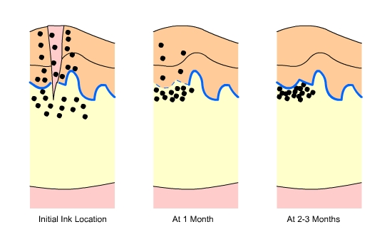
Fig.3 Ink Location: soon after the tattoo is received, one month after, and two to three months after. Note the reformation of the epithelial-dermal junction over time and the concentration of ink just underneath it.

What about the sun?

Sun exposure equals sun damage, whether you realize it or not. Langerhans cells, a type of dendritic cell, are present throughout the epidermis, but mostly located in the stratum spinosum. During sun exposure, many Langerhans cells will undergo apoptosis (a type of cell death where the cell breaks apart into many small fragments) while others migrate into the dermis and a minor inflammatory reaction occurs. The inflammatory reaction is not restricted to the epidermis, but also involves the dermis. Such a reaction causes the recruitment of more phagocytic immune cells to the area.
With the presence of larger than normal amounts of migrating phagocytic cells, the chances of ink movement increases, thus accelerating the fading of the tattoo.

3.2 Class Work

- What makes the tattoo permanent? Which skin layer does the tattoo affect? Cite evidence.

- Which skin layers are damaged during the tattoo ink placement? Cite evidence.

- Which cells initially take up the ink?

- Why do tattoos fade over time? Cite evidence.

- What are Langerhans cells?

- What effect does the sun have on tattoos? Cite evidence.

Aim:
3.3

Objective:

Real world connection:

Vocabulary:

Activity: THINK INK…PAIR SHARE
THINK INK: What about our skin helps be able to bleed, feel, and sweat? Think how that is connected to structure and function.

PAIR SHARE:

3.3 Class Notes
Accessory Organs
Structure | Made up of | Function
Pore

Sweat Gland

Oil (sebaceous) gland

Erector Pilli/Arrector Pilli

Blood vessel

Nerve

Adipose tissue (fat molecule)

Hair follicle

3.3 Class Notes

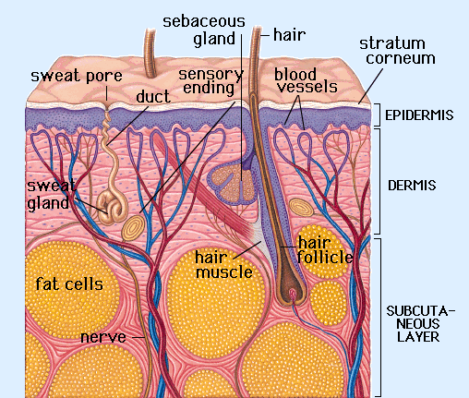

3.3 Class Work
Label the following diagram
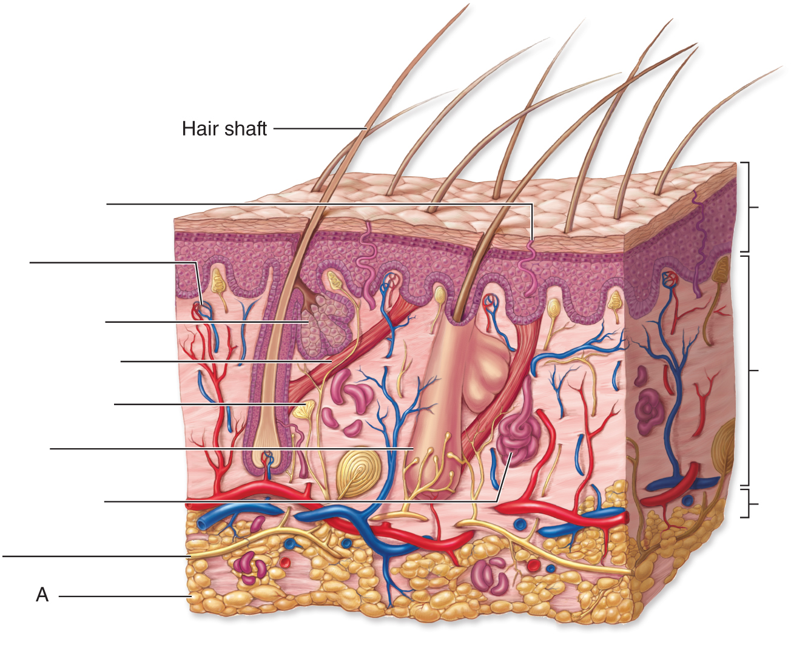
Section 2:
Match the structure of the skin with its definition.
___1. Adipose Tissue A. opening of skin that allows sweat out
___2. Errector pili muscle B. carries oxygen and nutrients to the dermis
___3. Blood vessel C. secretes sebum which lubricates the skin
___4. Dermis D. Fat tissue
___5. Duct of a sweat gland E. Layer of the skin that contains blood vessels
___6. Epidermis F. Outermost layer of skin
___7. Keratin G. Connects skin to underlying tissues
___8. Melanin H. senses touch, pain, temperature and pressure
___9. Nerve I. carries sweat to the surface of the skin
___10. Pore J. Protein that makes cells waterproof and harder
___11. Sebaceous gland K. Moves hair when you have goose bumps
___12. Subcutaneous layer L. Pigment that develops when you are exposed to UV rays and darkens your skin

3.3 Class Work
Answer the following questions
- How does our epidermis protect our body from invasion by germs?

- How do sweat glands help regulate body temperature?

- How do blood vessels help regulate body temperature?

- Where is Vitamin D produced?

- What causes Vitamin D to be produced in our bodies?

- Why is Vitamin D important in our bodies?

- Why are sensory receptors important in our bodies?

- Where is most of the fat stored in our bodies?

- Where is melanin produced?

- When is melanin produced?

3.3 Class Work

LINES OF LEARNING (LOL): Choose to be an accessory organ.

R | Role: You are an accessory organ. You are trying to convince your skin why you are the most important accessory organ, using examples to support your answer.
A | Audience: Your skin
F | Format: A Letter
T | Topic: Which is the most important accessory organ

Dear skin,

Aim:
3.4

Objective:

Real world connection:

Vocabulary:

Skin Color
Factors that affect skin color
1. Melanin
2. Carotene
3. Hemoglobin (Blood supply)

3.4 Class Notes

Historical/Cultural Theories Behind Skin Color
Theory | Explanation
- Biblical Curse

- Heat of the Sun/UV Radiation

- Migration

- Biological Differences

- Evolution (Environment + Biology)

3.4 Class Notes

Skin Color Scale: ______________________________________________________
- Developed in 1917 by Harvard Medical School dermatologist, Thomas Fitzpatrick
- Purpose: ____________________________________________________________________

_____________________________________________________________________________
- Skin type does not change, only how tan you can get
- Current use: ________________________________________________________________

____________________________________________________________________________

The Fitzpatrick Scale:
Skin Type | Skin Color | Characteristics
I (Scores 0-7) | White; very fair; red or blond hair; blue eyes; freckles | Always burns, never tans
II (Scores 8-16) | White; fair; red or blond hair; blue, hazel, or green eyes ; Fairly skinned Caucasians | Usually burns, tans with difficulty
III (Scores 17-25) | Cream white; fair with any eye or hair color; very common ; Darker Caucasians | Sometimes mild burn, gradually tans
IV (Scores 25-30) | Brown; typical Mediterranean caucasian skin | Rarely burns, tans with ease
V (Scores over 30 | Dark Brown; mid-eastern skin types; Hispanics; Blacks | very rarely burns, tans very easily
VI Scores over 30) | Black | Never burn
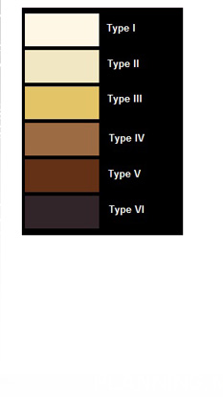

3.4 Class Notes
So What Does This Mean?
If you have Type I skin (very white), your levels of:
Melanin?:

Carotene?:

Hemoglobin?:

Is this skin type to your advantage or disadvantage? Why?

If you have Type VI skin (very dark), your levels of:
Melanin?:

Carotene?:

Hemoglobin?:

Is this skin type to your advantage or disadvantage? Why?

3.4 Class Work
What type of skin do you have?
Circle what applies to you. Then follow other directions below.
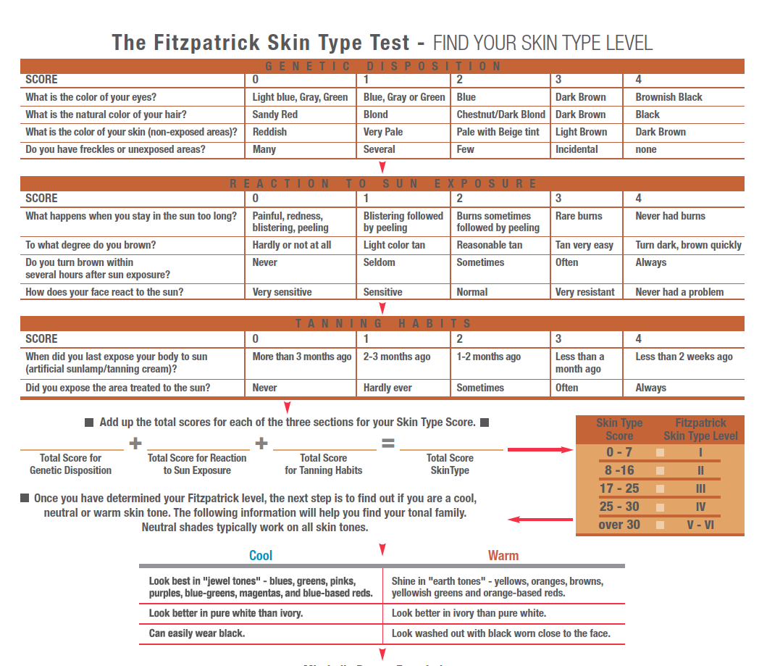
3.4 Class Work
Answer the following questions:
Section 1: Post-Questions of Fitzpatrick Scale Calculator
- According to the Fitzpatrick scale, what skin type are you?

- What does that indicate about your levels of:
- Melanin

- Carotene

- Hemoglobin

- What does that indicate about the likelihood you can get skin cancer?

- What does that indicate about skin treatment you should be doing?

Section 2: Testing Your Knowledge
- Why does exposure to sunlight or sunlamps darken skin?

- Would you expect to find the highest rate of skin cancer among the Blacks of tropical Africa, research scientists in the Artic, Norwegians in the Southern United States or Blacks in the United States? Explain your answer.

