Packet # 11

End of year TASK
Debate:
Is the passing of ObamaCare good or bad for the American public?

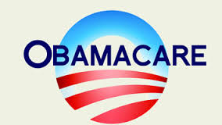

/ | Completed Class Notes
/ | Completed Classwork
/20 | Handed Packet in on Time
/ | Expectations Tracker
/ | Total Points
Comments:

Due Date: __________________________

DAILY EXPECTATIONS TRACKER

To ensure EVERY student is doing what he/she needs to do,
I am holding you accountable to follow daily class expectations.

Following each expectation = 5 points
MAX # of points = 100 points

It is YOUR RESPONSIBILITY that Ms. Francois stamps/checks this by the end of the period.
You CANNOT get it any other time!!!!!

You will NOT receive a check if you did not follow all classroom policies or actively work on the practice problems during the allotted class time. Ms. Francois is the final judge about you following daily expectations.

 | Arrive on Time | Participation  in Class | Behavior | Classwork effort | Homework completion
Monday
Tuesday
Wednesday
Thursday
Friday

Table of contents

1st reading | The Affordable Care Act: Student Discussion Guide  Author: Jason Tomaszewski
2nd reading | Five reasons Americans already love ObamaCare — plus one reason why they’re gonna love it even more, soon  Author: Sally Kohn
3rd reading | Obamacare: Unfair to the young middle class, punished enough already  Author: Matthew Fleischer

Contact information
Email: pfrancois@hs-gc.org
Website: msfrancoisap.weebly.com

Critical thinking question: As human beings, we all get sick. Whether you are young, old, rich, poor, we often need health care. Recently, the Affordable Care Act (also known as Obamacare) has been passed to ensure that all Americans receive health insurance. However, many argue that this has come with a lot of problems. Is the passing of the Obamacare Act good or bad for the American public? Justify your position.

Objective: I will write an argumentative essay on Obamacare.

Class notes

Anticipation Guide: Read Scenario

Scenario:

Have you met Jaime?
Jaime’s a 27-year-old college graduate who hasn’t been to the doctor since her 11th grade physical. She makes less than $20,000 a year. Like millions of Americans, Jaime does not have health insurance.
Sometimes you need more than a good night's sleep
Jaime shared her story with us:
"Every time I get sick, I get you know... If it can't be fixed with Advil, NyQuil and a good night's sleep I don't really have a solution for it.
Between all of the obligations I already have like utilities and rent and student loan payments, within my budget, there's no way I can afford health care.
If something bad happened to me... if I were in an accident or if I developed some kind of serious illness, there's no possible way I could afford it."

Now that you have read the scenario, respond below.

THINK INK:
Below, write your opinions in full sentences (with at least two reasons) on the question:
Is everyone having health care good or bad?
PAIR  Your partner should write down their opinion. | SHARE  You should share out what you and your partner discussed to another person. You should then write down that person’s opinion
Questions/Wonderings: Write down any questions you have or any wonderings on the topic. Must write something down in the space below!

Using the annotation symbols, mark up the text as you read. Write down any comments or questions you have on the side. After you finish reading, you will work in groups to annotate a poster text.

The Affordable Care Act: Student Discussion Guide
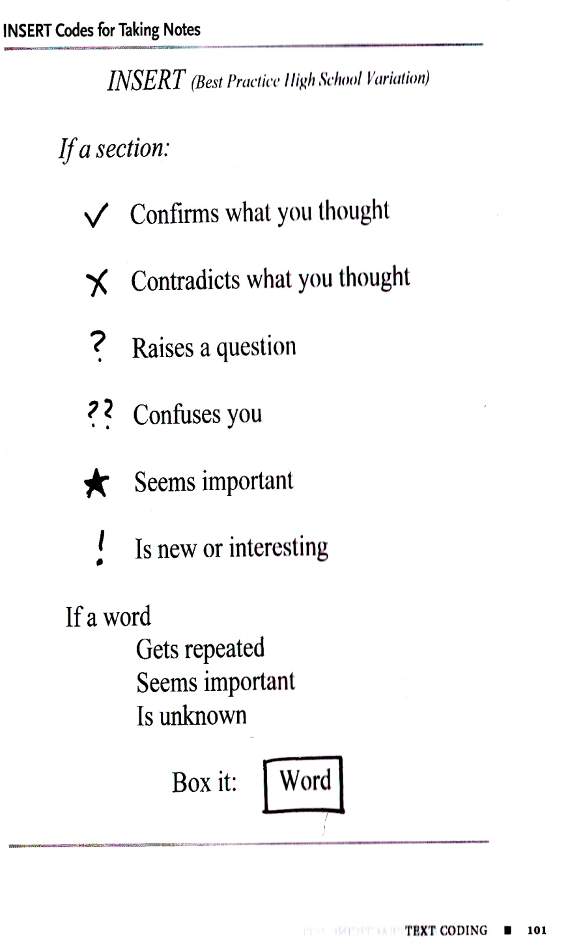
After years of debate, legislation and an official endorsement from the Supreme Court, the Affordable Care Act is being implemented. Yet many students may not understand the complicated health-care law commonly known as “Obamacare.” What Is It?

By expanding public and private insurance coverage, The Affordable Care Act was designed to (1) increase the quality and affordability of health insurance and (2) decrease the number of uninsured people. These measures also aim to reduce the costs of healthcare for both individuals and the government.
The law provides government financial help (subsidies) for those who qualify, along with other measures that work to expand the number of people who have health insurance. It also creates new rules that insurers must follow, including covering people with pre-existing conditions and charging the same rates regardless of gender.
To get coverage under the Affordable Care Act, people will access a series of state exchanges that the federal and state governments have created across the country. These exchanges allow citizens to shop for and purchase health insurance.
The law does not impact people who receive health coverage from their employers. Rather, it was written specifically for Americans who are currently uninsured or who cannot afford the type of coverage they need.
Those purchasing new insurance plans via the exchanges can enroll through March 31, 2014. Most plans will take effect as early as January 1, 2014.

How Is It Different From Government-Run Healthcare in Other Countries?
It is well documented that many countries, such as England and Canada, provide health care to their citizens. The Affordable Care Act does not mimic any of these countries’ health care systems any more than the old U.S. system did.
For example, the Canadian government sponsors health insurance for all citizens. That coverage is provided by, and funded by, the government. In the U.S., only some citizens receive government-run, government-funded health coverage (via Medicaid). While the Affordable Care Act will increase the number of people using government-provided insurance, the law’s primary function is giving more Americans access to private health care. The law therefore makes it easier and more affordable for them to purchase their insurance from private companies.
Often the term “universal healthcare” is used to describe the government-run and government-funded healthcare systems of other countries. (Beyond paying their taxes, citizens do not need to pay anything additional to receive healthcare. In that sense, it is “free.”) In the United States, the Affordable Care Act shares some of the motivations of universal healthcare, but the law only guarantees availability of healthcare for all—citizens must enroll to receive the coverage and pay something for it, even if that cost is reduced by government financial assistance.
What Are the Political Objections to the Law?
Because the law requires everyone to have health insurance, opponents claim it represents an overreach by the federal government. There is also strong resentment among Republicans for the way in which the law was passed. With Democrats in control of both the Senate and the House of Representatives at the time, the Affordable Care Act was passed with little to no involvement of Republicans. This combination of ideological differences and personal resentment regarding the law has led Republicans (who in 2013 control the House) to attempt to nullify it.
Article by Jason Tomaszewski, EducationWorld Associate Editor
Education World
- Copyright © 2013 Education World - See more at: http://www.educationworld.com/a_admin/affordable-care-act-student-discussion-guide.shtml#sthash.so5eeK6g.uvq2bdVu.dpuf

Questions to Answer
Cite evidence for the answer to each question:
- What countries provide some form of free, universal health care for their citizens?

Explain:

Cite evidence:

Reference Notation: (Author Page #): _____________________________________

- A medical professional who supports universal health care outlined a History of Universal Health Care Efforts in the U.S. She listed some American beliefs, values and political ideas that help explain why the United States does not provide government-run, free universal healthcare, the way that many other countries do. These beliefs, values and ideas include: interest-group influence, ideological differences, anti-communist and anti-socialist views, the entrepreneurial character of American medicine, a tradition of American voluntarism (meaning we don’t like to be told what to do), and the association of public programs with charity, dependence and personal failure. Do you think these beliefs, values and political ideas exist in the United States today?

Explain:

Cite evidence:

Reference Notation: (Author Page #): _____________________________________

- Depending on their political beliefs, some may view a law or policy positively, while others believe it represents “government overreach.” This is the case with the Affordable Care Act. In the United States, are there other issues that people tend to view in these two opposite ways?

Explain:

Cite evidence:

Reference Notation: (Author Page #): _____________________________________

- Republicans’ objections to the Affordable Care Act include beliefs that the law will result in increased health care costs and lower-quality care. What is your take on these objections?

Explain:

Cite evidence:

Reference Notation: (Author Page #): _____________________________________

- How do voters feel about the Affordable Care Act?
Explain:

Cite evidence:

Reference Notation: (Author Page #): _____________________________________

- How satisfied are Americans with their healthcare, compared to citizens of other countries?

Explain:

Cite evidence:

Reference Notation: (Author Page #): _____________________________________

- Have you experienced any challenges with your or your family’s healthcare or health insurance? If so, what laws or policies do you think would have helped the situation?

Explain:

Cite evidence:

Reference Notation: (Author Page #): _____________________________________

- Do you think the Affordable Care Act will be successfully implemented and reach its goal of improving Americans’ access to health care? Why or why not?
Explain:

Cite evidence:

Reference Notation: (Author Page #): _____________________________________

Read the following article in your group together.
Then fill out the graphic organizer following the reading:

Five reasons Americans already love ObamaCare — plus one reason why they’re gonna love it even more, soon
By Sally KohnPublished September 30, 2013
http://www.foxnews.com/opinion/2013/09/30/five-reasons-americans-already-love-obamacare-plus-one-reason-why-theyre-gonna/
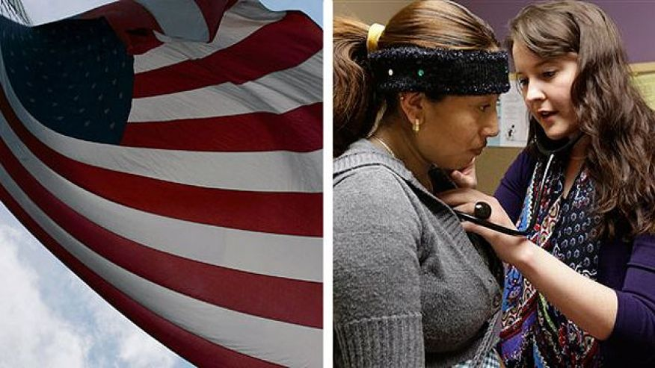
There’s a reason Republicans have been rushing to try and defund the Affordable Care Act before October 1, when major sections of the law take effect.
Republicans know what polls show — that most Americans don’t know what’s in ObamaCare, but when told what the law actually includes, a strong majority support the law.
Once state health insurance exchanges take effect, and premiums for all Americans go down, Republicans know the law will only become more popular and harder to repeal.
As Republican Senate Minority Leader Mitch McConnell said, “It's a lot harder to undo something than it is to stop it in the first place.”
Exactly.
Because just like Republicans railed against Social Security and Medicaid and Medicare when they were first proposed, those programs are now highly effective and broadly popular parts of our social safety net — supported even by strong majorities of Republican voters.
Americans of all political stripes like choice and competition, which is precisely what the ObamaCare health insurance exchanges will create.

So, for those of you who have been too busy criticizing ObamaCare for partisan reasons to actually look at what’s in the law — and see what Americans like about it — here is a handy-dandy review:
1. ACA allows young Americans to stay on their parents’ insurance plans
Because of ObamaCare, which allows kids to stay on their parents insurance plans until age 26, 3.4 million young Americans now have coverage.
The percentage of uninsured young people (ages 19 to 25) fell accordingly, from 48% in 2010 to 21% in 2012.
According to polling, three-in-four Americans support this part of the Affordable Care Act including, yes, over two-thirds of Republicans.
2. ACA bans insurance companies from denying coverage for pre-existing conditions
Another aspect of ObamaCare that has already taken effect is the ban on insurance companies denying coverage to patients based on pre-existing conditions.
That means an end to insurance company horror stories like four-month-old Alex Lange being denied health insurance because he was too chubby.
This is why the conservative allegation about death panels is so ironic; while the actual ACA law does not contain death panels or anything remotely like them, the fact is that prior to ObamaCare, insurance companies were effectively operating like death panels in denying life-saving coverage to anyone with a pre-existing condition and by applying life-time spending caps on coverage.
The ban on pre-existing condition limits, which will apply to every single American by 2014, is supported by 83% of Americans.
3. ACA offers tax credits to small businesses to buy insurance
The Affordable Care Act expands tax credits to help small businesses provide health insurance to their workers. Companies with fewer than 50 employees do not have to provide insurance, but even for these businesses, ObamaCare will make it easier and cheaper if they choose to do so.
According to polling, 88% of Americans think these small business tax credits are great, including — wait for it ... yes, 83% of Republicans. That’s right, over eight-in-ten Republicans support the provision of ObamaCare that helps small businesses afford and expand their health insurance offerings to employees.
4. ACA requires companies with more than 50 employees to provide health insurance
Over 96% of companies with more than 50 employees already provide health insurance to their employees. And contrary to Republicans claiming otherwise, studies show the vast majority of those employers do not plan to drop or reduce that coverage because of ObamaCare.
Also, there is no evidence that ObamaCare has led to companies slashing full-time workers. In fact, since ObamaCare passed in March 2010, over 90% of the gain in employment has been full-time positions.
Still, we know that companies that can afford to provide health insurance to their workers and yet fail to do so off-set the costs of care onto the rest of us — whether the cost of emergency room treatment that gets passed on to other consumers, or Medicaid coverage that we pay for as taxpayers.
In Florida alone, more than 50,000 workers at companies like McDonald’s and Burger King are on the state’s Medicaid rolls. Especially with tax credits available to small businesses, there is no excuse for companies to pass the buck. And 75% of Americans support this element of ObamaCare.

5. ACA provides subsidies to help individuals afford coverage
Many of the 45 million Americans who lack health insurance simply don’t have enough money to afford coverage. ObamaCare will lower the cost of premiums but also provide subsidies to help low- and middle-income Americans purchase insurance.
Americans who earn $45,000 per year (about 400% of the federal poverty level) will qualify for some form of subsidy. The amount of the subsidy will be based on income as well as the cost of health coverage in a particular state but, for instance, according to a subsidy calculator created by the Kaiser Family Foundation, a 27-year-old living in Houston, Texas, who earns just $15,000 a year could sign-up for a mid-level plan for about $300 per year with the help of subsidies. Without subsidies, that plan would cost $2,400 per year.
The few Americans who think subsidizing care is a bad idea should, again, note that we already subsidize health care to a far greater degree in the form of Medicaid and also when the uninsured rely on free emergency room care and pass those astronomical costs on to the rest of us. But most Americans — 76% to be exact — support the individual subsidy. That includes 61% of Republicans.
There’s even more aspects of ObamaCare that the American people already support — including the employer mandate, the increased Medicare payroll tax on higher-income Americans and the expansion of Medicaid.
And then, starting October 1, here’s one more:
6. State-based health insurance exchanges
Americans of all political stripes like choice and competition, which is precisely what the ObamaCare health insurance exchanges will create. So it’s no wonder that 80% of Americans — including 72% of Republicans — support the health insurance exchange program in ObamaCare. And that’s even before the exchanges have taken effect!
Plus, a new report shows that health insurance premiums will be even lower under ObamaCare than originally projected.
Personally, as someone who pays through the nose for individual insurance in New York State — a state where, historically, few individual insurance options have even been available — I can’t wait to enroll in ObamaCare and see my premiums plummet, as they are expected to by at least 50%.
Again, all this is why Republicans are in such a desperate rush to try and defund ObamaCare before October 1 — even if it means holding our economy hostage and even if most voters, including Republicans, oppose the repeated and wasteful defunding attempts.
After all, the law is already popular when it’s not fully in effect and most people haven’t felt its benefits. We all know what will happen when ObamaCare takes effect — and works!
Republicans who are throwing temper tantrums over sour grapes need to grow up.
Congress passed the Affordable Care Act, President Obama signed it into law and the Supreme Court upheld its constitutionality.
The cost of doing nothing on health care reform was too great and the cost of repeatedly refighting the political battles of the past is obscene. But then again, it makes perfect sense why Republicans refuse to just give up and shut up — because the minute they do, there will be no more distractions from all the good things about ObamaCare.

Sally Kohn joined the Fox News Channel in 2012 as a contributor.

BEFORE  reading | PREVIEW
1. What do I already know about the topic?

2. What do I think I will learn?

DURING reading | CLUNKS AND GISTS
 | FIRST SECTION | SECOND SECTION | THIRD SECTION
 | Clunks:  Gist: | Clunks:  Gist: | Clunks:  Gist:
AFTER  reading | WRAP UP
Questions that I have:

What I learned:

Author’s argument:

Textual evidence author uses  to support argument  (Include Ref Citation) | Explain the evidence. | What I think about the evidence?  How weak/strong is this argument?
Gaps and/or inconsistencies in argument:

Read the following article in your group together.
Then fill out the graphic organizer following the reading:

Obamacare: Unfair to the young middle class, punished enough already
October 29, 2013|By Matthew Fleischer, guest blogger

http://articles.latimes.com/2013/oct/29/news/la-ol-obamacare-health-insurance-rates-increase-too-expensive-20131029

The Obama administration came out with a report Monday arguing that 1 million single adults between the ages of 18 and 35 will be eligible for an Obamacare insurance plan costing less than $50 a month.
That’s news to me.
I’m a healthy 34-year-old with a taxable income hovering right around the Obamacare subsidy level who, for the last several years, has purchased a relatively inexpensive catastrophic health insurance plan from Blue Shield. I get to see the doctor four times a year for a $30 co-pay, and I won’t have to spend the rest of my life working off the debt if I get hit by a bus.

Last month, however, I received a letter from my insurance company informing me that my plan was “no longer available” due to “new requirements for health coverage under the Affordable Care Act.” I am being funneled into the closest equivalent plan under the new California health exchange, and my monthly premium is going to rise by nearly 43% to $214 a month.
My old plan was as bare-bones as they came, so I assumed that even though the new plan would cost more, my coverage would improve under Obamacare, at least marginally.
It did not.
Under my old plan, my maximum out-of-pocket expense was $4,900. Under the new plan, I’m on the hook for up to $6,350. Copays for my doctor visits will double. For urgent-care visits, they will quadruple. Though slightly cheaper plans exist if I decide to shop around on the exchange, I will lose my dental coverage should I switch.
Needless to say, I am not pleased.
Most young, middle-class Americans I know are happy that millions of previously uninsured people will receive free or heavily subsidized insurance under the Affordable Care Act.
We just didn’t realize that, unless we had health insurance at work, we’d be the ones paying for it.
Supporters of Obamacare note that young people have been footing the bill for the older generation for decades through programs like Social Security and Medicare. You pay when you’re young and reap the benefits as you grow older.
Both of those programs, however, are public, with no profit motive. They are both funded by payroll taxes, which, when I see them deducted every month, I don’t have to worry about them being funneled to the pockets of greedy insurance CEOs through creative accounting measures.
Payroll taxes are also collected from almost every wage-earner. With Obamacare, however, people with insurance through their jobs are insulated from the costs imposed on those who shop for individual polices. And most of them will be able to keep their group plans.
Older people in the individual market, meanwhile, may see their premiums go down, regardless of how well-off they may be. That’s because Obamacare mandates that older people can’t pay more than three times the rate of younger members of the pool.
Even the young, healthy and wealthy really don’t have much of a stake in paying for Obamacare. A 43% healthcare increase to a millionaire does not have the same impact as it does on someone making $45,000.
Backers of Obamacare also note that although young healthy people are being asked to sacrifice, they are the ones most likely to be eligible for a subsidized plan. But what exactly does that mean? According to Covered California’s online calculator, were I to make $30,000 (hardly rolling in dough), I would be eligible for a subsidy of $40 a month.

I would still be paying more than I am now for substandard health insurance.
What I mean by substandard is this. We’ve been hearing people complain that the Obamacare-approved policies cover too much, not too little. That’s part of the reason premiums are higher. But from my view, a higher monthly premium along with higher copays create a disincentive. Paying more to see a doctor means there’s less chance I’'ll use that service unless I’m absolutely desperate.
All of this isn’t simply idle hand-wringing. If young healthy people like myself feel we’re being taken advantage of, and opt out of purchasing insurance -- paying the penalty instead -- the healthcare exchanges will collapse. (The penalty in year one for opting out is only $95 or 1% of your salary, whichever is higher -- far less than the cost of even the most basic insurance plan.)
When Obamacare comes fully online, it will do wonders to provide healthcare for people who were not eligible for Medicaid but still could not afford health insurance. If this system is going to be sustainable, however, we’re going to need to find a way to get older and wealthier Americans to chip in more. Because, right now, it’s young, middle-class people just outside the subsidy range who are biting the bullet. Young, middle-class people who already bore the highest toll in the recent financial collapse, who have seen our wages sliced and our job prospects dwindle.
You can only ride our backs for so long before we’re going to tell you enough is enough.

BEFORE  reading | PREVIEW
1. What do I already know about the topic?

2. What I think I will learn?

DURING reading | CLUNKS AND GISTS
 | FIRST SECTION | SECOND SECTION | THIRD SECTION
 | Clunks:  Gist: | Clunks:  Gist: | Clunks:  Gist:
AFTER  reading | WRAP UP
Questions that I have:

What I learned:

Author’s argument:

Textual evidence author uses  to support argument  (Include Ref Citation) | Explain the evidence. | What I think about the evidence?  How weak/strong is this argument?
Gaps and/or inconsistencies in argument:

SOCRATIC SEMINAR—collecting information

Your claim:

Textual evidence + Reference Citation:

Why is this important?

Point 1: | Point 2 | Point 3
Supporting textual evidence:  Reference: | Supporting textual evidence:  Reference: | Supporting textual evidence:  Reference:
Why is this evidence important? | Why is this evidence important? | Why is this evidence important?
What does this evidence mean for your argument? Does it agree with it or disagree with it? | What does this evidence mean for your argument? Does it agree with it or disagree with it? | What does this evidence mean for your argument? Does it agree with it or disagree with it?
Gaps and/or inconsistencies in claim:

SOCRATIC SEMINAR—collecting information

Your counterclaim:

Textual evidence + Reference Citation:

Why is this important?

Point 1: | Point 2 | Point 3
Supporting textual evidence:  Reference: | Supporting textual evidence:  Reference: | Supporting textual evidence:  Reference:
Why is this evidence important? | Why is this evidence important? | Why is this evidence important?
What does this evidence mean for your argument? Does it agree with it or disagree with it? | What does this evidence mean for your argument? Does it agree with it or disagree with it? | What does this evidence mean for your argument? Does it agree with it or disagree with it?
Gaps and/or inconsistencies in counterclaim:

