Aim:
5.4

Objective:

Real world connection:

Vocabulary: urinalysis, Albumin, Bilirubin, glucose, ketones, microbes

Urinalysis
Use the following website to take notes on the following pages: http://www.nlm.nih.gov/medlineplus/ency/article/003579.htm
What does a urinalysis typically test for in the urine?

What are two methods for collecting urine?

Urinalysis checks for:
Physical color appearance - ____________________________________________________________________________________________________________________________________________________________________________________________________
Microscopic appearance - ____________________________________________________________________________________________________________________________________________________________________________________________________
Chemical appearance - ____________________________________________________________________________________________________________________________________________________________________________________________________
5.4 Class Notes

Urinanalysis
Use the following website to take notes on the following pages: http://www.nlm.nih.gov/medlineplus/ency/article/003579.htm

What are four major reasons a urinalysis may be done?
1.
2.
3.
4.

What are considered to be normal urine test results?

What does abnormal urine test results mean?

5.4 Class Notes

Use this website to fill in the following chart:
http://www.kidneyhealthcare.com/2009/09/abnormal-contents-of-urine.html

Explain indicators of disease that are present in urine. What does their presence in urine mean for the patient?

Albumin
Bilirubin
Glucose
Ketones
Microbes
Blood
(red blood cells)
White blood cells

Aim:
5.5

Objective:

Real world connection:

Vocabulary:

Virtual Urinalysis
For this portion of the lab, you will need to answer questions at the end of the virtual lab and fill out the following data sheets:
- Macroscopic Observations Data Sheet
- Chemstix Urinalysis Data Sheet
- Microscopic Observations Data Sheet

Tests on urine can provide clues to many diseases and information about your overall health. A routine urine-screening test may be done to help find the cause for many types of symptoms. The kidneys remove waste material, minerals, fluids, and other substances from the blood for elimination in the urine. Therefore, urine can contain hundreds of different bodily waste products. Many factors, such as diet, fluid intake, exercise, and kidney function, affect what is in urine. A urine test may be done as part of a routine physical examination to screen for a disease or infection of the urinary tract. Symptoms that may lead to a urine test include discolored or foul-smelling urine, pain during urination, difficulty urinating, flank pain, or fever. Urine tests are also performed to monitor the treatment of certain conditions such as diabetes, kidney stones, a urinary tract infection, hypertension, or some types of kidney or liver disease. Macroscopic examination requires only that the observer has a sense of sight and smell. The most cost-effective device used to screen urine chemistry is a plastic dipstick. This microchemistry system has been available for many years and allows qualitative and semi-quantitative analyses within a few minutes by simple but careful observation. The color change occurring on each segment of the strip is compared to an established color chart to obtain results. Microscopic urinalysis requires only a relatively inexpensive light microscope.
5.5 Class Work
Urinalysis Lab
http://biologyonline.us/Online%20A&P/AP%202/Northland/AP2lab/Lab%201%20online/lab4/9.htm#6)_Virtual_Urinalysis_Lab (scroll and Click Virtual Urinalysis Lab)
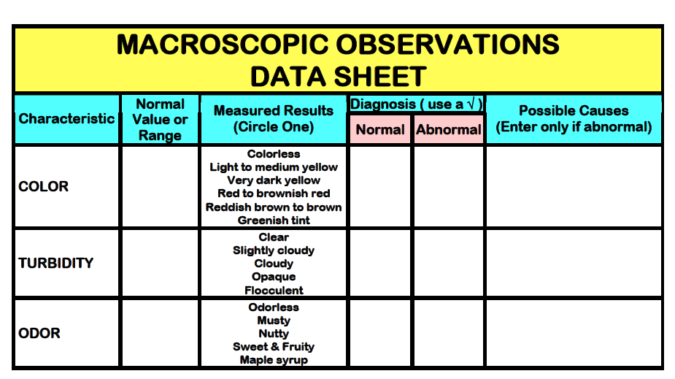
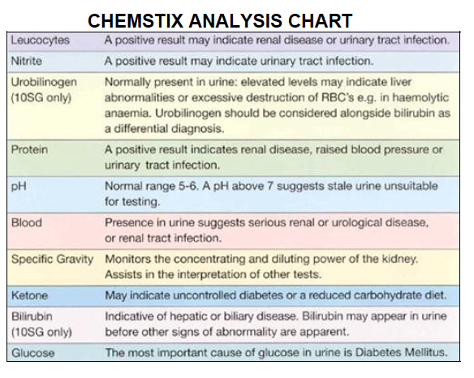
5.5 Class Work

Urinalysis Lab

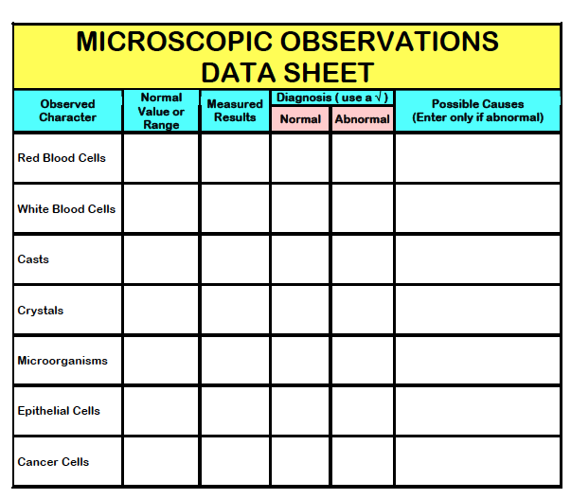

5.5 Class Work

Virtual Urinalysis Lab Questions
- What metabolic by-product from hemoglobin colors the urine yellow?
- How can adequate water intake be judged by the color of urine?
- What is hematuria?
- What is the normal value for glucose in the urine?
- What is ketonuria
- Elevated levels of white blood cells produce what condition in urine?
- What cells would be found in urine that comes from the urethra or bladder?
Aim:
5.6

Objective:

Real world connection:

Vocabulary: Urinary Tract Infection (UTI),

Urinary Tract Infections
Use the following website to answer the questions IN YOUR OWN WORDS:
http://medicalcenter.osu.edu/patientcare/healthcare_services/womens_health/urinary/uti/Pages/index.aspx

What causes urinary tract infections?

Which bacteria most likely lead to a UTI?

Where does this bacteria normally live?

5.6 Class Notes

Urinary Tract Infections—Types & Symptoms
Use the following website to answer the questions IN YOUR OWN WORDS:
http://medicalcenter.osu.edu/patientcare/healthcare_services/womens_health/urinary/uti/Pages/index.aspx

Describe the different types of urinary tract infections:
Urethritis- ____________________________________________________________________________________________________________________________________________________________________________________________________
Cystitis - ____________________________________________________________________________________________________________________________________________________________________________________________________
Pyelonephritis - ____________________________________________________________________________________________________________________________________________________________________________________________________
What are the symptoms of a urinary tract infection?

5.6 Class Notes

UTI Risk Factors in Women
Use this website to take notes below:
http://www.nytimes.com/health/guides/disease/urinary-tract-infection/risk-factors.html
- UTI’s are more common in ________________________
Describe the risk factors specific to WOMEN:
Structure of the Female Urinary Tract- ____________________________________________________________________________________________________________________________________________________________________________________________________
Sexual Behavior - ____________________________________________________________________________________________________________________________________________________________________________________________________
Contraceptives - ____________________________________________________________________________________________________________________________________________________________________________________________________
Pregnancy- ____________________________________________________________________________________________________________________________________________________________________________________________________
Menopause - ____________________________________________________________________________________________________________________________________________________________________________________________________
Allergies - ____________________________________________________________________________________________________________________________________________________________________________________________________Antibiotics - ____________________________________________________________________________________________________________________________________________________________________________________________________
5.6 Class Notes

UTI Risk Factors (Diseases)
Use this website to take notes below:
http://www.nytimes.com/health/guides/disease/urinary-tract-infection/risk-factors.html
- UTI’s are more common in ________________________
What increases the risk in men from getting a UTI?

Describe medical conditions that increase the risk of UTI
Diabetes- ____________________________________________________________________________________________________________________________________________________________________________________________________
Kidney Problems - ____________________________________________________________________________________________________________________________________________________________________________________________________
Neurogenic Bladder - ____________________________________________________________________________________________________________________________________________________________________________________________________
Sickle Cell Anemia - ____________________________________________________________________________________________________________________________________________________________________________________________________
Immune System Problems - ____________________________________________________________________________________________________________________________________________________________________________________________________
Urinary Tract Abnormalities - ____________________________________________________________________________________________________________________________________________________________________________________________________
5.6 Class Notes

UTI Diagnosis & Treatment
Use the following website to answer the questions IN YOUR OWN WORDS:
http://medicalcenter.osu.edu/patientcare/healthcare_services/womens_health/urinary/uti/Pages/index.aspx

Describe the four ways urinary tract infections are diagnosed:
Urinalysis- ____________________________________________________________________________________________________________________________________________________________________________________________________
Intravenous Pyelogram (IVP) - ____________________________________________________________________________________________________________________________________________________________________________________________________
Cystoscopy (Also called cystourethroscopy) - ____________________________________________________________________________________________________________________________________________________________________________________________________
Renal ultrasound - ____________________________________________________________________________________________________________________________________________________________________________________________________
What are some treatments for urinary tract infections?

5.6 Class Notes

UTI Treatment & Prevention
What are some behavior modifications a patient should make if they have an UTI?

Name five steps that can be taken to prevent urinary tract infections:
1.
2.
3.
4.
5.

5.6 Class Work

Answer the following questions:

1. Urinary tract infections (UTIs) include all the following conditions EXCEPT
a. vaginitis.
b. cystitis.
c. pyelonephritis.
d. urethritis.

2. The most common culprit in urinary tract infections is
a. Candida albicans
b. Escherichia coli
c. Chlamydia trachomatis
d. Neisseria gonorrhea

3. All of the following pertain to urinary tract infections (UTI's) except:
a. the short the urethra in females increases risk of cystitis
b. an enlarged prostate gland increases the incidence of infections
c. incomplete or infrequent emptying of the bladder increases risk of infection
d. urethral infections easily spread to the bladder
e. typically begin in kidneys and descend to the bladder and urethra

4. Why are women more susceptible to urinary tract infections than men?
a. The urethra is shorter in women and the opening is closer to the anus.
b. The urethra combines with the reproductive system in men.
c. The urethra is shorter in men but farther from the anus.
d. The urethra combines with the vagina in women.

5. The most important predisposing factor to upper urinary tract infection is:
- obstruction of urinary flow
- diabetes mellitus
- pregnancy
- recurrent urinary tract infection

6. Most men are immune to urinary tract infections.
a. True
b. False
Aim:
5.7

Objective:

Real world connection:

Vocabulary: Kidney Stones, Renal Failure, Nephritis, Nephrosis, Interstitial Cystitis, Benign Prostatic Hyperplasia, Renal Artery Stenosis, Ureterocele

The diseases being covered in this lesson are:
- Kidney Stones
- Renal Failure
- Nephritis
- Nephrosis
- Interstitial Cystitis
- Benign Prostatic Hyperplasia
- Renal Artery Stenosis
- Ureterocele
- Bladder Cancer

Unit 5 REFERENCE SHEET:
Urinary System Pathology (Study of Diagnosis & Treatment)

Disease | What is It? | Symptoms | Causes | Treatment
Kidney Stones  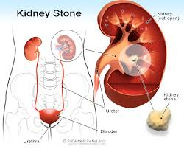 |  |  | The urine does not have the correct balance of fluids causing crystals to form from ions. The crystals stick together and grow and the pain is caused when the crystals move from the kidney down the ureter and then down the urethra.
Renal (kidney) Failure  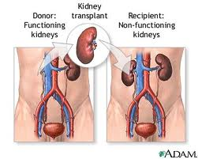 |  |  | The kidney fails to properly filter the blood (due to blood supply blockage, drugs, injury, high blood pressure, diabetes) leaving high levels of waste products in the blood. The high levels of waste products interact with the body causing the symptoms.
Nephritis  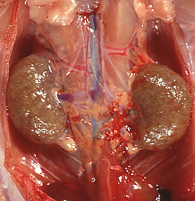 |  |  | Inflammation of the nephrons in the kidney caused by infections, toxins, or antibodies (autoimmune disorder). The inflammation leads to blood and proteins leaking into the urine causing protein levels to fall and fluids to accumulate.
Disease | What is It? | Symptoms | Causes | Treatment
Nephrosis  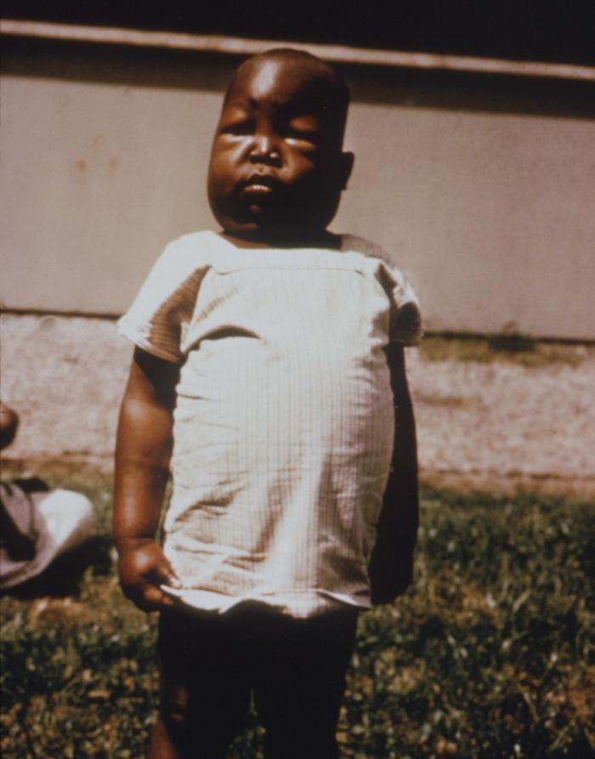 |  |  | Infection, drugs, or antibodies (autoimmune disorder) damage the glomerulus in the nephrons causing abnormal excretion of protein in the kidney (similar to nephritis but without the inflammation).
Interstitial Cystitis  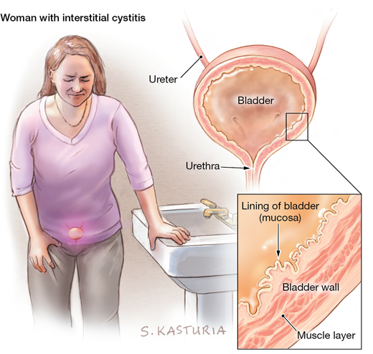 |  |  | Unknown underlying cause. The bladder lining is damaged causing urinary chemicals to leak into surrounding tissue casing the symptoms.
Benign Prostatic Hyperplasia  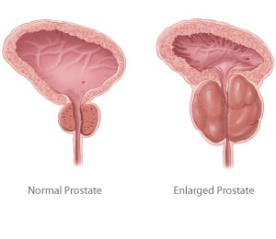 |  |  | Excess testosterone reaches the prostate causing it to enlarge and obstruct the urethra.
Disease | What is It? | Symptoms | Causes | Treatment
Renal Artery Stenosis  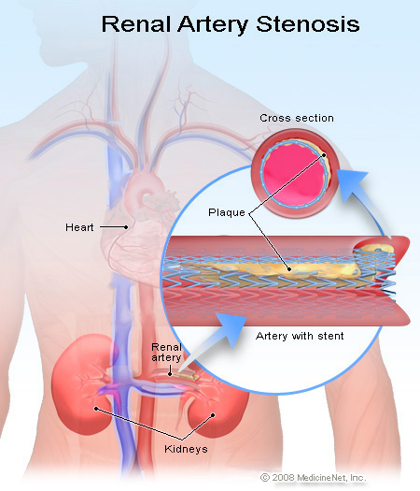 |  |  | Narrowing of the artery going to the kidneys caused by atherosclerosis or other diseases. The reduced blood flow causes the kidney to start dying and leads to kidney failure.
Ureterocele  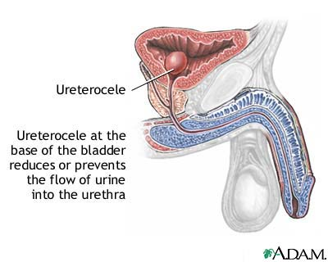 |  |  | The swollen area prevents urine from moving freely into the bladder. The urine collects in the ureter and stretches its walls, blowing it up like a water balloon.
Bladder Cancer  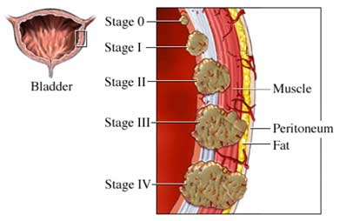 |  |  | - Cigar/cigarette Smoking  - Chemical Exposure at work (Exposure to toxic chemicals such as arsenic, phenols, aniline dyes, and arylamines)  - Long Term Bladder infection  - Men over the age of 55

5.7 Class Work

Skin Diagnosing
Patient Scenarios
Directions: For each scenario, in a paragraph (at least 5 sentences) please provide the following information:
- Patient diagnosis (what disease does he/she have)
- Symptoms that indicate that diagnosis
- What parts are affected
- Why did it happen? (Causes)
- Suggested treatment

Example: This patient is diagnosed with squamous cell carcinoma. This is because the patient showed symptoms such as dry, scaly skin. This disease had an impact on the epidermis layer of the skin. The patient has this cancer as a result of being out in the sun too much without wearing protection. To treat this cancer, I suggest performing an excision to remove it and apply a cream to keep the spot smooth.

Patient#1
A patient comes in complaining about frequent urinations that produce foul smelling, cloudy urine. They also have noticed a burning sensation when they urinate.

5.7 Class Work

Patient #2
A patient comes in with swelling in their face and arms. They have foamy urine and have put on some weight even though they have had less of an appetite. Their blood pressure is high. Their kidney is not swollen.

Patient #3
A patient comes in complaining about really dark urine that comes in small amounts. Their face and eyes are swollen, they have high blood pressure and there are feeling sick. Their kidney is swollen.

5.7 Class Work

Patient #4
A patient comes in with bloody urine and nausea. They are experiencing the worst pain they have ever felt in their lower back.

Patient #5
A patient comes in complaining about having a hard time getting to work or driving anywhere because of a constant sensation of their bladder being full. They also have been urinating much more often, find it painful when they do, and the condition seems to keep reoccurring.

