Packet #4
UNIT 2:
Talking Like a Doctor—
Introduction to Human Body

/ | Completed Class Notes
/ | Completed Classwork
/ | Completed Homework
/20 | Handed Packet in on Time
/ | Expectations Tracker
/ | Total Points
Comments:

Due Date: ____________________

DAILY
EXPECTATIONS TRACKER

To ensure EVERY student is doing what he/she needs to do,
I am holding you accountable to follow daily class expectations.

Following each expectation = 5 points
MAX # of points = 100 points

It is YOUR RESPONSIBILITY that Ms. Francois stamps/checks this by the end of the period.
You CANNOT get it any other time!!!!!

You will NOT receive a check if you did not follow all classroom policies or actively work on the practice problems during the allotted class time. Ms. Francois is the final judge about you following daily expectations.

 | Arrive on Time | Participation  in Class | Behavior | Classwork effort | Homework completion
Monday
Tuesday
Wednesday
Thursday
Friday

TABLE OF CONTENTS

2.4 | Homeostasis & Feedback Mechanisms
2.5 | Anatomical Terms
2.6 | Doctor Questioning

Contact information

Email: pfrancois@hs-gc.org

Website: msfrancoisap.weebly.com

2.4
Aim:

Objective:

Real world connection:

Vocabulary: *Homeostasis * Negative Feedback * Positive feedback *

CLASS NOTES

Homeostasis

TERM | PREFIX | SUFFIX
Homeostasis

 | YOUR DEFINITION
BOOK DEFINITION

Cells must maintain a balance of:
1.
2.
3.
4.
5.
6.
7

2.4
CLASS NOTES

How does your body reach homeostasis in the following situations?

Body Problem | What happens? | How body reaches homeostasis  (What your body does) Identify Steps
You’re too hot

Body Problem | What happens? | How body reaches homeostasis  (What your body does) Identify Steps
You are hungry

2.4
CLASS NOTES

Positive and Negative Feedback Mechanisms

WORD | DEFINITION
Feedback

Most homeostatic mechanisms are examples of ______________________________

Feedback Mechanism + Definition | Example
Negative Feedback:

Positive Feedback:

2.4
GROUP WORK

Station One:
Uterine Contractions

During childbirth, the muscles of the uterus push the child through the vagina. Each time the uterus pushes is called a contraction. The Ferguson reflex is the female body's response to each of these contractions.
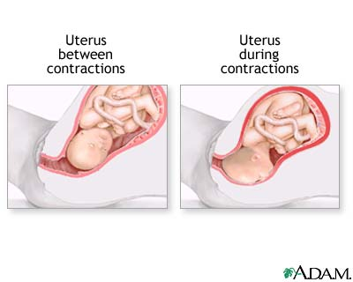
When there is a pressure on the uterus, the hormone, oxytocin, is secreted and uterine contractions are stimulated. This, in turn, increases oxytocin production, which increases contractions even more, until the baby is delivered.

- What hormone is secreted in the Ferguson reflex?
- What does this hormone cause the uterus to do during childbirth?
- Is the Ferguson reflex a positive or a negative feedback loop?
- How do you know this? Cite from text.

2.4
GROUP WORK

Station Two:
Blood Glucose Regulation

The human body wants blood glucose (blood sugar) maintained in a very narrow range. Insulin and glucagon, both produced and secreted by the pancreas, are the hormones that make this happen.

Insulin is secreted when the blood glucose level is a HIGH and will work to bring the blood glucose levels down. Similarly, as blood glucose decreases, the amount of insulin secreted by the pancreas goes down.

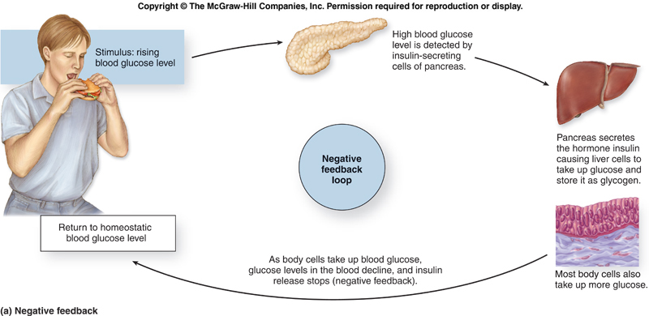
Glucagon is also secreted by the pancreas. If blood glucose is LOW, more and more glucagon is secreted. The effect of glucagon is to make the liver release the glucose it has stored in its cells into the blood stream, with the net effect of increasing blood glucose.

- What two hormones the pancreas secretes and what do they each do?

- Our principal says that the regulation of blood glucose levels is a positive feedback loop? Explain whether the principal is right or wrong. Cite from the text.

2.4
GROUP WORK

Station Three:
Blood Clotting

Coagulation is a complex process by which blood forms clots (i.e. scabs). It is an important part of homeostasis, because clots and scabs stop bleeding and begin to repair the damaged skin or other blood vessel. Disorders of coagulation can lead to an increased risk of bleeding (hemorrhage) or obstructive clotting (thrombosis).

Coagulation begins almost instantly after an injury to the blood vessel has damaged the skin. Injured tissues secrete hormones into the blood that activate platelets, the cells that cause clotting. An activated platelet will secrete hormones to activate more platelets, causing a rapid cascade and the formation of a blood clot.

- What type of cells assist in clotting your blood when you have a deep cut?

- Is blood clotting a positive or a negative feedback loop?
Explain why citing evidence from the text.

- Draw a diagram that shows the feedback loop of blood clotting.

2.4
GROUP WORK

Station Four:
Blood Pressure

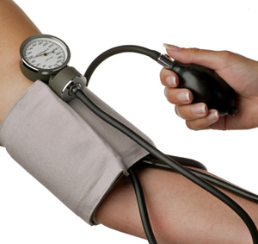
The baroreflex or baroreceptor reflex is one of the body's homeostatic mechanisms for maintaining blood pressure. It provides a feedback loop in which an elevated blood pressure causes heart rate and blood pressure to decrease. In a similar fashion, decreased blood pressure activates the baroreflex, causing heart rate and blood pressure to increase.

- 1. What type of mechanism is causing changes in your blood pressure and what does it dos?

- 2. Is maintaining your blood pressure a positive or a negative feedback loop? Explain why citing evidence from the text.

3. Draw a diagram that shows the feedback loop of maintaining your blood pressure.

2.4
CLASS WORK

- What is homeostasis?
  - Our body trying to maintain internal balance.
  - Our body trying to disrupt internal balance
  - Our body trying to overheat
  - Our body trying to cool down

- When a person becomes homeless, it is harder to maintain homeostasis. Which of the following is a correct example of homeostasis being disrupted under the condition of homelessness?
  - When exposed to extreme cold, frost bite sets in because the body cannot maintain temperature balance in a constantly cold environment
  - Without a constant source for food, the body becomes stronger and healthier
  - All of the above
  - One of the above

3. Homeostasis is the condition in which the body maintains:
- The lowest possible energy usage
- A relatively stable internal environment, within limits
- A static state with no deviation from preset points
- A changing state, within an unlimited range

4. Which of the following is NOT an example of homeostasis?
- Sweating to cool the body
- Excreting watered down urine to rid the body of excess water
- Use of insulin to lower blood sugar
- Using a thermometer to measure body temperature

5. In this mechanism, an increase or decrease in the variable being regulated triggers a response that moves the variable in the opposite direction:
  - set point
  - negative feedback
  - positive feedback
  - body temperature

6. In this mechanism, a response increases the value of a variable in the same direction, triggering an “explosive” response:
    - set Point
    - negative Feedback
    - positive Feedback
    - running away from a bear

7. Diabetes is caused by a breakdown in this mechanism:
  - eating
  - positive feedback
  - negative feedback
  - exercise

2.4
CLASS WORK

Write a TIEDIEDC paragraph contrasting negative feedback and positive feedback. Make sure to explain what each term means AND provide an example by citing evidence from the text. Use transition words to indicate you are contrasting.

T = Topic; I = Intro of evidence; E = Evidence (Quote); D = Development of Evidence; C = Conclusion)

2.5
Aim:

Objective:

Real world connection:

Vocabulary: Anatomical position, superior, inferior,
ventral, dorsal, medial, lateral, proximal, distal, superficial, deep

CLASS NOTES

Why do doctors use a specific language?

Think-Ink  Jot down in one minute your thoughts. | Pair-Share  Share what you discussed with your group.

CLASS NOTES
2.5

The Language of Anatomy

Language of Anatomy involves:
- _______________________________
- ____________________________________________
- ____________________________________________
- ____________________________________________
- ____________________________________________

Anatomical Position

- To avoid confusion, we always assume body is in a
STANDARD position = _________________________ position
- The position we are use to standing in is called the _____________________________ position
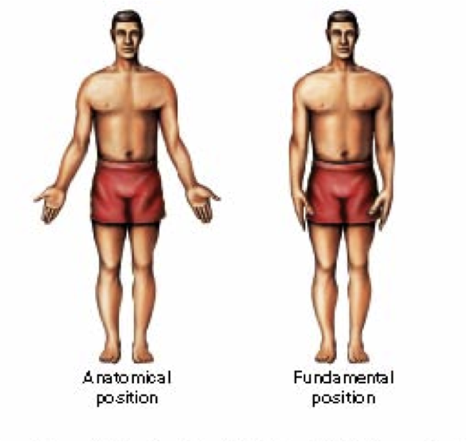
Compare & contrast what you see using a Venn Diagram:

CLASS NOTES
2.5

Directional Terms

Term | Definition | Illustration | Example
Superior (cranial) |  |  | The forehead is superior to the nose
Inferior (caudal) |  |  | The bellybutton is inferior to the breastbone

Ventral (anterior) |  |  | The breastbone is anterior to the spine
Dorsal (posterior) |  |  | The heart is posterior to the breastbone

CLASS NOTES
2.5

Directional Terms

Term | Definition | Illustration | Example
Medial |  |  | The heart is medial to the arm
Lateral |  |  | The arms are lateral to the chest

Proximal |  |  | The elbow is proximal to the wrist (meaning that the elbow is closer to the shoulder or attachment point of the arm than the wrist is)
Distal |  |  | The knee is distal to the thigh

CLASS NOTES
2.5

Directional Terms

Term | Definition | Illustration | Example
Superficial (external) |  | 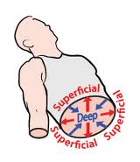 | The skin is superficial to the skeleton
Deep (internal) |  |  | The lungs are deep to the rib cage

Sample Questions
- The wrist is ___________________________ to the hand
- The breastbone is _______________________ to the spine.
- The brain is ___________________________ to the spinal cord.
- The thumb is _____________________________ to the fingers.
- The nose is ______________________ to the lips

GROUP WORK
2.5

1. Each student needs a stack of note cards or post-it notes. On the cards they write anatomical directional and orientation terms. Students should also put an arrow or arrows pointing in the direction the term describes on their cards.
At a minimum, students should include the following terms: superior, inferior, anterior, posterior, medial, lateral, intermediate, proximal, distal, superficial, and deep.

2. After students have completed their cards, have them find a partner. Using tape if they do not have post-it notes, students then take turns placing the cards in the correct location on their partner’s body. For example, if the card is SUPERIOR (with an arrow pointing up), it could be placed on a student’s forehead; or, if the card is DISTAL (with an arrow pointing toward the outer edge), the card might be placed on the student’s fingers or wrists.

3. As they place each card on their partner’s body, they should make a correct sentence using the term.

Examples: The head is SUPERIOR to the neck.
The fingers are DISTAL to the elbow.

Write your sentences below:

CLASS WORK
2.5

- What is the anatomical position and why is understanding this position important to an anatomy student?

- Using the terms listed below, fill in the blank with the proper term:

- The heart is located __________________________ to the diaphragm.
- The muscles are ______________________________ to the skin.
- The shoulder is _______________________________ to the elbow.
- In anatomical position, the thumb is _________________ to the index finger

- The shoulder is _______ to the wrist:
- Distal
- Lateral
- Medial
- Proximal

- The forehead is ___________ to the chin:
- Anterior
- Inferior
- Superior
- Posterior

Circle one:
- The nose is found on the (anterior/posterior) portion of the head
- In the anatomical position, the stance of the body is erect, with the arms hanging to the side, palms facing (forward/backward)
- The thumb is (proximal/distal) to the shoulder.
- The nose is (medial/lateral) to the ear.
- The heart lies (superficial/deep) to the ribs.
- The eyes are on the (ventral/dorsal) side of the body.

2.6
Aim:

Objective:

Real world connection:

Vocabulary: Family history, symptoms, causes/risk factors, diagnosis, treatment, future prevention, prognosis

CLASS NOTES

Thinking Like A Doctor
Look at the flowchart below and fill in the boxes:
What do you feel when sick or injured?
1.

2.

3.

4.

5.
6.

1. Student feels sick.

What are some specific questions the Doctor asks you?
1.

2.

3.

4.

5.

2. Student explains symptoms to a Doctor
(or Ms. Francois).
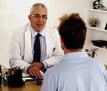

CLASS NOTES
2.6

Thinking Like A Doctor Continued

3. Doctor runs some tests or checks for pain.
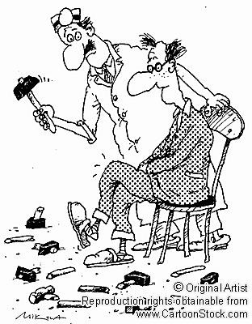
What are some specific tests or “checks for pain” the Doctor uses?
1.

2.

3.

4.

5.
6.

4. Doctor finds an answer based on the data from tests.

Doctor Notes

When you feel sick, the different ways you feel are called _____________________ of the sickness.

Factors that can increase a person from getting sick are called ____________________ ______________________

Observations

- When the doctor collects information from tests, he is collecting medical _______________________.

- Based on the medical data the doctor has collected, he can make a __________________________, or a

declaration of what the sickness or disease is.

Inferences

- Doctor makes ______________________________, which will help the patient to get better.

- Doctor makes suggestions on how to prevent the sickness from happening again.

CLASS NOTES
2.6

As a Doctor, we need…
- Basic Info about the patient (Age, height, weight, etc)
- Family history: ___________________________________________________________
- Symptoms: ____________________________________________________________
- Causes/Risk factors: ____________________________________________________
- Diagnosis: ______________________________________________________________
- Treatment: ______________________________________________________________
- Future Prevention: ______________________________________________________
- Prognosis: ______________________________________________________________
Doctor-Patient Interview

(Patient is sitting on the “patient chair” – the demonstration counter at the front of the room. Doctor walks in to greet the patient.)

Dr. Francois: Hello there __________________. (Reads patient chart as he says the following.) I am your new doctor so I just wanted to get some basic information about you so I can know how best to serve you. I see you are 70 years old. Happy belated birthday as I see it just passed on August 27th. On your chart, the nurse wrote you are 5’6” and you are 180 lbs, so you are overweight. Can you tell me a little bit about your family history?

Patient: (looks down at floor and answer) I was born in Florida, the oldest of two girls born to Scandinavian parents. I think my grandmother died of colon cancer, but I don’t think anyone else in my family had cancer. I also have a history of high blood pressure and diabetes from my mother side.

CLASS WORK
2.6

Dr. Francois: It looks like other doctors have had trouble diagnosing you. So what brings you here today? Can you tell me a bit about your symptoms?

Patient: (Patient attempts to answer, but hesitates a few seconds and then talks slowly and quietly. Should talk in this voice throughout the interview) Yes. I’ve been having a lot of trouble with my skin. It hurts every time I touch it. I have random spots on my arm that has been dry and peeling. I keep scratching it and so it would turn red and sore.

Dr. Francois: Hmmmm interesting. Have you been on vacation lately? Have you been exposed to a lot of sun?

Patient: Ummmmmm. Well I have not been on vacation for months. However, I LOVE the sun! I go sailing almost every weekend. And I spend many, many hours playing on the beach and in the water. Even the sunburns I keep getting (our fair skin never tanned) didn’t discourage me—as soon as we have healed, we’d be back outside. I

Dr. Francois: For how many hours would you be in the sun for one day? Do you wear any form of protection?

Patient: I will be in the sun all day, every day. I do wear sunscreen. I married a physician, and he insisted that I use sunscreen regularly and remember to wear a hat outdoors. I am very careful.

Dr. Francois: Have you had skin cancer in the past?

Patient: I have a history of sunburns. Because of my history of sunburns, my doctor checked me carefully for any changes in moles or any other signs of skin cancer. Sure enough, when I was 56, she found a few that were beginning to change. Eventually, I had three of the moles removed surgically. Both the oncologist who did the surgery and my regular doctor said that because we caught the skin cancer early, my chances of recovery were very good.

I
2.6
CLASS WORK

Dr. Francois: Okay, well if you don’t mind we’re going to do some basic tests today to see what these sores are. Let me help you get on the table. (Dr. gives patient a hand as she slides off the table and stands in front of it). I will need to remove a small skin sample to examine under the microscope. I am going to shave off the top layer of skin with this blade and send it out for some tests.

Patient: Sure. (Turns head away as skin scraped off). Ouch!

Returns to office two days later

Dr. Francois: Okay, thanks. We have the results. You definitely have skin cancer. It is a matter of figuring out what type of skin cancer. Considering your symptoms, you have squamous cell carcinoma. In order to treat this you need to do one of the following:

- Excision: Cutting out the skin cancer and stitching the skin together:
- Scraping away cancer cells and using electricity to kill any that remain; It is used to treat cancers that are not very large or deep
- Freezing the cancer cells, which kills them
- Medication: Skin creams
- Removing a layer of skin and looking at it immediately under a microscope, then removing many layers of skin until there are no signs of the cancer; Usually used for skin cancers on the nose, ears, and other areas of the face.

If you do not take any necessary precautions such as stay out of the sun or put suntan lotion and a hat when you are in the sun, then it is going to keep coming back. It can lead to a worse form of cancer such as melanoma.

I
2.6
CLASS WORK

Use this chart to collect all your necessary information
Patient Chart
Name: Condoleezza Lopez D.O.B.:
SS#: 123-45-6789 Sex:
Age: Height: Weight:
Family History | Symptoms
Causes/Risk Factors | Diagnosis (explain why)
Treatment (explain why) | Prevention (explain why)
Prognosis (explain why) | Other Notes

I
2.6
CLASS WORK

You are now ask to write letter to Dr. Francois (head doctor), explaining the scenario in the following format

LETTER ORGANIZER
Dear Dr. Francois,

Dear Dr. Francois,

