Packet #2
UNIT 1:
Becoming Chemists—
Scientific Method

/ | Completed Class Notes
/ | Completed Classwork
/ | Completed Homework
/20 | Handed Packet in on Time
/ | Expectations Tracker
/ | Total Points
Comments:

Due Date: ____________________

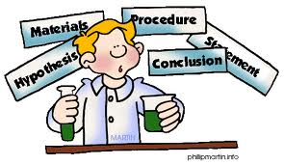

DAILY EXPECTATIONS TRACKER

To ensure EVERY student is doing what he/she needs to do,
I am holding you accountable to follow daily class expectations.

Following each expectation = 5 points
MAX # of points = 100 points

It is YOUR RESPONSIBILITY that Ms. Francois stamps/checks this by the end of the period.
You CANNOT get it any other time!!!!!

You will NOT receive a check if you did not follow all classroom policies or actively work on the practice problems during the allotted class time. Ms. Francois is the final judge about you following daily expectations.

 | Arrive on Time | Participation  in Class | Behavior | Classwork effort | Homework completion
Monday
Tuesday
Wednesday
Thursday
Friday

Table of contents

1.4 | Observations
1.5 | Tables
1.6 | Graphing
1.7 | Introduction and Conclusion

Contact information

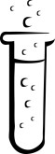
Email: pfrancois@hs-gc.org

Website: msfrancoischem.weebly.com

1.4
Aim:

Objective:

Real world connection:

Vocabulary: *observation * inference * qualitative observation * quantitative observation *

CLASS NOTES

What are observations? What are inferences?
Observation
(also known as Data)

Inference

Example:
Observations | 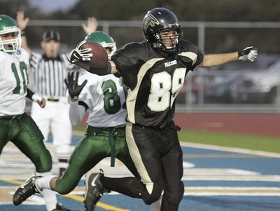  Inferences

CLASS NOTES
1.4

Two Kinds of Observations:

Qualitative Observation | Examples:
Quantitative Observation  NOTE: YOU MUST USE UNITS!!!!!! | Examples:

Examples: Decide if the following are qualitative or quantitative observations:
- Chemical A and chemical B reacted creating bubbles. _____________________________
- The chemical reaction released 10 joules of heat into the environment. _______________
- The beaker contained 10 mL less water that the previous day. _______________________
- The brown rock is heavier than the black rock. ______________________________________
- The bear has a number 3 shaved into its fur. _________________________________________

YOU TRY: Observation vs. Inference Practice!
Under each description, circle either OBSERVATION or INFERENCE.

Ex. The sun is yellowish/orange today.
OBSERVATION INFERENCE

- There are 20 students in this room.
OBSERVATION INFERENCE

- The sun is (or is not) shining.
OBSERVATION INFERENCE

- It must be summer because the sun is out.
OBSERVATION INFERENCE

- The students are excited to be at school today.
OBSERVATION INFERENCE

5. It took the students 2.35 seconds to stand up today.
OBSERVATION INFERENCE

1.4
CLASS NOTES

YOU TRY!: You will practice your own observations:

Picture | Qualitative Observation | Quantitative Observation | Inference
Pigs
Polar Bears
Grizzly Bears
Summary: Explain why is it so important to make observations and not inferences when completing a science experiment. (ANSWER IN 1 SENTENCE)

CLASS WORK
1.4

Label the following as observation or inference:

1.The plant is inside a house. __________________________________
2. The stool is made of wood. __________________________________
3. The plant is healthy. _________________________________________
4. The leaves of the plant are green. __________________________
5. The plant needs water to live. ______________________________

For the following picture, note down 6 observations (3 qualitative and 3 quantitative) and 3 inferences

Qualitative Observation | Quantitative Observation | Inference

1.5
Aim:

Objective:

Real world connection:

Vocabulary: *Table * Title * Column * Row *

CLASS NOTES

What are tables?

- ________________________________ are a way for people to see the data you have collected during an experiment in a much ___________________ way and be able to analyze it more _________________________________________

- Requirements for a table:
- Each table should have a ________________ to say what type of information the table is showing.
  - title must have the _______________________ of the experiment
  - every row and column should be ________________ with a _________________
  - unit of measurement you are using is written in the ________________
  - You must record your data ____________________________
  - You must _____________________________________ in your table.
  - __________________ box in the _______________ of the table

CLASS NOTES
1.5

Parts of a table:

- The first ___________________ (vertical row) in a table lists the items to be compared (the _______________________ variable)
- The first ___________________ (horizontal row) of the table lists the specific characteristics being compared (the _____________________ variable)
- Within the _______________ of the table, the collected __________________ is recorded.

Example: Identify the independent and dependent variables from the table
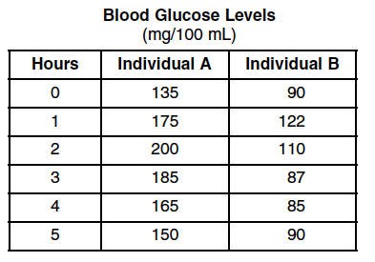

INDEPENDENT VARIABLE:

DEPENDENT VARIABLE:

YOU TRY!: Write down what is correct about this data table

CLASS NOTES/WORK
1.5

What is wrong with this data table?

ACTIVITY WITH A PARTNER: How does the volume change when the size of the paper keeps getting cut in half? Create a table collecting at least 6 different results.

HYPOTHESIS:

INDEPENDENT VARIABLE:

DEPENDENT VARIABLE:

Summary: What must a table include? (LIST it out)

1.1
1.6
Aim:

Objective:

Real world connection:

Vocabulary: *Graphs * X-axis * Y-axis * Intervals * Number scale * Direct Relationship * Indirect Relationship *

CLASS NOTES

Graphs

- Graphs make it easier to see __________________ in the data rather than looking at large sets of numbers.

Two main types of graphs used in science

Bar Graph | Example:
Line Graph | Example:

CLASS NOTES
1.6

EXAMPLE: Which need a bar graph and which need a line graph?

- How does air pressure affect the height of a basketball?

- What is the relationship between the color of light bulb and number of insects attracted to it?

- How many A’s, B’s, C’s, D’s and F’s will this class have on the first test?

Reading graphs: Look at the graph on the right and answer the questions.

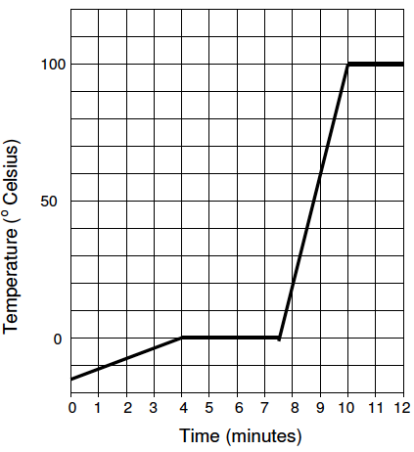
- What is the label on the x-axis? the y-axis?

- What units are used to describe the x-axis?
the y-axis?

- Describe in detail what you think the experimenter did to get the data for this graph.

- Over what time interval(s) does the temperature remain constant? Include units.

- Over what time interval(s) is the temperature rising? Include units.

CLASS NOTES
1.6

- What is the temperature of the water after four minutes? Include units.

- At what time is the temperature 10ºC? Include units

Relationships within a graph

Creating a good graph: Ask yourself…
- Is there a title at the top that shows the relationship between the independent and dependent variable?
- Are there axes labeled with proper units?
  - Is the Independent variable on the _______________
  - Is the dependent variable on the _________________
- Is the number scale correct? Are the numbers in even increments on both the horizontal and vertical axis? Are they all attached to a line? Did you start at zero?
- Is your data graphed correctly? Did you only graph the averages? Does each bar correspond to the correct number on your chart?
- Is it neat and easy to read?
- Did you use most of the available space?
CLASS NOTES
1.6

Example:
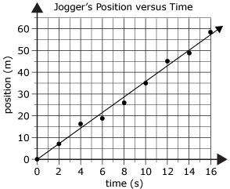
- Title:

- Independent Variable:
What axis is it located?

- Dependent Variable:
What axis is it located?

- Number scale on x-axis:
Number scale on y-axis:

- Does it start at zero?

YOU TRY!: Plotting the Points
Below are the data you collected from a boiling water experiment. Please follow the procedural instructions on the line graph provided below.

- At what temperature would you expect to see the temperature at 5.5 minutes?

- Is the temperature increasing or decreasing? What type of relationship is it?

I
1.6
CLASS WORK

Practice: Graph the following data…
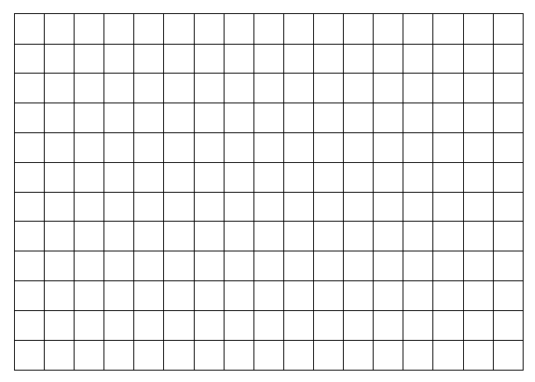
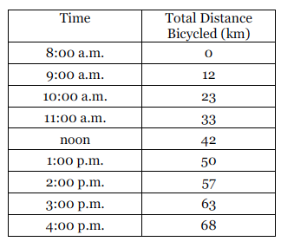

- How would you expect the graph to look if data were available for 5 and 6 p.m.? Then, identify one factor that might cause the graph NOT to look like this.

- Use your graph to estimate the total distance traveled by 10:30 a.m. Can you be absolutely certain of this value? Why or why not?

- Compare the distance traveled during the first hour of the trip with the distance traveled during the last hour of the trip. Suggest a possible explanation for the difference. How is this difference illustrated on the graph?

CLASS WORK
1.6

You want to plan a vacation, but you can’t decide where to go. You decide to compare the last year’s temperatures of three cities. Hopefully, you will be able to not only decide which city to visit, but at what time of year!

Use the data table below to draw a perfect graph (everything included and labeled correctly) of the data you researched for the three cities:

Last Years Temperatures for Three American Cities
City | Jan | Feb | March | April | May | June | July | Aug | Sept | Oct | Nov | Dec
San Diego | 20 | 19 | 28 | 28 | 28 | 32 | 20 | 37 | 30 | 29 | 23 | 20
Denver | -1 | 0 | 5 | 28 | 30 | 35 | 38 | 42 | 38 | 28 | 10 | 0
Detroit | -10 | -8 | 4 | 16 | 32 | 33 | 37 | 40 | 38 | 20 | 10 | 5

Title: _________________________________

CLASS WORK
1.6

Answer the following questions based on the graph you created on the previous page:

  - If you wanted to go snow skiing, which city and when would be the best to visit?

  - What information on the graph would support your decision?

  - If you wanted to go surfing, which city and when would be the best option?

  - What information on the graph would support your decision?

  - Which city experiences the greatest temperature variation?

  - How does the graphed data support your answer?

  - What really important detail is missing from this data table that could have a major impact on your vacation plans?

  - Why is this missing information so important to know before you go on your trip?

1.7
Aim:

Objective:

Real world connection:

Vocabulary: * Introduction *Conclusion *

CLASS NOTES

How to write a well-formulated introduction and conclusion?

An introduction must contain the following:
- state the goals and objectives of the laboratory
- describe what data will be collected
- describe how that data will be used to arrive at conclusions at the completion of the laboratory.

A conclusion must contain the following:
    - Restate the lab’s problem
    - Summarize your results—state any trends you saw and why
    - State if your hypothesis was correct, incorrect, or inconclusive.
    - Sources of error
    - Suggestions to improve experiment
    - Explain how information gained in lab can be applied to real-life situations and how does it relate to major scientific principles, classnotes, or text
    - State at least one question that you have remaining from the experiment

CLASS NOTES
1.7

EXAMPLE: (label each sentence with the component that it follows)

QUESTION:
What effect does the surface area have on the rate of dissolving?

HYPOTHESIS:
If I increase the surface area of the Alka Seltzer, then the rate at which the tables dissolve increases because the Alka Seltzer has more contact points with water.

INTRODUCTION:

In this experiment, we are looking to test the effect of surface area on the rate of dissolving. In order to do this, we will test the effect of three different surface areas of an Alka Seltzer Table (whole tablet, chunks, crushed) on the rate at which an Alka Seltzer dissolves. We will take data of the time it takes for a whole table, ¼ chunks and completely crushed Alka Seltzer to completely dissolve. If it takes longer to dissolve as you use smaller pieces, that means the surface area has a negative effect. If it takes shorter to dissolve as you use smaller pieces, that means the surface area has a positive effect.

DISCUSSION AND CONCLUSION:
In my hypothesis, I stated if I increase the surface area of the Alka Seltzer, then the rate at which the tables dissolve increases because the Alka Seltzer has more contact points with water. In this experiment, my hypothesis was proved to be correct. This is evident through my data. For example, the mean rate of the whole tablet took 20 seconds slower than the mean rate of the chunked tablet. In addition, there is a 36 second difference between the whole tablet and crushed tablet.

CLASS NOTES
1.7

Conclusion continued…

Overall, the experiment was successful. However, there are some sources of error that probably affected the results of the experiment. One source of error could be how the tablet was broken into pieces. The chunks may not have all been the same size, which could have affected the rate. In the future, a knife could be used to break everything into equal size. Another source of error could be the timing of the test. There is a possibility that the timing could be off because the counting down may not have started immediately after the tablet hit the water. In the future, having one person drop the tablet while someone else starts the stopwatch could help with more accurate timing.
After having completed the experiment, some questions popped into mind. I wonder how would temperature have an impact on the dissolving rate. I also wonder if using a different type of tablet would have an impact.

YOU TRY!: Point out all the elements that are missing from the following.
Purpose: How does the magnitude of vibrations affect the amplitude of a seismograph?

Hypothesis: An increase in the magnitude of vibrations will result in an increase in amplitude of the seismograph

I
1.7
CLASS NOTES

Introduction:
The purpose of this laboratory investigation is to determine how the magnitude of vibrations affects the amplitude of a seismograph. A seismograph (or seismometer) is an instrument that is used to measure the strength of the seismic waves that occur during an earthquake. The “magnitude of the vibrations” is a term that describes their strength or intensity. The amplitude of a seismograph is the height of the waves traveling through the medium.
What is wrong with the introduction?

I
1.7
CLASS NOTES

Conclusion:
This lab investigated how the magnitude of vibrations affects the amplitude of a seismograph. In order to study the problem we created three magnitudes of movement and measured the amplitude of each with a seismograph. My results showed the trial with the greatest amplitude was trial three because the table was being hit with the most force, making the table and the pen move more than the other three trials. The trial with the least amplitude was trial two because the table was hit with the least amount of pressure. While observing the experiment, I noticed that the more vibrations or higher magnitude resulted in a higher amplitude on the seismograph. The harder the table was being hit, the higher the amplitude rose. This proves my hypothesis was correct.
I believe the results are accurate because while the experiment was in progress, the frame moved at the same rate as the table. It was proven in trials one through three that the increased magnitude of table movement caused the greatest amplitude differences on the seismograph. It is clear, therefore, that the movement of the frame also corresponds to the amplitude of the seismograph. The bar and marker shared the same relationship with the table and the frame. The more the frame moved, the greater the amplitude on the seismograph.
In order to further investigate this problem, next time I would try the experiment on a different surface and would add additional movements of varying forces for further readings on the seismograph.

What is wrong with the conclusion?

1.7
CLASS WORK

Practice:
Practice writing an introduction and conclusion based on results from the cutting activity the day before:

Question: How does the volume change when the size of the paper keeps getting cut in half?

HYPOTHESIS:

INDEPENDENT VARIABLE:

DEPENDENT VARIABLE:

CONSTANTS:

