Packet #1
UNIT 1:
Thinking Like a Doctor—
Scientific Method

/ | Completed Class Notes
/ | Completed Classwork
/ | Completed Homework
/20 | Handed Packet in on Time
/ | Expectations Tracker
/ | Total Points
Comments:

Due Date: ____________________

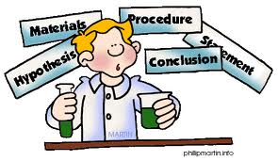

DAILY
EXPECTATIONS TRACKER

To ensure EVERY student is doing what he/she needs to do,
I am holding you accountable to follow daily class expectations.

Following each expectation = 5 points
MAX # of points = 100 points

It is YOUR RESPONSIBILITY that Ms. Francois stamps/checks this by the end of the period.
You CANNOT get it any other time!!!!!

You will NOT receive a check if you did not follow all classroom policies or actively work on the practice problems during the allotted class time. Ms. Francois is the final judge about you following daily expectations.

 | Arrive on Time | Participation  in Class | Behavior | Classwork effort | Homework completion
Monday
Tuesday
Wednesday
Thursday
Friday

TABLE OF CONTENTS

1.1 | Testable Questions
1.2 | Types of Variables
1.3 | Hypothesis
1.4 | Materials & Procedure

Contact information

Email: pfrancois@hs-gc.org

Website: msfrancoisap.weebly.com

1.1
Aim:

Objective:

Real world connection:

Vocabulary: *scientific method * testable question *

CLASS NOTES

What is the scientific method?

- The ________________________________ is an _______________ method that is used to find ____________________ to questions about the world around us.

Parts of the Scientific Method:
- _________________________________________________________
- _________________________________________________________
- _________________________________________________________
- _________________________________________________________
- _________________________________________________________
- _________________________________________________________
- _________________________________________________________

CLASS NOTES
1.1

Step 1: Question/Problem

All questions must be __________________________

WHAT IS A TESTABLE QUESTION?

    - They ________________ be a yes or no question.
    - You must be able to run an ______________ to test the question.
    - You must be able to _______________ the results
A testable question is NOT:

- __________________________________________

- __________________________________________

EXAMPLE: Which question is considered a testable question? Circle answer.

“How do students learn best?”
“Do students learn better before or after eating?”

Explain why: _____________________________________________________________

_________________________________________________________________________

YOU TRY!: Which is a testable question?

How does studying affect your test scores? Testable Not Testable
Does the length of a straw affect how easy it is to drink soda? Testable Not Testable
What is at the center of the Earth? Testable Not Testable

Summary: WHAT IS A TESTABLE QUESTION? (ANSWER IN 1 SENTENCE)

1.1
CLASS WORK

Circle the questions, which are testable using scientific experimentation.

1. Are there more seeds in Fugi Apples or Washington Apples?
2. What types of apples grow in Missouri?
3. Why do people smoke?
4. How does talking to a plant affect a plants height?
5. Where are whales found in the world?
6. What happens if you do not eat breakfast?
7. Which planet is the most interesting one to study?
8. Which objects are attracted by a magnet: paperclip, penny, foil?
9. Will larger or smaller seeds germinate faster?
10. Do larger or smaller seeds make prettier flowers?
11. Do flying saucers really exist?
12. Which pill design – tablet, caplet, or capsule – will dissolve faster?
13. Does the color of a surface affect its temperature?
14. Why does doing homework help your grades?
15. How does the size of a helicopter’s blade length affect the speed and number of rotations?
16. Does the temperature of a classroom affect student performance?
17. How does talking to a plant affect the plant?

Change 2 of the NON-testable questions to TESTABLE questions below:

1.

2.

CLASS WORK
1.1

Write a testable question for each of the following ideas for experiments.

- 1. You want to figure out how many pine cones are on the average branch of a pine tree.

- You want to know whether or not a McDonald’s super-sized fry has more fries in it than a large fry.

- You want to know whether or not people can taste the difference between different colored M&Ms.

- You want to know what the most popular color for a car is.

- You want to know what type of soda 11th graders at HSGC prefers.

Make up three of your own questions for new experiments you’d like to try.
1.

2.

3.

1.2
Aim:

Objective:

Real world connection:

Vocabulary: *Variable * Independent Variable * Dependent variable * Constant * Controlled Variable

CLASS NOTES

What is a variable?

In any experiment, you will have __________________________________.

Variable

Example: What might affect how well a student does on a test?

CLASS NOTES
1.2

YOU TRY!

What variables can affect the taste of soda?

There are three types of variables:

1. | what you change on purpose in an experiment  Also called the “ __________________________” variable
2. | what you measure in an experiment. It CHANGES AS A RESULT OF a different CHANGE  Also called the “ _______________________________” variable
3. | the condition or conditions that remain the same in an investigation.

INDEPENDENT VARIABLE: | DEPENDENT VARIABLE:
Cause
Before
Input
What you do
What you change on purpose
What you manipulate

CLASS NOTES
1.2

Example: How does talking on your cell phone affect your phone bill?

What do you need to consider for this experiment?

What can you change directly/purposefully?

What will change as a result?

What things do you want to be the same?

YOU TRY!:
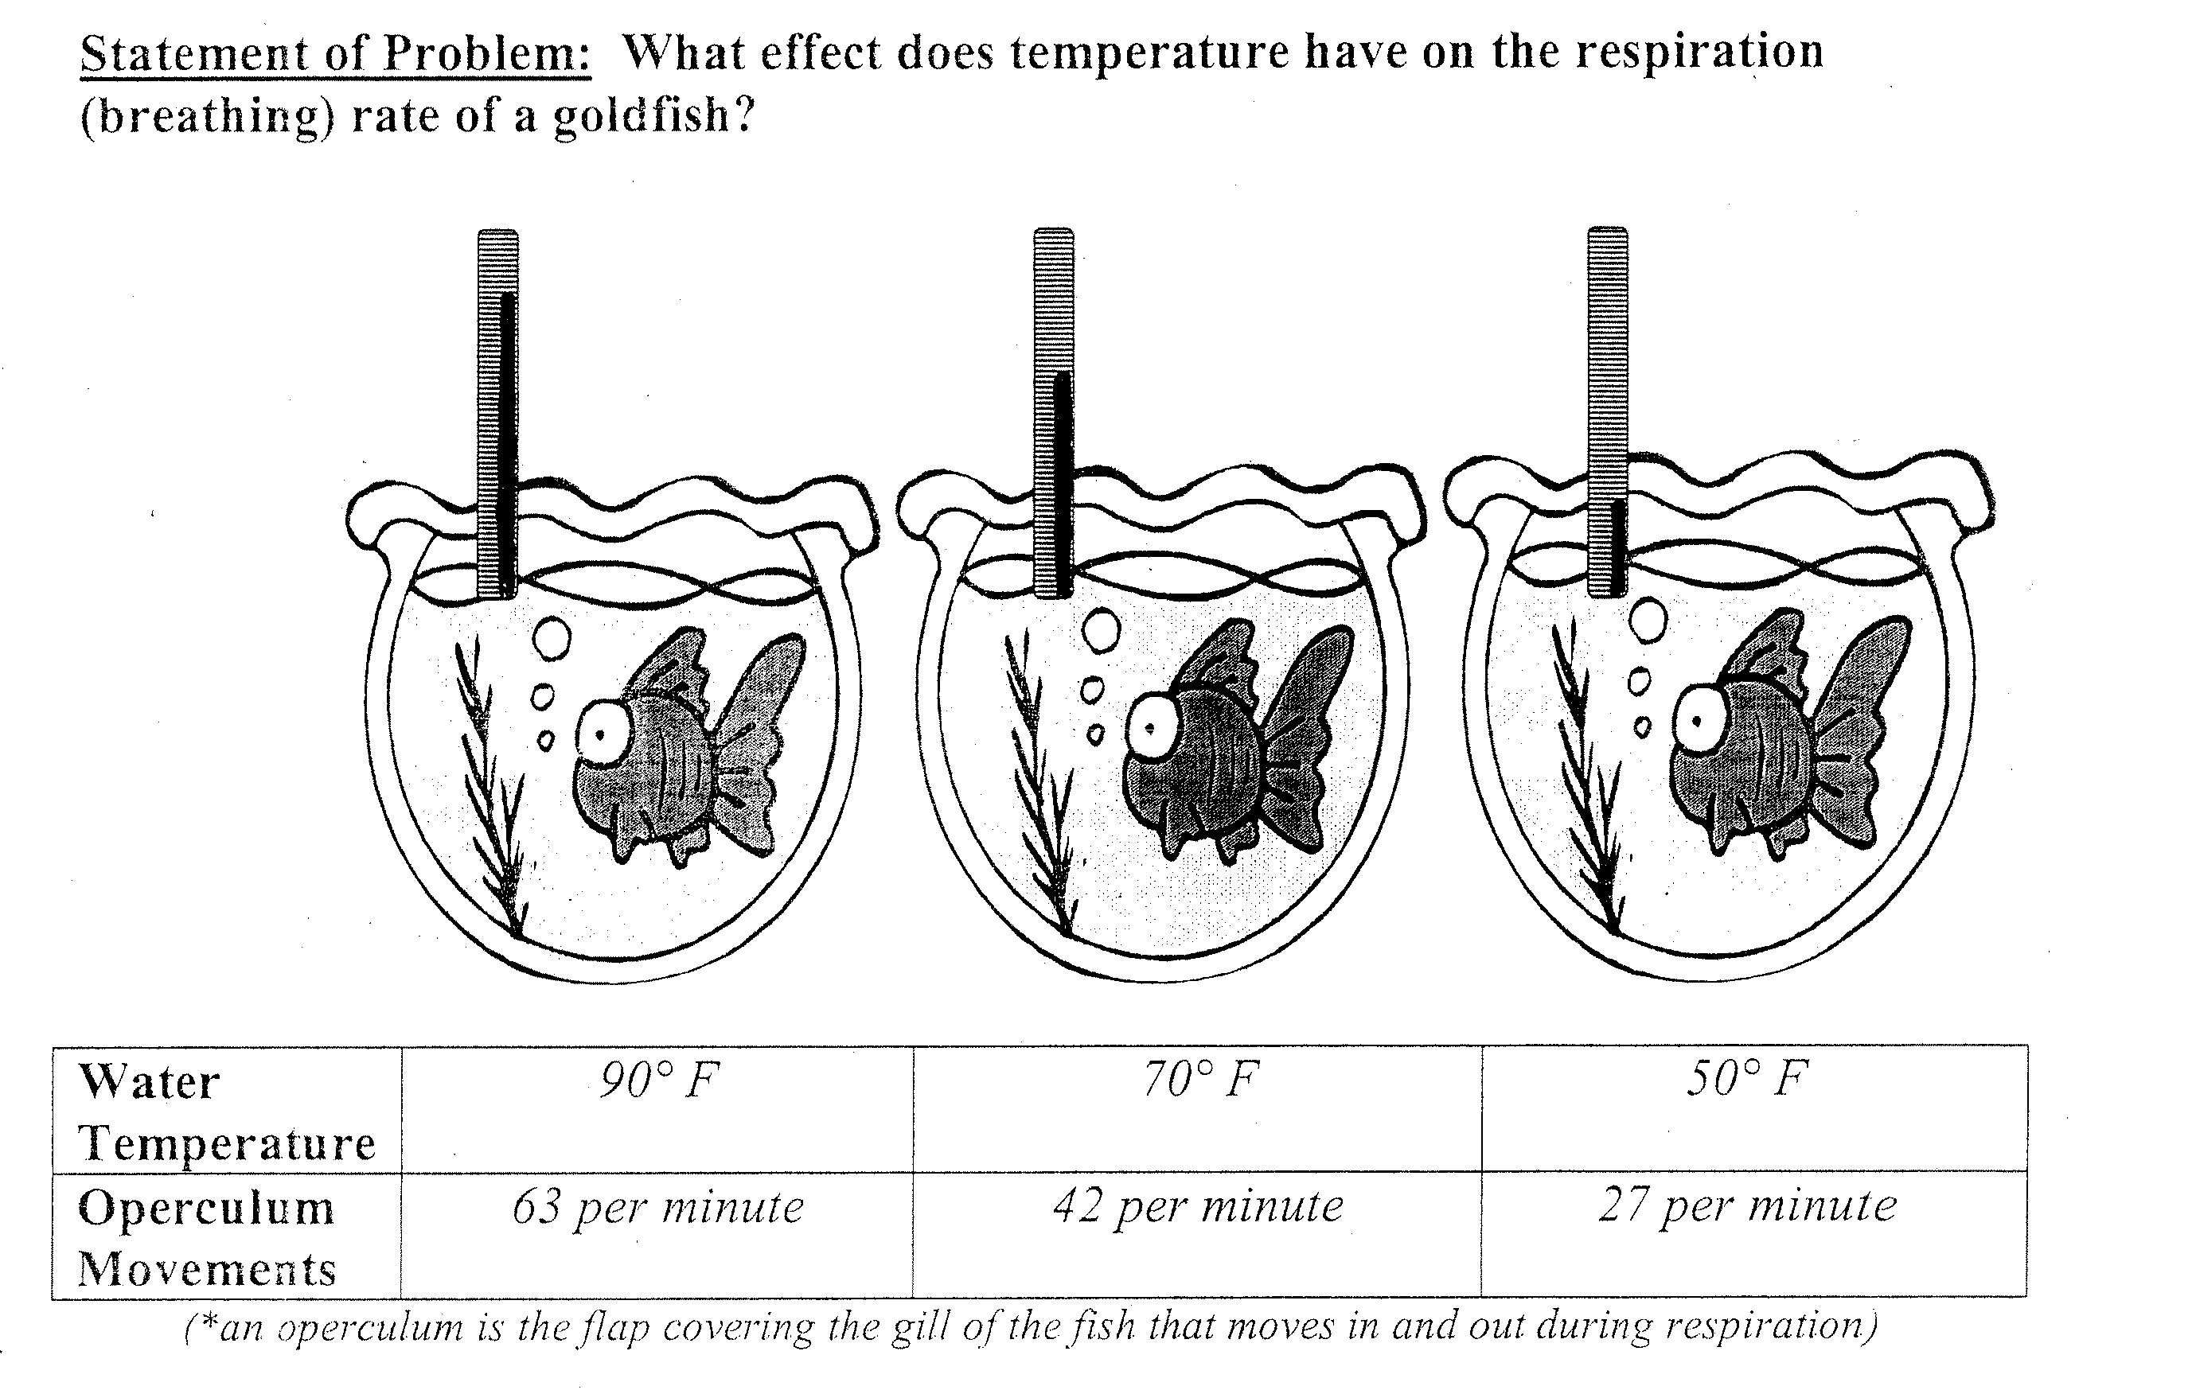

Step 1: Question/Problem

All questions must be __________________________

WHAT IS A TESTABLE QUESTION?

    - They ________________ be a yes or no question.
    - You must be able to run an ______________ to test the question.
    - You must be able to _______________ the results
A testable question is NOT:

I
1.2
CLASS NOTES

INDEPENDENT VARIABLE:

DEPENDENT VARIABLE:

CONSTANTS:

Two groups of students were tested to compare their speed working math problems. Each group was given the same problems. One group used calculators and the other group computed without calculators.

Testable Question:

What is the independent variable?

What is the dependent variable?

What are the constants?

Summary: WHAT DISTINGUISHES AN INDEPENDENT VARIABLE FROM A DEPENDENT VARIABLE? (ANSWER IN 1 SENTENCE)

1.1
CLASS WORK
1.2

Identify the independent variable and dependent variable of the following:

- Students watched a cartoon either alone or with others and then rated how funny they found the cartoon to be.

Independent Variable:

Dependent Variable:

Constants:

- A comprehension test was given to students after they had studied textbook material either in silence or with the television turned on.

Independent Variable:

Dependent Variable:

Constants:

- Some elementary school teachers were told that a child’s parents were college graduates, and other teachers were told that the child’s parents had not finished high school; they then rated the child’s academic potential.

Independent Variable:

Dependent Variable:

Constants:

1.2
CLASS WORK

For the following, write what kind of experiment you would design and then identify the independent variable and dependent variable.

- Drinking energy drinks makes people more aggressive.

Experiment:
___________________________________________________________________________________________
___________________________________________________________________________________________
___________________________________________________________________________________________

Independent Variable:
Dependent Variable:
Constants:

- Taking a nap in the afternoon makes people more relaxed and less irritable for the rest of the day.

Experiment:
___________________________________________________________________________________________
___________________________________________________________________________________________
___________________________________________________________________________________________

Independent Variable:
Dependent Variable:
Constants:

- Eating breakfast in the morning increases the ability to learn in school.

Experiment:
___________________________________________________________________________________________
___________________________________________________________________________________________
___________________________________________________________________________________________

Independent Variable:
Dependent Variable:
Constants

1.3
Aim:

Objective:

Real world connection:

Vocabulary: *Hypothesis *

CLASS NOTES

Step 2: Form a Hypothesis

Hypothesis

- It is _______________ a guess

- A hypothesis must be _______________________ (you can set up an experiment) and ___________________ (it can possibly be proven false)

- It is a _____________________ and ________________________ prediction

CLASS NOTES
1.3

How to write a hypothesis

- A hypothesis is written as an ________-___________-_____________________ statement: _______ I do this, ____________ will happen _____________________ of this reason

- The “if” part is what you change on purpose which is also called _________________________ variable

- The “then” part is the result of the change which is also called _________________________ variable

Example:
How does the amount of daylight affect how many eggs laid by a chicken?
H: If the amount of daylight increases, then the chickens will lay more eggs.

Independent variable:

Dependent variable:

YOU TRY!

Can you identify the Independent Variable and the Dependent Variable? Circle the Independent Variable and UNDERLINE the Dependent Variable.

- If I increase the amount of chocolate I eat, then I will probably increase the number of pimples I get.

- If the amount of salt in soil is increased, then plants will show less growth.

- If the color of light shining on a plant is changed, then plant growth will be affected.

- If I increase the temperature, then the amount of time necessary for bacteria to grow will be lower.
CLASS NOTES
1.3

Writing the hypothesis

Example: Question: How does room temperature affect student performance?

Hypothesis: If ________________________________________________________________

then ________________________________________________________________________

Independent variable:

Dependent variable:

YOU TRY!

How will batting practice affect a player’s batting average?

HYPOTHESIS:

Independent variable:

Dependent variable:

Summary: WHAT INFORMATION DOES A HYPOTHESIS INCLUDE?

I
1.3
CLASS WORK

For each of the following questions, write a reasonable hypothesis using the correct format.

1. How does the depth of the Lake of the Ozark affect its temperature?
HYPOTHESIS:

Independent variable:
Dependent variable:

2. How does advertising for can collection week affect the number of cans collected?
HYPOTHESIS:

Independent variable:
Dependent variable:

3. How does the size of a paper towel affect the amount of water it can hold?
HYPOTHESIS:

Independent variable:
Dependent variable:

4. Does fertilizer affect the growth of a plant?
HYPOTHEIS:

Independent variable:
Dependent variable:

CLASS WORK
1.3

First make sure every sentence is a well-written hypothesis (If you need to look at yesterday’s work, please do); if you need to rewrite it, do so.

Then, identify the Independent Variable and the Dependent Variable? Circle the Independent Variable and UNDERLINE the Dependent Variable.

- If a car uses a higher quality gas, then it will be able to travel a farther distance.

- If you push your pencil when you write, it will get dull faster.

- The more you read, the faster you read.

- Black cars get hotter than white cars.

- If you wear Nike basketball shoes, you make more baskets than if you wear Adidas.

1.4
Aim:

Objective:

Real world connection:

Vocabulary: *Materials * Procedure *

CLASS NOTES

Step 3: Perform the Experiment (Materials & Procedures)

To test the hypothesis you need:

Materials

Procedure

NOTE: Other people should be able to look at your procedure and do the exact same procedure and get the same results without you telling them anything or giving them any clues.

CLASS NOTES
1.4

Materials:

- Complete list of all the things you need

THINK: Ingredients for a recipe

  - _______________________________________________________
  - Accurate and specific so that it can be replicated or done again by someone else
  - Example:
  - Don’t say: beaker
  - Say: 200 ml beaker

Example: Circle the parts that are specific.

- 4 quarter pieces of Alka-Seltzer tablets
- 2 half pieces of Alka-Seltzer tablets
- 1 whole piece of Alka-Seltzer tablet
- 100 mL of Water
- 250 mL Beaker
- Stop watch

Procedure:

You need to specify:
1. ______________________________ : Any step that requires that a specific amount of something be used should make it clear EXACTLY how much to use, and should include UNITS (examples: 2 teaspoons of baking soda, 150 ml vinegar, etc.).

2. _____________________________: Procedures should be very clear about how many times you have to repeat the experiment in order to make sure you get accurate results. (Repeat steps 3-5 2x). KEY WORD: REPEAT ___x.

CLASS NOTES
1.4

Writing a Procedure for…

IN A PRE-LAB in your LAB NOTEBOOK:
- best written as a _________________________ sequence.
- Every step should start as a _______________________ (examples: “gather,” “pour,” “measure,” “record,” etc.). There should not be any step that starts with words like “Next,” “Then,” “Second,” “Third,” etc.
- DO NOT use “I” or “you”
- Each action should be listed as a ______________________________ step

Example:
- Don’t Say: We are taking the temperature every 2 minutes.
- Say: Take the temperature every 2 minutes.

YOU TRY!:
- Don’t Say: You should count the number of drops it takes for the water to overflow and repeat 3 times.
- Say:

IN A TYPED LAB REPORT:
- It must be in _____________________ form with ______________________ words
- Steps are written in ________________________
  - Past tense = happened already (ends with –ed normally)
- Steps are written in ______________________________
  - Passive voice = DO NOT use I, we, you

Example:
- Don’t Say: We are taking the temperature every 2 minutes.
- Say: The temperature was taken every 2 minutes.

Summary: What is the purpose of writing a procedure?

I
1.4
CLASS WORK

Circle the transition words.

First, add 100 mL of water to the beaker. Next, drop in one-quarter piece of Alka-Seltzer. Using the stopwatch, observe the length of the reaction. Afterwards, record the length of the reaction in the correct place in the provided Data Table below. Repeat the experiment three more times: once with a half tablet, once with three quarter tablets and once with a whole tablet. Following this step, record your data on the class data table in the front of the room. Then copy the data obtained from the other lab groups. Average the length of reaction from all of the groups for each differing amount of Alka-Seltzer afterwards. Finally, plot the average lengths on a graph (See the Data Analysis section for further details)
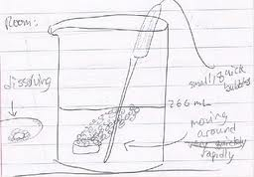
Is this procedure written correctly for a lab report? Explain your answer.

CLASS WORK
1.4

Practice:
- Write down a set of procedures for making a peanut butter and jelly sandwich
- Write them as though you were writing a set of procedures for an experiment inside your lab notebook: clear, complete, and easy enough for an intelligent 4th grader to follow and get it right.

- Write them as though you were writing a typed lab report.

