SCIENCE LAB REPORT FORMAT
After you finish the experiment, you will type up a formal lab report. The lab report is due in one week from completing the lab. Lab reports provide scientists an opportunity to read and understand what you did in the experiment as well as analyze your results.

RULES:
- Each lab report must be typed.
- Each lab report must have the following heading on the LEFT hand side:
Name
Subject—Period ______
Teacher Name
Date
- In the middle after the heading, include the following

Lab #___: Title of Lab
Lab Completed on mm/dd/yyyy

- The lab report should be typed in Times New Roman, 12 pt. font.
- The lab report should be SINGLE SPACED.
- All headings should be bold, capitalized, and underlined and have a colon (:) at the end.
- After each section, skip a space.

Your Lab Report Will Include the Following:

- Question: The question to be answered in the experiment should be clearly written on the first page of the lab notebook entry.

- Introduction: A brief (five sentence) introduction to the experiment should be written at the top of the page. The introduction should state the goals and objectives of the laboratory and describe what data will be collected and how that data will be used to arrive at conclusions at the completion of the laboratory.

- Variables: You will be expected to identify the independent variable, dependent variable, and controlled variable.

- Hypothesis: Should be written as If __________, then ____________ because ________________. The hypothesis is a one-sentence liner where you make your prediction and support it with an explanation. The “if” is the independent variable and the “then” is the dependent variable.

- Equations: Write down any equations that will be used during the experiment to perform any calculations

- Materials: Your materials list must be very complete. You must indicate how much of each material will be used in the experiment. Leave a couple of lines so you can add extra things you forgot.

- Procedure: The steps should be written as a paragraph. Use transitional words. Everything should be in the past tense. Do not use you, I, or we!

- Data and Calculations: This is where you record all the data and results you collected during the experiment. This is typically done in the form of tables and charts. Also show any calculations you made for the experiment.

- Discussion and Conclusion: The conclusion is the most important part of the experiment. This is where you analyze your results. In paragraph and sentence form in 10-15 sentences include:

Paragraph 1: Introduction
    - Restate the lab’s hypothesis
    - State if your hypothesis was correct, incorrect, or inconclusive.
    - Summarize your results—state any trends you saw and why
Paragraph 2: Body
    - 2 Sources of error
    - 2 Suggestions to improve experiment
Paragraph 3: Conclusion
    - Explain how information gained in lab can be applied to real-life situations and how does it relate to major scientific principles, classnotes, or text
    - State at least two questions that you have remaining from the experiment (propose a new but related question that you could do an experiment for)

Below features how your lab report will be set up:

Princess Francois
Chemistry—Period 1
Ms. Francois
October 5, 2013

Lab #1: Effect of Surface Area on Rate
Lab Completed on 10/1/13

QUESTION:
What effect does the surface area have on the rate of dissolving?

INTRODUCTION:
In this experiment, we are looking to test the effect of surface area on the rate of dissolving. In order to do this, we will test the effect of three different surface areas of an Alka Seltzer Table (whole tablet, chunks, crushed) on the rate at which an Alka Seltzer dissolves. We will take data of the time it takes for a whole table, ¼ chunks and completely crushed Alka Seltzer to completely dissolve. If it takes longer to dissolve as you use smaller pieces, that means the surface area has a negative effect. If it takes shorter to dissolve as you use smaller pieces, that means the surface area has a positive effect.

VARIABLES:
- Independent variable: surface area
- Dependent variable: rate at which the Alka Seltzer tablets dissolve
- Controlled variables:
1. amount of water
2. amount of Alka Seltzer
3. temperature of water

HYPOTHESIS:
If I increase the surface area of the Alka Seltzer, then the rate at which the tables dissolve increases because the Alka Seltzer has more contact points with water.

EQUATIONS:
N/A

MATERIALS:
- 6 Alka Seltzer Tablets
- Petri dish
- Mortar and pestel
- water
- beaker
- stopwatch

PROCEDURE:

First, one whole Alka Seltzer Tablet was placed into 100 mL of water. Afterwards, the time it took to dissolve was recorded. Next, the beaker was rinsed thoroughly. The first two steps were repeated for a second trial. Following that, the mean was then calculated between the two trials.
For the second part, an Alka Seltzer tablet was broken into small pieces in a petri dish. The small pieces of Alka Seltzer were placed into 100 mL of water. Then, the time was recorded for how long it takes to dissolve. Next, the beaker was rinsed thoroughly. Steps five through seven were repeated for the second trial. The mean was calculated between the two trials.
For the third part of the experiment, an alka seltzer tablet was completely crushed into powder in a petri dish. All the powder was dumped into 100 mL of water. The time was then recorded for how long it took to dissolve. Next, the beaker was rinsed thoroughly. Afterwards, steps ten through twelve were repeated for a second trial. Finally, the mean of the two trials was calculated.

DATA AND CALCULATIONS:

DATA:
Time It Takes for Tablet to Dissolve
 | Whole Tablet | Chunks | Crushed
Trial 1 | 90s | 78s | 53s
Trial 2 | 100s | 72s | 65s
Mean | 95s | 75s | 59s

CALCULATIONS:
Whole Tablet: 90+ 100 = 95s
2

Chunks: 78+72 = 75s
2

Crushed: 53 + 65 = 59s
2
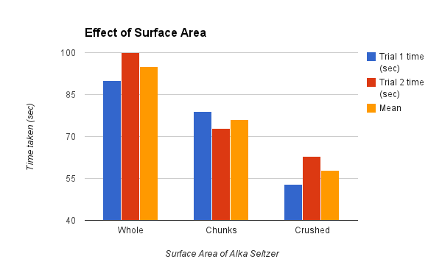

DISCUSSION AND CONCLUSION:
In my hypothesis, I stated if I increase the surface area of the Alka Seltzer, then the rate at which the tables dissolve increases because the Alka Seltzer has more contact points with water. In this experiment, my hypothesis was proved to be correct. This is evident through my data. For example, the mean rate of the whole tablet took 20 seconds slower than the mean rate of the chunked tablet. In addition, there is a 36 second difference between the whole tablet and crushed tablet.
Overall, the experiment was successful. However, there are some sources of error that probably affected the results of the experiment. One source of error could be how the tablet was broken into pieces. The chunks may not have all been the same size, which could have affected the rate. In the future, a knife could be used to break everything into equal size. Another source of error could be the timing of the test. There is a possibility that the timing could be off because the counting down may not have started immediately after the tablet hit the water. In the future, having one person drop the tablet while someone else starts the stopwatch could help with more accurate timing.
After having completed the experiment, some questions popped into mind. I wonder how would temperature have an impact on the dissolving rate. I also wonder if using a different type of tablet would have an impact.

