Lab
4
Date: | Title: Calcium & Bone Strength

Exp. Number  4 | Experiment/Subject:  Calcium & Bone Strength | Date: Put date lab was performed
Name: YOUR NAME | Lab Partner  WHO YOU WORKED WITH | Locker/Desk No. N/A | Course & Section #  Class & Period

Question:
How does removing calcium from bones with various liquids affect bone strength?

Background information (don’t copy into nb)
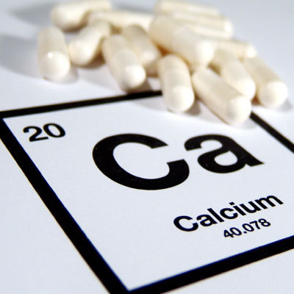
CALCIUM: Calcium is an important mineral needed for multiple functions within the body. It is the most abundant mineral in the body, and is used so often that it must constantly be replenished through the diet. More than 99% of the calcium in your body is stored in the bones. The calcium found in bones helps maintain the strength and structure of bones, along with other minerals such as phosphorus, but it is also stored in bones for removal when the body needs it. Bones are composed of a variety of substances. Calcium compounds are found in the hard, outer layer of bones. Calcium provides for the toughness and strength of bones. Bone cells remove calcium phosphate and calcium carbonate from the blood to form bone in a process called ossification Specialized cells in bone tissue are responsible for adding and removing calcium from the bones depending on the amount of calcium in the bloodstream. This means only 1% of calcium is normally found in the body outside of bone and is crucial to important body functions

Calcium in the bloodstream and body tissues functions to:
- Allow cells to respond to cellular signals, such as hormones
- Stabilize the blood pressure in vessels
- Assist insulin in allowing glucose to enter cells
- Assist in blood clotting
- Assist in the release of neurotransmitters at the synapse of nerves
- Facilitate muscle contractions (contractions WOULD NOT occur without calcium)
- Assist sperm in the fertilization of the egg

Essentially calcium is needed for the heart to pump, the brain and nerves to work, to keep our bones hard, to make our muscles move, even for reproduction of the human species, and this is only a list of the most important functions!

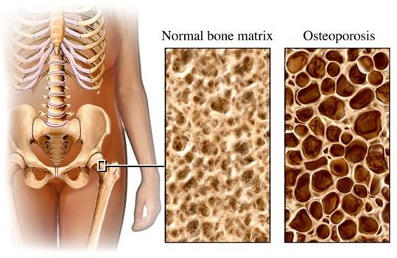
Osteoperosis:
Calcium is continually added to bone from about the third
trimester of pregnancy into early adulthood. At this point, a small
amount of calcium will be lost from bones naturally, as bone-
forming processes become slower than bone removal. This
natural bone loss is called osteopenia, and makes bones
slightly less dense and more prone to fracture. In some
individuals, the rate and amount of mineral loss is accelerated
and can lead to a condition called osteoporosis, in which bones become very porous, fragile, and brittle. More than 80% of those who suffer from osteoporosis are women over the age of 65. More than 55% of people over the age of 50 have some degree of osteoporosis.

Using a specialized x-ray machine, the density of bone minerals, such as calcium, can be determined through a bone mineral density (BMD) test. A BMD test can diagnose the onset of osteoporosis. There are treatment options that can decrease the risk of osteoporosis that include diet changes, exercise, and medications.

Case Scenario:
You are a family physician at HASPI Medical Center. You have just informed a 43-year-old female patient that her bone mineral density test shows early signs of osteoporosis. She is a pack-a-day smoker and does not really want to change any of her lifestyle habits, or take calcium supplements. The patient does not understand why it is such a big deal that she is losing calcium, and thinks it is just a lie made up by the supplement companies. In order to create a visual example of the impact of calcium loss on bone tissue, you have set up the following experiment for your patient. Conduct the experiment over the next week to show your patient what can happen when important minerals and/or bone tissues are lost.

Introduction: Write this section AFTER you have completed the hypothesis and procedure.
Make sure to include:
- T = Topic (state goals & objectives of lab)
- I = Introduction of Evidence (what data will be collected)
- E = Evidence (how it will be collected—summarize experiment)
- D = Development of Evidence (what data might you expect and what conclusion can you come to)
- C= Conclusion

variables:
Independent variable:

Dependent variable:

Constants:

hypothesis:
*Write it using if-then-because statement. (Predict which liquid would affect [increase/decrease] the strength the most)

equations:
N/A

materials:
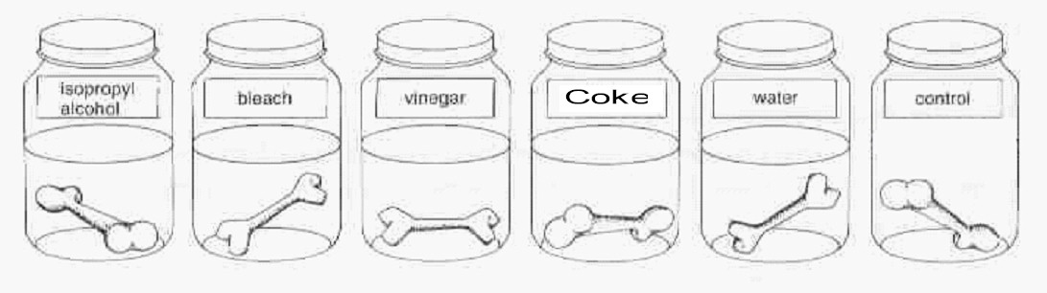
30 mL Vinegar (Acetic Acid) 30 mL Bleach
30 mL Coke 30 mL isopropyl alcohol
30 mL Water Triple Beam Balance
Graduated cylinder 3 Chicken bones
3 Beakers/cups Paper towels

 | Procedure:  List each step and write it in the command voice. | Observations:
1. | Obtain three beakers/cups and label one with a “W” for water, one with a “V” for vinegar, and the other with a “X” for liquid of choice
2. | Using the graduated cylinder, measure out 30 ml of water and pour it into the beaker/cup labeled “W”.
3. | Using the graduated cylinder, measure out 30 ml of vinegar and pour it into the beaker/cup labeled “V”.
4. | Using the graduated cylinder, measure out 30 ml of chosen liquid and pour it into the beaker/cup labeled “X”.
5. | Choose three chicken bones and remove all excess muscle from the bone. Dry off the bones with a paper towel. MAKE SURE TO WASH YOUR HANDS AFTER HANDLING RAW CHICKEN!!!
6. | Obtain a paper towel and scale. Weigh the paper towel
7. | With a paper towel on the scale, weigh each chicken bone separately. Subtract the weight of the towel from the total weight w/ bone and record bone’s weight in as the starting weight for each column in the table.
8. | Place a bone in the beaker/cup containing water. Make sure the bone is completely covered. If it is not covered, then add more water.
9. | Place a bone in the beaker/cup containing vinegar. Make sure the bone is completely covered. If it is not covered, then add more vinegar.
10. | Place the third bone in the beaker/cup containing liquid of choice. Make sure the bone is completely covered. If it is not covered, then add more bleach.
11. | Make your initial observations of the bones. This could include the bones’ color, texture, smell, firmness, etc.
12. | Place all three beakers/cups in a safe place where they will not be disturbed. Use a piece of paper or paper towel with your group name placed under the beakers/cups to identify them. The bones will be observed and weighed at the end of five days.
13. | WASH YOUR HANDS WITH SOAP AND WATER EVERY TIME YOU HANDLE THE CHICKEN BONES!
After 5 days
 | Procedure:  List each step and write it in the command voice. | Observations:
1. | Remove the bone from the water beaker/cup and dry it off on a paper towel.
 | Obtain a paper towel and scale. Weigh the paper towel
2. | Place the bone on the paper towel and record its weight in grams. Subtract the weight of the towel from the total weight w/ bone and record weight of bone in grams. Make a note of any visual observations as well.
3. | Repeat Step 2 for the other bones.

Data and calculations:

Weight of Paper Towel: _______________________________________________

Table 1. Bone Weight
Time  Period | Water (Control) |  | Vinegar
 | Weight of paper towel + bone (g) | Weight of bone (g) | Weight of paper towel + bone (g) | Weight of bone (g) | Weight of paper towel + bone (g) | Weight of bone (g)
Initial
(0 hr)
96 hours

Table 2. Bone Observations & Weight
Time  Period | Water (Control) |  | Vinegar
 | Weight from Table 1 | Observations | Weight from Table 1 | Observations | Weight from Table 1 | Observations
Initial
(0 hr)
96 hours

GRAPH:

Create a double bar graph of the weights for each bone before and after the test period on the graph provided below. Be sure your graph includes:
- Title for the graph
- X and y axis clearly labeled (with titles and units)
- Bars for initial weight and post weight
- A key to distinguish the bars
- Number scale with evenly spaced intervals

Title: ________________________________________________________________

Key:

discussion:
- What liquid did you and your partners choose to soak chicken bone C in?

- Why did you choose that particular liquid?

- Compare and contrast the three bones placed in the various liquids.

- Was there any evidence that calcium was removed from any of the bones? If so, what was it? From which liquids was the calcium removed?

- Why do you think the liquids had the effect they did on the bones? What did those liquids have in common?

conclusion:
- My hypothesis was correct incorrect inconclusive (circle one)

- 2 pieces of evidence (use numbers) that proved my hypothesis to be correct:

- Sources of error:

- Things to change in the experiment:

- Two questions about experiment:

- REAL WORLD CONNECTION: Explain how these results show the impact of calcium loss in bones. How does this experiment reflect what happens in osteoporosis?

Group work reflection:
Roles: (4 pts) Please put first AND last name!
- Task Manager: __________________________________________________
- Spokesperson: _________________________________________________
- Data Collector: _________________________________________________
- Resource Manager _____________________________________________

Checklist: (4 pts)
- Did each person play a part in the lab and on task?
- Did you follow safety rules?
- Were all parts of lab completed?
- Was group workspace cleaned up?

Answer the following questions: (10 pts)

What worked well the most during the assignment for the group?

What did not work so well during the assignment for the group? Where did you disagree as a group or saw mistakes in each other’s work?

What will you do next time to improve how your group worked together?

How much did you as an individual participate in the group?

What can you do next time to improve your own performance in the lab group?

Group Rubric:

 | Poor  1 point | Developing  2 points | Good  3 points | Excellent  4 points | Group Rating  (YOU RATE) | Teacher  Rating
Contribution | One or more members do not contribute. | All members contribute, but some contribute more than others. | All members contribute equally. | All members contribute equally, and some even contribute more than was required.
Cooperation | Teacher intervention needed often to help group cooperate. | Members work well together some of the time. Some teacher intervention needed. | Members work well together most of the time. | All members work well together all of the time; assist others when needed.
On task | Team needs frequent teacher reminders to get on task. | Team is on task some of the time. Needs teacher reminders. | Team is on task most of the time. Does not need any teacher reminders. | Team is on task all of the time.  Does not need any teacher reminders.
Communication | Members need frequent teacher intervention to listen to each other and speak to each other appropriately. | Members need some teacher intervention to be able to listen to each other and speak to each other appropriately. | All members listen to each other and speak to each other in equal amounts. | Each member listens well to other members. Each member speaks in friendly and encouraging tones.
Total Score: /32 |  |  |  |  | /16 | /16

- TOTAL SCORE ON REFLECTION: _________/50

- GROUP RATING: _________/32

- Completion of Lab: ____________/50

- Overall Score on Lab: _____________

