Handout for Phlebotomist

What is Phlebotomy?
The process of making an incision in a vein with a needle .
It takes the blood by entering the veins, usually through the middle arm or wrist .

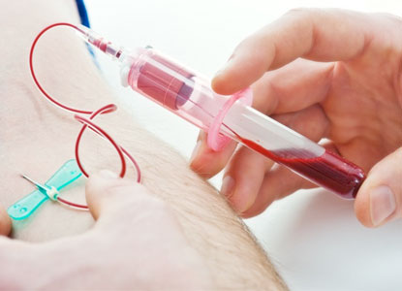

Work Environment?
Phlebotomists work everywhere, such as hospital, clinics, and labs.
Yes, they have to wear Uniform, Certain of phlebotomists have to wear purple or white uniform.
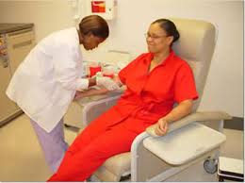

Daily Routine?
A phlebotomist works can vary widely from location to location.
An Phlebotomist have to be in a hospital, where they have to take people’s blood

Daily Routine 2
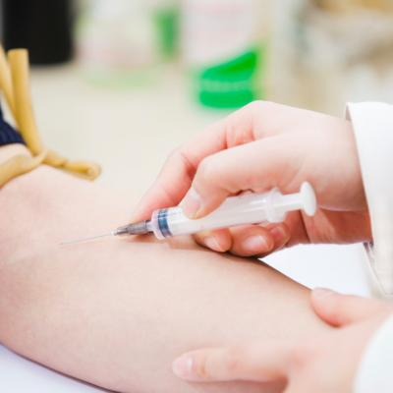

Qualifications-Education?

Certificate expect an average of 6 months class room work
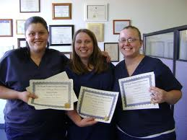

Qualification-Licensure/Certifications:
Phlebotomist required both license and certification
It takes 6 months to get a license and the certification.
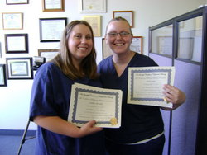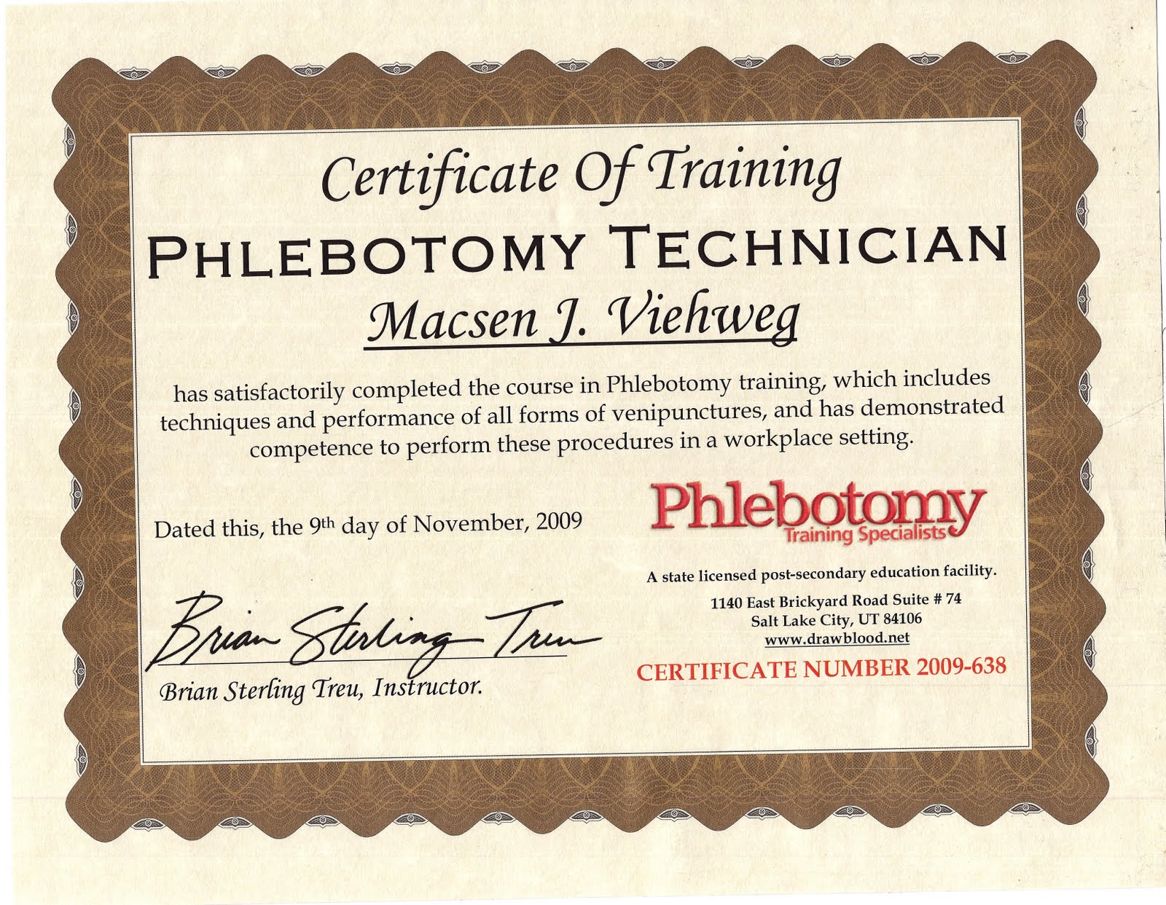

Important Qualities:

Recordkeeping, Blood Collection, Safety and Infection Control, Interpersonal Communication.

A high school diploma is required to begin study as a phlebotomist.

