` Handout for Medical Assistant

Overview: What is Medical Assistant?
Medical assistant usually complete many different tasks such as measuring a patient’s blood pressure or taking a patient’s temperature.
What does Medical Assistant do?
Medical assistant take record patient history and personal information, Measure vital signs, help the physician with patient examinations, give patients injections as directed by the physician, schedule appointments, and prepare blood for labatoratory tests.
Work environment: Where do Medical Assistant work? Medical Assistant work at in physicians and other healthcare facilities.
Uniform for Medical Assistant?
Medical assistant wear scrubs that is loose, sort sleeved top and drawstring pants.

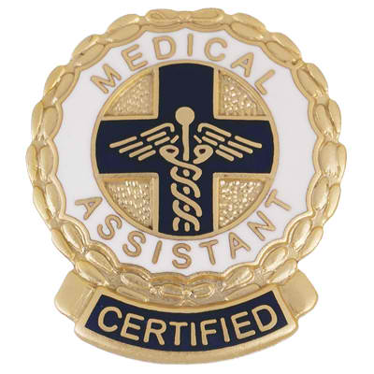
Daily Routine: What is the work schedule like?
The work schedule remains open foe nights or weekends, additional hours many be required unless there is a separate weekend.
Qualification-Education:
What tests required to become a Medical Assistant? Yes CMA-Certified Medical Assistant, and AAMA-American Association of Medical Assistant.

Qualifications-Licensure/Certifications:
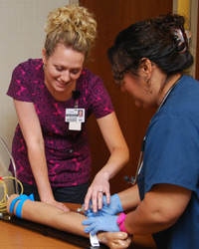
Is a license or certification required?
It depend because not every state requires to get one.

Important Qualities:
What personal qualities are needed for Medical Assistant?
Medical Assistant should always pay attention to detail, strong communication skills, and dependability.

Salary: The average salary for Medical Assistants is $26,000.
Median salary is $14.12.

Job outlook: How many job available now? How many jobs will be available in the future?
There are currently 4,047 Medical Assistant jobs available. New jobs that will be expected to gain is 162,900 new jobs during 2012 and 2022.
Minorities in the field: Ashlee Laatsch is a medical assistant who works at patient first, she has been in this field for 5 years. She decided to become a medical assistant because she enjoys helping and taking care of others.
Significance: Why is this health career field important?
This health career field is important because through interaction with patient assistant support patients. Also medical assistant make sure patient are correctly diagnosed.
Questions:
What is a Medical Assistant salary?
What does a Medical Assistant do?
What training do you need to become a Medical Assistant?

Conclusion: What have you learned from doing this project? What did you find more interesting? What questions did this project raise for you?
We learned what a Medical Assistant is and how it works. What we found more interesting is that how they work and help patients. What would we do without Medical Assistant.

