Hair Relaxers—Go Natural or Go Relaxing?
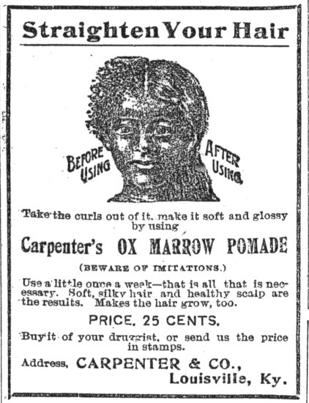
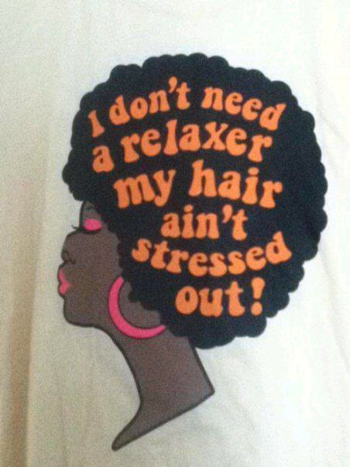
Notes: What do you think about this?

Notes: What do you think about this?

Go Natural: Pros
Argument |  | Cite Evidence (Quote & Website)
Go Natural: Cons
Argument |  | Cite Evidence (Quote & Website)
Go Relaxing: Pros
Argument | Cite Evidence (Quote & Website)
Go Relaxing: Cons
Argument | Cite Evidence (Quote & Website)

