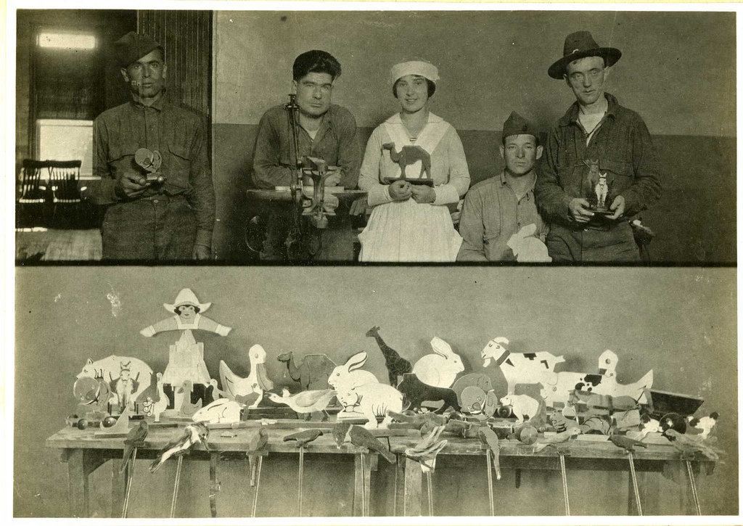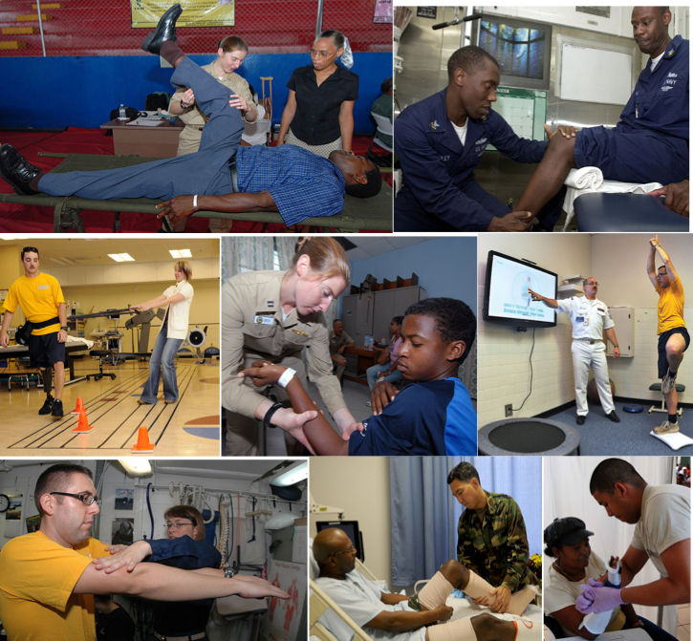

### Tal – Marie Davis Shantel Lewis

🙞 🙜

Occupation therapist work with injured and aiding patient in order to minimize pain, increase motion and increase strength.

🙞 🙜

Physical therapists are able to work anywhere. They have been found in hospitals, clinics, private clinics, homes, schools, care homes and emergency rooms.

A massage by a physical therapist is not the same as you receive at the spa. It helped reduce tightness that caused by pain.

#### Physical therapist help injured or ill patient to improve their movement

# Physical Therapist

## Occupation Therapist

Physical and Occupation Therapist

. What is Physical Therapist?

. What kinds of treatment do Physical Therapists do?

. Where can I go for Physical Therapist?

. What is an Occupational Therapist?

. What kinds of treatment do Occupational Therapists do ?

Physical Therapists are medical professionals who specialize in helping patients both recover from and manage immobility that result from injuries, illnesses, or surgeries. Physical therapy can be a very rewarding career, as it involves improving the overall quality of life for patients, as well as an average pay of $76, 000 a year in the US.

Occupation Therapists has a holistic philosophy, and deals with any physical, cognitive or emotional issue that keeps a person from succeeding in the areas important to him/her. You can find Occupational Therapists working in schools, hospitals, the military, nursing homes, rehab facilities, pediatric practice, wellness programs, community agencies, substance abuse rehab.

# Physical therapist & Occupation Therapist

## Q&A