Axial Skeleton

Structure of Bone
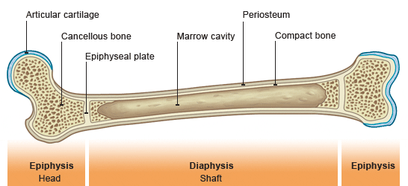

Using the following words to label the diagram:

Periosteum Bone Marrow Metaphysis
Compact bone Epiphysis Articular cartilage
Spongy bone Diaphysis

Skull Section
Anatomical Term | English Term
Cranium
Orbit
Mandible
Maxilla

Label the following parts of the CRANIUM using the words below:
Mandible Maxilla Orbit Nasal Bone Parietal bone
Occipital Bone Frontal bone Temporal bone Zygomatic bone

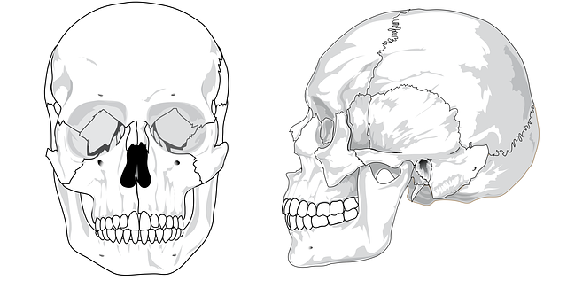

Label the picture below using the words above:

Thoracic Cage
Anatomical Term | English Term
Costae/Thoracic
Sternum

Label the picture below using the words below:
(Make sure to # all 12 ribs)

Sternum Costal Cartilage
True Ribs False Ribs Floating Ribs

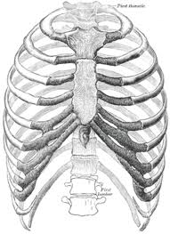

Vertebral Column
Anatomical Term | English Term
Vertebrae
Cervical
Lumbar
Thoracic
Sacrum
Coccyx

Label the picture below using the words above:

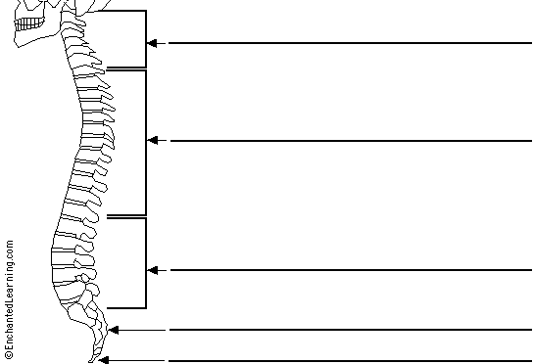

Appendicular Skeleton

Upper Limbs (Arms) Bones
Anatomical Term | English Term
Humerus
Radius
Ulna
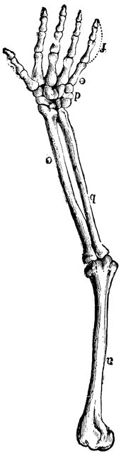

Hand Bones
Anatomical Term | English Term
Carpals
Metacarpals
Phalanges

Label the picture below using the words above:

Pectoral Girdle Bones
Anatomical Term | English Term
Clavicle
Scapula
Pectoral Girdle

Label the picture below using the words above:
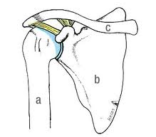

Pelvic Girdle (Pelvis) Bones
Anatomical Term | English Term
Os Coxae

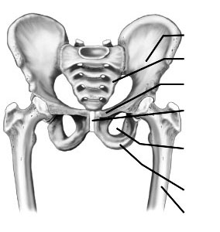
Label the picture below using the words below:

Sacrum
Coccyx
Femur
Ilium
Pubis
Ischium

Lower Limbs (Leg) Bones
Anatomical Term | English Term
Femur
Tibia
Fibula
Patella

Feet Bones
Anatomical Term | English Term
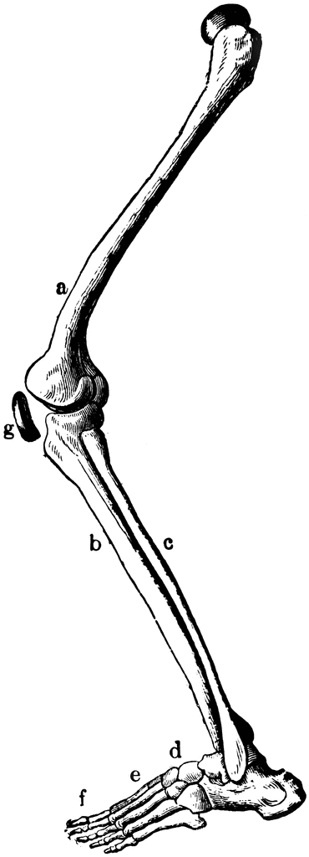
Tarpals
Metatarpals
Phalanges

Label the picture below using the words above:

Label the Following Parts
